Example
Task 1. Coordinates of vertices of the pyramid $\text{ABCD}$ are given as: $A\left(−7, −5, 6\right)$; $B\left(−2, 5, −3\right)$; $C\left(3, −2, 4\right)$; $D\left(1, 2, 2\right)$.
Find:
1) lengths of edges $\text{DA}, \text{DB}, \text{DC}$ as modules of vectors $\vec{\text{DA}}, \vec{\text{DB}}, \vec{\text{DC}}$;
$$\vec{\text{DA}}=(−7−1;−5−2;6−2)=(−8;−7;4)$$
$$\vec{\text{DB}}=(−2−1;5−2;−3−2)=(−3;3;−5)$$
$$\vec{\text{DC}}=(3−1;−2−2;4−2)=(2;−4;2)$$
USE OCTAVE
https://octave-online.net/,
octave:1> pA=[-7 -5 6]
pA =

-7 -5 6

octave:2> pB=[-2 5 -3]
pB =

-2 5 -3

octave:3> pC=[3 -2 4]
pC =

3 -2 4

octave:4> pD=[1 2 2]
pD =

1 2 2
octave:5> vDA=pA-pD
vDA =

-8 -7 4

octave:6> vDB=pB-pD
vDB =

-3 3 -5

octave:7> vDC=pC-pD
vDC =

2 -4 2
$\left|\vec{\text{DA}}\right|=\sqrt{(−8)^{2}+(−7)^{2}+4^{2}}=\sqrt{\text{64}+\text{49}+\text{16}}=\sqrt{\text{129}}≈\text{11},\text{358}$ (units of length)
$\left|\vec{\text{DB}}\right|=\sqrt{(−3)^{2}+3^{2}+(−5)^{2}}=\sqrt{9+9+\text{25}}=\sqrt{\text{43}}≈6,\text{557}$(units of length)

octave:8> lDA=norm(vDA)
lDA = 11.358
octave:9> lDB=norm(vDB)
lDB = 6.5574

2) the angle $D$ between edges $\text{DA}$ and $\text{DB}$ as the angle between two vectors $\vec{a}=\vec{\text{DA}}$ and $\vec{b}=\vec{\text{DB}}$;
$$\vec{\text{DA}}⋅\vec{\text{DB}}=(−8)⋅(−3)+(−7)⋅3+4⋅(−5)=\text{24}−\text{21}−\text{20}=−\text{17}$$
$$\text{cos}D=\frac{\vec{\text{DA}}⋅\vec{\text{DB}}}{\left|\vec{\text{DA}}\right|⋅\left|\vec{\text{DB}}\right|}=\frac{−\text{17}}{\sqrt{\text{129}}⋅\sqrt{\text{43}}}≈−0,\text{2283}$$

octave:10> scprDADB=dot(vDA,vDB)
scprDADB = -17
octave:11> cosD=scprDADB/(lDA*lDB)
cosD = -0.2283

3) the cross product of $\vec{a}=\vec{\text{DA}}$ and $\vec{b}=\vec{\text{DB}}$, i.e. $\vec{с}=\vec{a}×\vec{b}=\vec{\text{DA}}×\vec{\text{DB}}$;

$$\begin{aligned}\vec{c}=\vec{\text{DA}}×\vec{\text{DB}}=\left|\begin{matrix}\vec{i} & \vec{j} & \vec{k} \\ −8 & −7 & 4 \\ −3 & 3 & −5\end{matrix}\right|\begin{matrix}\vec{i} \\ −8 \\ −3\end{matrix}\begin{matrix}\vec{j} \\ −7 \\ 3\end{matrix}|=\text{35 \{}\vec{i}−\text{12 \{}\vec{j}\end{aligned}−\text{24 \{}\vec{k}−\text{21 \{}\vec{k}−\text{12 \{}\vec{i}−\text{40 \{}\vec{j}==\text{23 \{}\vec{i}−\text{52 \{}\vec{j}−\text{45 \{}\vec{k}$$

octave:12> c=cross(vDA,vDB)
c =

23 -52 -45

4) the mixed product of three vectors $\vec{\text{DA}}, \vec{\text{DB}}, \vec{\text{DC}}$;
$$\left(\vec{\text{DA}},\vec{\text{DB}},\vec{\text{DC}}\right)=\left|\begin{matrix}−8 & −7 & 4 \\ −3 & 3 & −5 \\ 2 & −4 & 2\end{matrix}\right|\begin{matrix}−8 \\ −3 \\ 2\end{matrix}\begin{matrix}−7 \\ 3 \\ −4\end{matrix}|=−\text{48}+\text{70}+\text{48}−\text{24}+\text{160}−\text{42}=\text{164}$$

octave:13> DADBDC=[vDA;vDB;vDC]
DADBDC =

-8 -7 4
-3 3 -5
2 -4 2

octave:14> mixedprDADBDC=det(DADBDC)
mixedprDADBDC = 164

TASK 2. Plot the graph of the function: $f\left(x\right)=−\frac{1}{3}x^{3}+3x^{2}−5x−1$

octave:15> L=ezplot('-1/3*x^3+3*x^2-5*x-1',[-2,7,-10,10])
octave:16> set(L,'LineWidth',3,'Color','k')

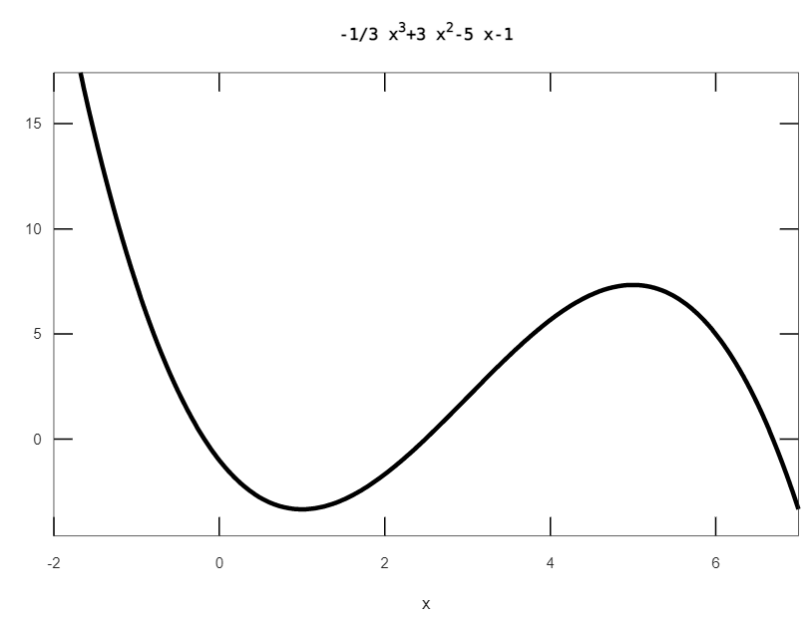
octave:17> grid on
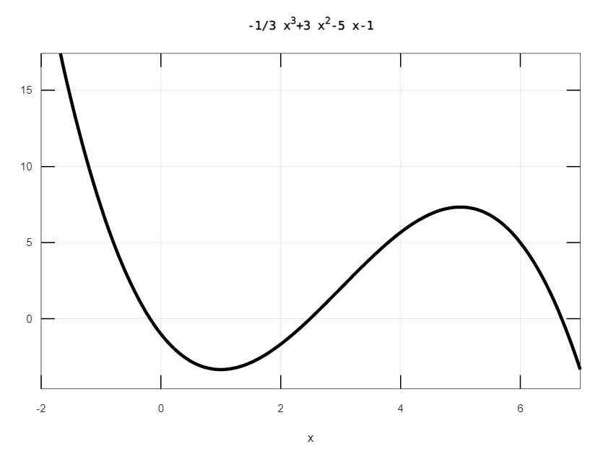
octave:18> hold on
octave:19> axis equal
octave:20> plot([-2,7],[0,0],'k')
octave:21> plot([0,0],[-5,17],'k')
octave:22> text(6.8,-0.2,'x')
octave:23> text(-0.2,16.8,'y')

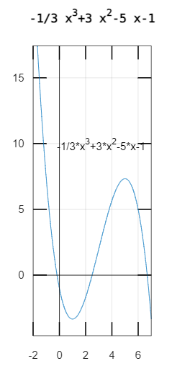

TASK 3. Solve tasks of topic: Simple and compound interest in economic studies
in your notes.

