Blake and Mouton Managerial Grid

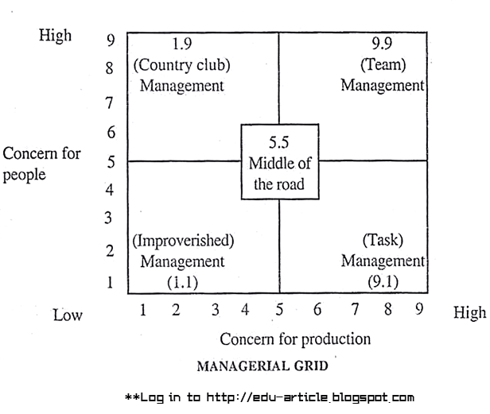

Concern for Production (Task-Oriented)
A concern for production means that managers direct subordinates towards goals. Managers with this style typically give instructions, spend time planning, emphasize deadlines and provide explicit schedules of work acitivities. They simply want to get the job done.

Concern for People (Relationship-Oriented)
A concern for people means that managers are mindful of subordinates, respect their ideas and feelings, establish mutual trust. These managers are friendly, provide open communication, develop teamwork, and are oriented toward their subordinates’ welfare.

Impoverished Management (1,1)
Managers that score low on concern for production and low on concern for people are labelled as having an ‘Impoverished Management’ style or ‘Indifferent Management’ style. They exert minimum effort to get required work done and to maintain interpersonal relationships. The motives for this type of managerial behaviour can differ. The main concern for Impoverished Managers is often to not be held responsible for mistakes.

Country Club Management (1,9)
Managers that score low on concern for production and high on concern for people are considered to have a ‘Country Club Management’ style. Managers with this style pay a lot of attention to the security, well-being and harmony of subordinates. They firmly belief that being accomodating to the needs of subordinates will ultimately increase performance, as everybody will be happy and contented. As a consequence, the primary emphasis of Country Club managers is given to people rather than to work outputs. The resulting work atmosphere is therefore usually quite friendly and easy-going, but not very productive. Individual subordinates that are more task-focused might experience this management style as frustrating.

Authority-Compliance Management (9,1)
The dictorial ‘Authority-Compliance’ Management’ style (or ‘Produce-or-Perish’ style) implies that managers score high on concern for production and low on concern for people. These type of managers usually believe that subordinates’ needs are relatively unimportant. Efficiency in operations, however, should be the dominant orientation. In order to boost performance, managers try to make subordinates comply by using tangible rewards such as monetary bonuses. Managers may even use their coercive powers to punish subordinates if targets are not being met. This style is largely based on McGregor’s Theory X that states that employees generally have little ambition, avoid responsibilities, and are mostly extrinsically motivated.

Middle-of-the-Road Management (5,5)
Managers that score medium on concern for production and medium on concern for people have a ‘Middle-of-the-Road Management’ style. They attempt to balance between an organization’s performance targets and the needs of employees. This is essentially a compromising approach in which the manager tries to avoid conflict with subordinates whilst pushing for moderate production. The major downside of this approach is the danger that neither aspect (concern for production and concern for people) is delivered to satisfactorily levels.

Team Management (9,9)
If managers score high on concern for production and high on concern for people, they can be labelled as having a ‘Team Management’ style. This style is often considered to be the most effective and is recommended for managers because organization members work together to accomplish tasks and maintain good relationships. This approach relies heavily on making subordinates feel that they are constructive parts of the organization by encouraging teamwork and commitment, involving them in decision-making, and showing respect and mutual trust. This management style is largely in line with McGregor’s Theory Y that states that employees are intrinsically motivated, enjoy their job, and want to work to better themselves without a direct reward in return. According to multiple subsequent research from Blake and Mouton, Team Management forms the best basis for exercising sound leadership.

