Методичні рекомендації до виконання лабораторних
та самостійних робіт здобувачів

Content module 2
Organization and functioning of the customs risk management system

Topic 4. Analysis and assessment of customs risks, development of customs risk management measures to determine the forms and scope of customs control

Laboratory work 4
Selection of a financial institution from the State Customs Service of Ukraine (SCSU) Guarantor Register, whose conditions for guaranteeing the payment of customs duties and activities best meet the needs of business entities, using the decision support system (DSS)

The aim of the work is to gain practical skills in building decision support systems in the Decision Making Helper package on the example of the task of determining the most appropriate alternative for a foreign economic operator in choosing a financial institution to ensure payment of customs duties from the current register of guarantors of the State Customs Service of Ukraine.

Task 4.1

To select a financial institution from the current register of guarantors of the SCSU, whose conditions for guaranteeing the payment of customs duties and activities best meet the needs of business entities, using the algorithm described above.
It is necessary to determine the categories of financial services providers registered by the SCSU as guarantors as of 01.09.2023 (https://data.gov.ua/dataset/scsu-register-guarantors/resource/f14e4a13-4223-4c3f-8fd0-0036f0d7eee8). Next, it is necessary to determine the selection criteria and conduct a situation game to select the best one in order to obtain the optimal solution.

Methodological recommendations for task 4.1

Before using a software product, it is necessary to form an array of data that is used in the decision-making process.
1. Task statement.
The client of a financial institution, a foreign economic operator, is looking for an alternative option for issuing a guarantee of payment of customs duties for placing goods under the common transit procedure. Several alternatives were selected:
1) object 1 – banks;
2) object 2 – insurers;
3) object 3 – financial companies.
The comparison of alternatives is based on the following three criteria: the level of ownership of the rights to issue a general guarantee, the cost of the guarantee service, and the stability of functioning in the financial services market.
2. Characteristics of the criteria.
The “cost of the guarantee service” is a quantitative criterion and has a unit of measurement – the tariff rate.
The criteria “level of ownership of the rights to issue a general guarantee” and “stability of functioning in the financial services market” are qualitative criteria and have the following ratings: “low”, “medium”, “high”.
3. Evaluation of alternatives.
Fill in the table with the scores by criteria for each alternative (Table 1).

Table 1
Evaluation of alternatives

Alternative and criterion | Banks | Insurers | Financial companies
Cost of the guarantee service, the average tariff rate
Level of ownership of the rights to issue a general guarantee
Stability of functioning in the financial services market

4. Determination of weight.
Determine the weight for each of the criteria based on their importance. In this software product, importance is assessed on a differential scale from 1 to 5 (from low to high). Submit the results in the Table 2.
Table 2
Weight according to the criteria

Criteria | Weight
Cost of the guarantee service
Level of ownership of the rights to issue a general guarantee
Stability of functioning in the financial services market

5. Enter data into the software product.
Launch the Decision Making Helper. The main working window will appear on the screen (Fig. 1). This working window has a simple toolbar that allows you to create a new project (New), open an existing project (Open), and save any changes (Save). Use the Save button and name your project My Project.
Options are added to the programme by clicking the button with the plus sign, as shown in Fig. 2. Each option must be named – in this case, it is a bank, insurer, or financial company. You can add 26 options to the Decision Making Helper, but since only the Demo version is used in the lab, the maximum number of alternatives is 3.
Criteria are added in the same way and their names are formed, which are presented in the source data (see Table 1). The Decision Making Helper allows you to create up to 300 criteria, but our version has permission for only 3 of them (Fig. 3).
The last step is to enter the weight of importance of each of the criteria (see Table 2). To do this, move the arrow to the required score (Fig. 4). By default, the arrow is on the Importance mark.

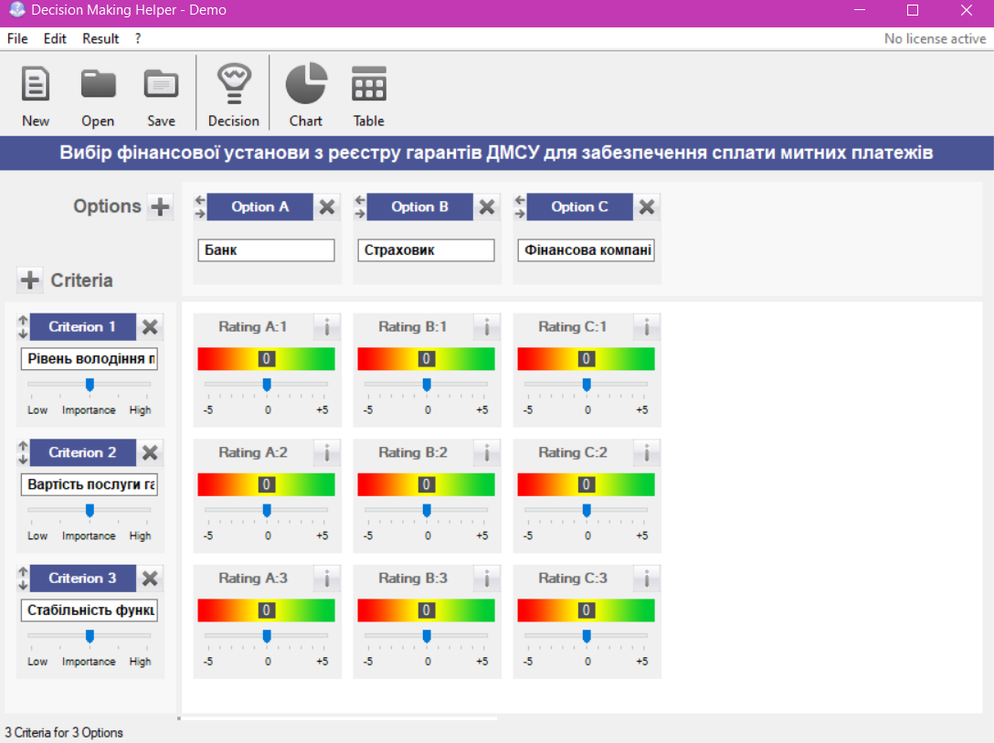

Fig. 1. The main working window of the Decision Making Helper

Add
an alternative
Enter
name

Fig. 2. Options entry window (alternative)
Enter
name
Add
criterion

Fig. 3. Procedure for entering criteria

Criteria weight scale

Fig. 4. Window for entering criteria
In Table 9, the student independently submitted the assessment of the objects. To enter them into the programme, it is necessary to determine the level of fulfilment of the criteria for each option by moving the arrow to the required rating (from -5 “low level” to +5 “high level”, 0 – neutral level) (Fig. 5). You can also make comments to each rating by using the corresponding button, comments can be either numerical values or qualitative characteristics.

Add
comment
Scale
rating assessments

Fig. 5. Algorithm for determining the level of fulfilment of criteria for each option

6. Perform calculations of the built model with the system for selecting the best alternative.
To implement this stage, click the Decision button on the top panel of the programme (Fig. 6). The Decision Making Helper software automatically calculates the decision value for each option (alternative), in percentage from -100 % to +100 % and in the words “unsatisfactory / rather unsatisfactory / neutral / rather positive / positive”. The results can also be seen in a tabular version (Table) (Fig. 7).
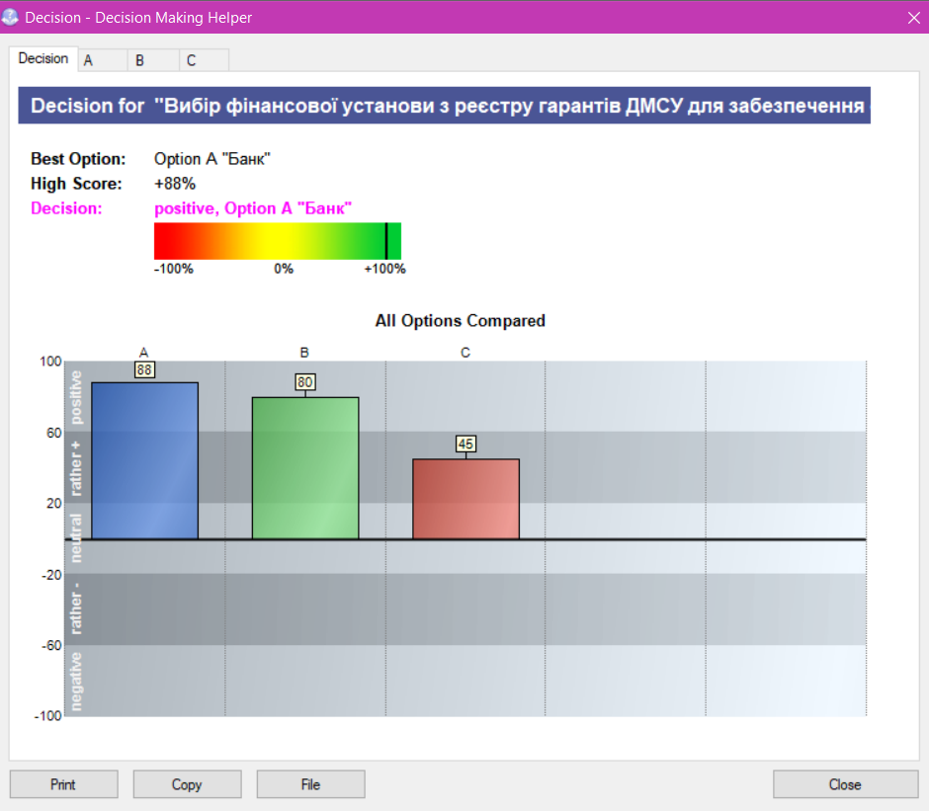

Fig. 6. Summary window with results in the Decision Making Helper (according to rating points)

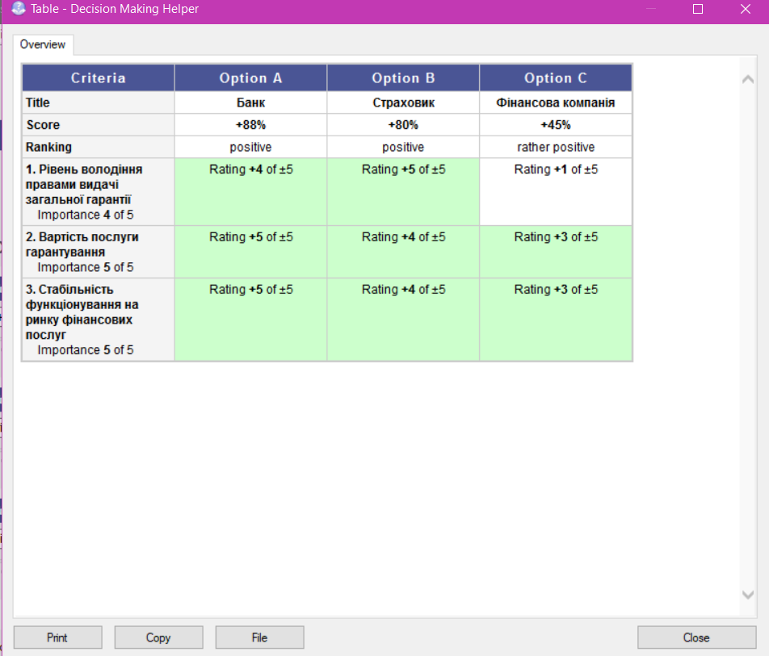

Fig. 7. Summary table with results
7. Graphical representation of the calculation results.
To graphically represent the calculation results, click the Chart button on the toolbar, which will allow you to see the results in three-dimensional space, on the so-called radar (Fig. 8). Please note that in each result window, if necessary, the functions of copying and printing are implemented, which are performed by the corresponding buttons located in the lower left corner of the window.

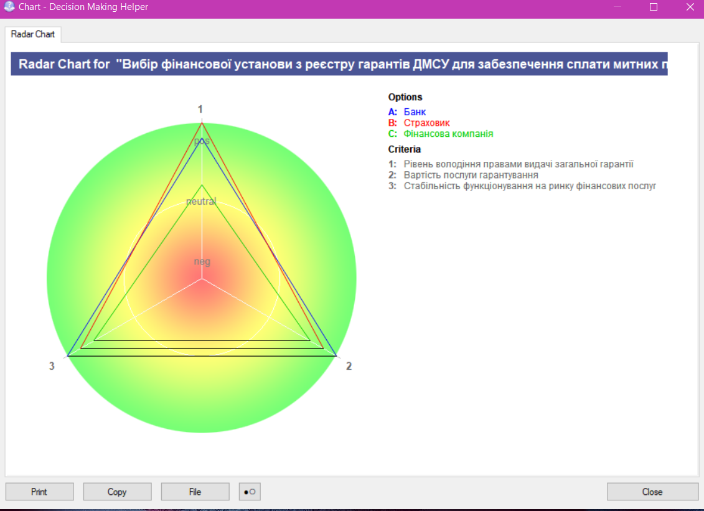

Fig. 8. Graphical representation of the results

Methodological recommendations for independent work of the applicant
In the course of independent work on this topic, it is necessary to get acquainted with the main issues of the lecture material, with the main and additional literature, legislative and regulatory materials, information from Internet resources, as well as to work through the questions for independent in-depth study and control questions for self-diagnosis, complete test tasks and individual assignments.

Questions for independent in-depth study
1. Analyse how the entry into force of the provisions of the Convention on the Common Transit Procedure has affected the requirements for business entities in terms of ensuring the payment of customs duties.
2. Study the development of electronic customs risk management mechanisms.

Checklist for self-diagnosis
1. Name the RMS tools that can be used at the tactical level of risk management.
2. What are the risk profiles according to different classification criteria?
3. What is the source of information for guidance as an RMS tool?
4. What information do the lists of risk indicators contain?
5. How is the decision on the application of certain customs formalities made on the basis of the list of risk indicators?
6. In which areas of customs control can methodological recommendations be developed for the work of customs officials in analysing, identifying and assessing risks and which have already been developed?
7. Describe random selection as an RMS tool in the process of assessing the risk of ARAMS on a customs declaration.
8. Define the concept of "regional risk management".
9. For what purpose was the module "Risk Profile Builder" of the ACCS “Inspector” developed?

