Методичні рекомендації до виконання лабораторних
та самостійних робіт здобувачів
Content module 1
Content and description of customs risks

Topic 1. Essence, classification and sources of customs risks

Laboratory work 1
Use of online customs payment calculators as a tool to mitigate customs risks of a shortfall in tax revenues to the state budget

The aim of the work – to acquire practical skills in using Ukrainian and foreign online customs payment calculators and interpreting the results obtained in the context of minimising customs risks.

Task 1.1
In accordance with the option in the group list (Tab. 1), calculate customs payments in two ways using the online customs payment calculator of the Ukrainian customs broker UKRTRANSAGENT and the online customs payment calculator SimplyDuty developed by the British logistics services company ParcelWorks. Compare the results and draw a conclusion on how automation of customs payments calculation affects the mitigation of customs risks. Based on the results of the assignment, prepare an individual report, which should include: Student's name, general information, description of the stages of work and results, conclusions. Possibility of using the results in the master's thesis, practical work.

Distribution of students by laboratory work options
Table 1
Distribution of students by options

Number in the group list | The first country | The second country
1, 4, 7, 10, 13, 16 | Switzerland | Mexico
2, 5, 8, 11, 14 | Brazil | Romania
3, 6, 9, 12, 15 | India | Canada

Methodological recommendations for task 1.1
Customs in Ukraine is characterised by a variety of risks, in particular, the most significant are those related to the reduction of customs payments as a result of the understatement of the customs value of goods by foreign economic operators during importation or due to incorrect classification, compliance with non-tariff regulation measures, etc. This is why there is a need to improve the customs clearance procedure for risky goods using automated methods, including online customs payment calculators.
In order to access the online calculators that will be used in the lab, please follow the links provided:
1) online customs payment calculator of the Ukrainian customs broker UKRTRANSAGENT: https://ukrtransagent.com.ua/dodatkovo/kalkuljator-mytnyh-platezhiv/;
2) online customs payment calculator by the British company ParcelWorks SimplyDuty: https://www.simplyduty.com/import-calculator/.
1. Online calculator of customs payments of the Ukrainian customs broker UKRTRANSAGENT
Follow the link. The basic page for entering initial data is shown in Fig. 1.

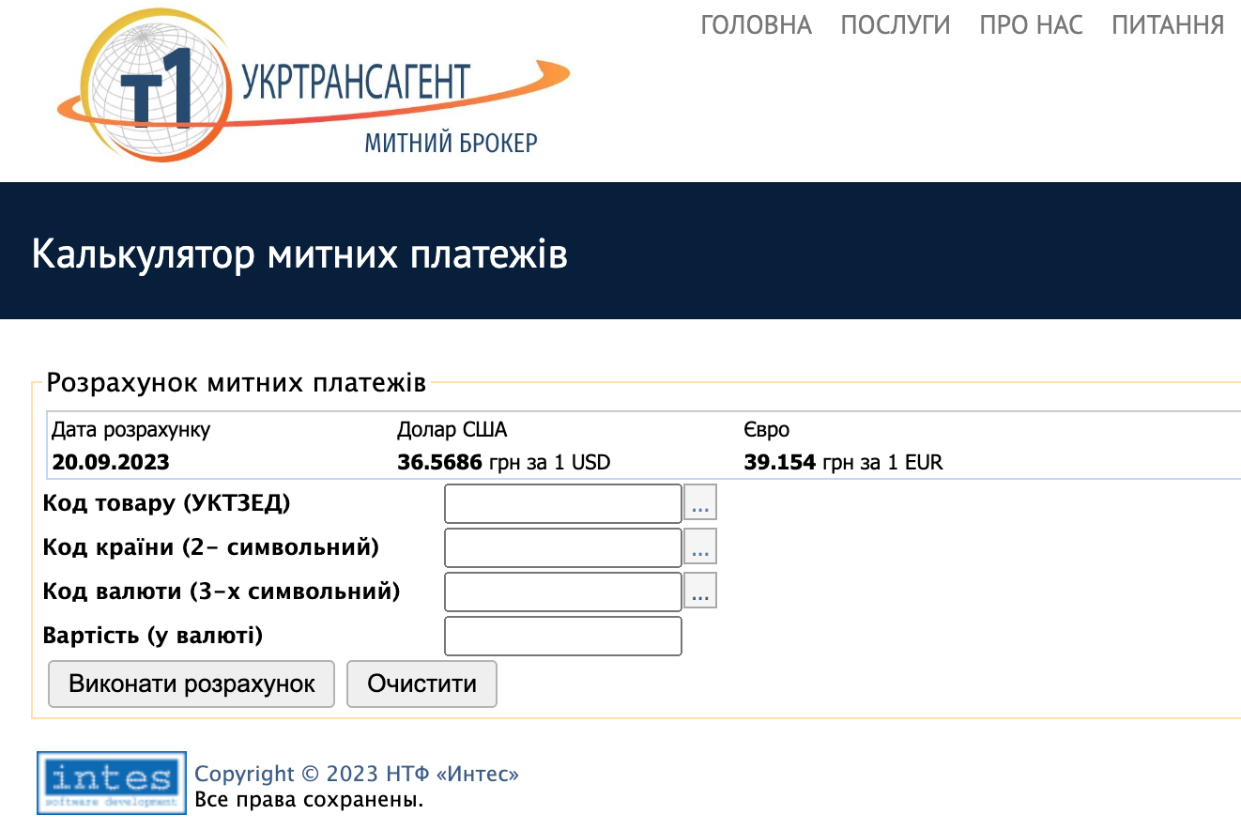

Fig. 1. Basic page for entering initial data
To fill in the “Product code UCT ZED (Ukrainian classification of foreighn economics goods)” field, you should either enter the product code according to UCT ZED (Ukrainian classification of foreighn economics goods) or use the UCT ZED (Ukrainian classification of foreighn economics goods) search (Fig. 2). The choice of goods is at your own discretion.

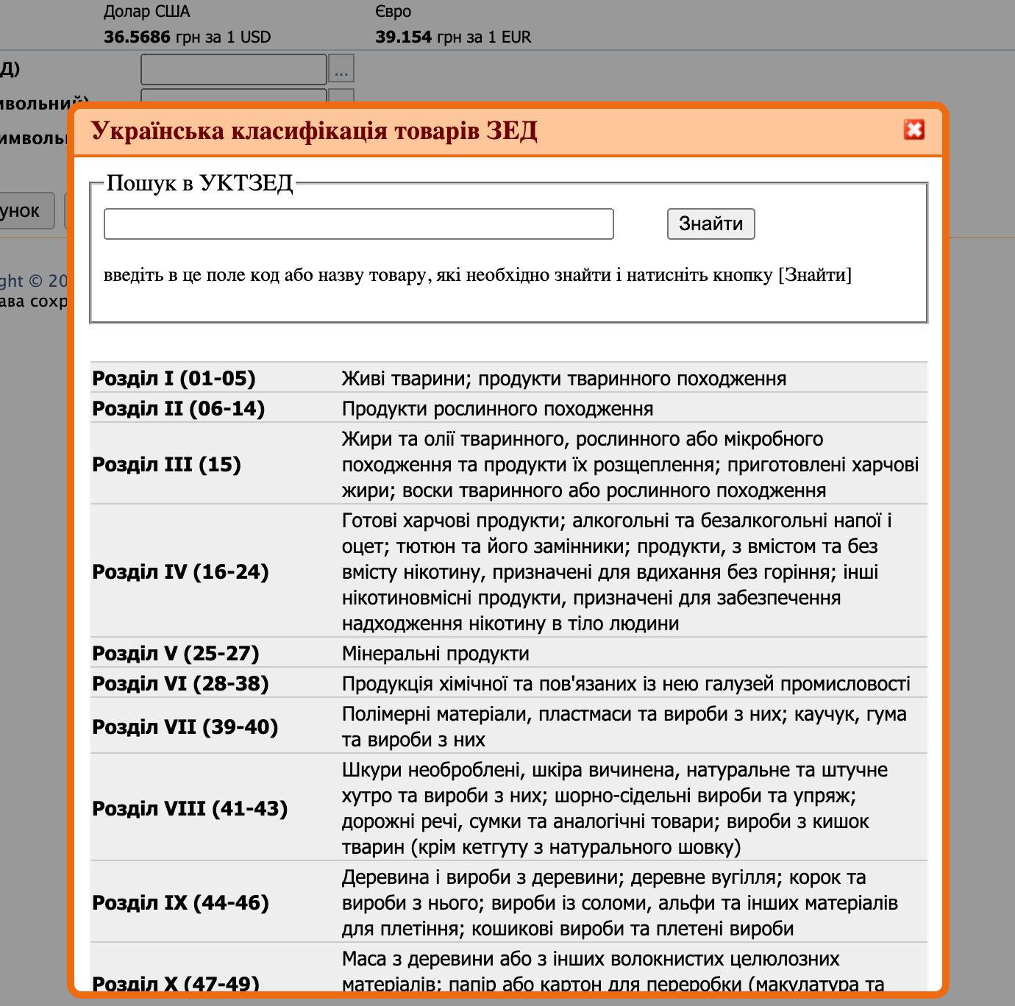

Fig. 2. Search window in the UCT ZED (Ukrainian classification of foreighn economics goods)

Enter the 2-digit country code either independently or using the country classifier (Fig. 3).
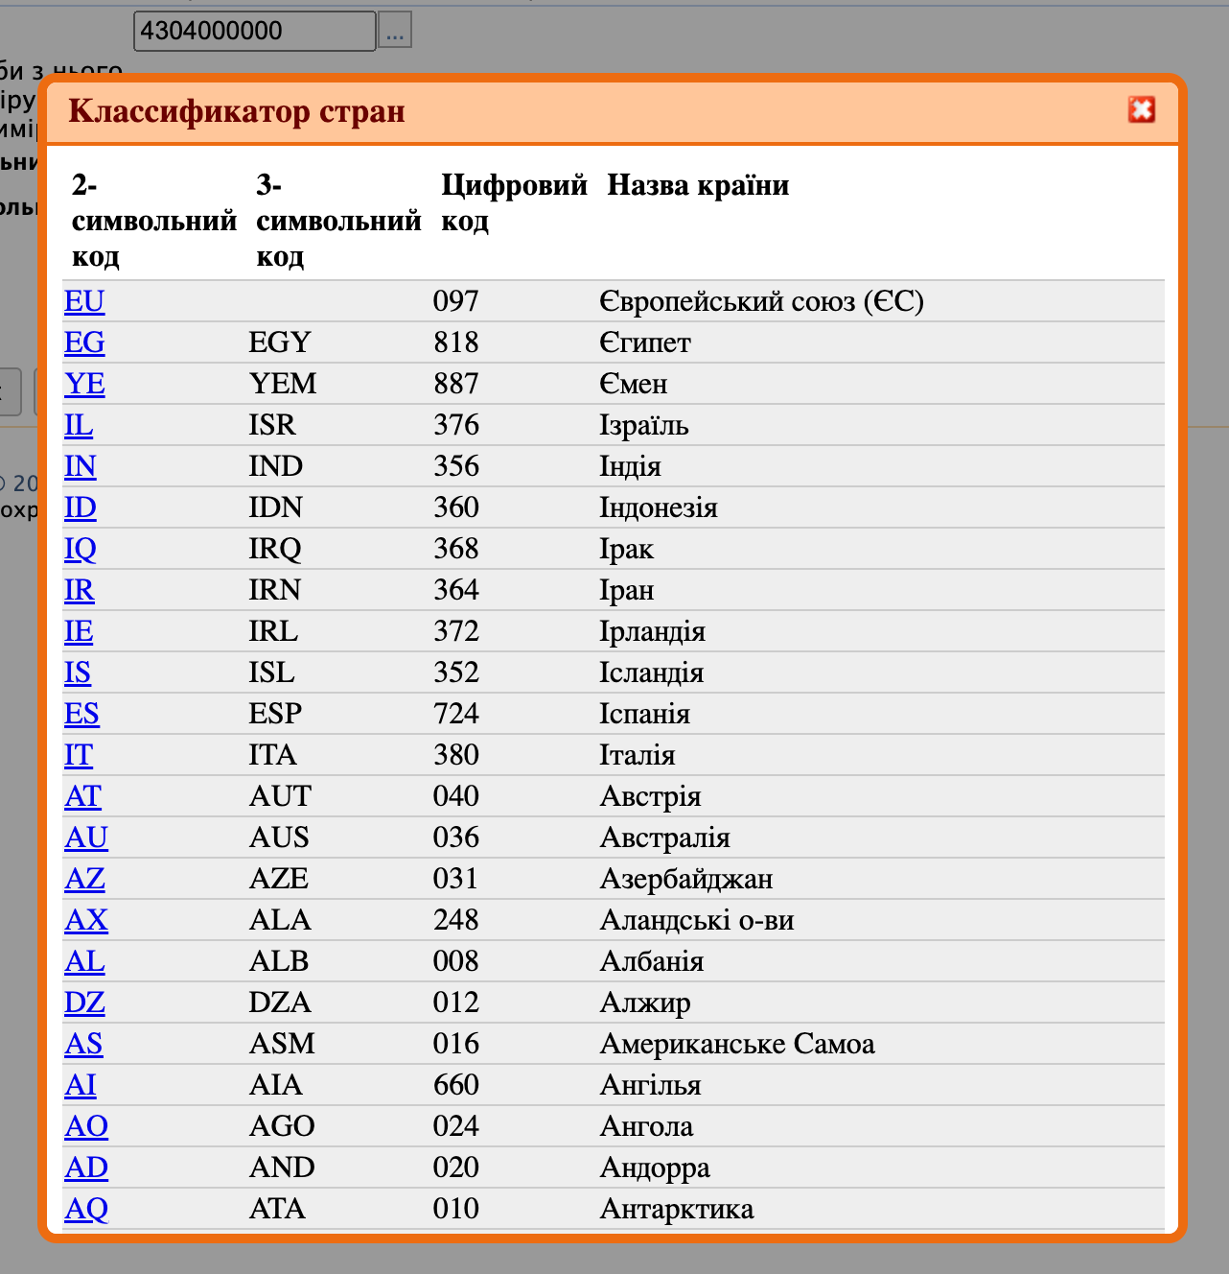

Figure 3. Classification of countries

Similarly, fill in the “Currency code (3-digit)” field either independently or using the currency classifier (Fig. 4).

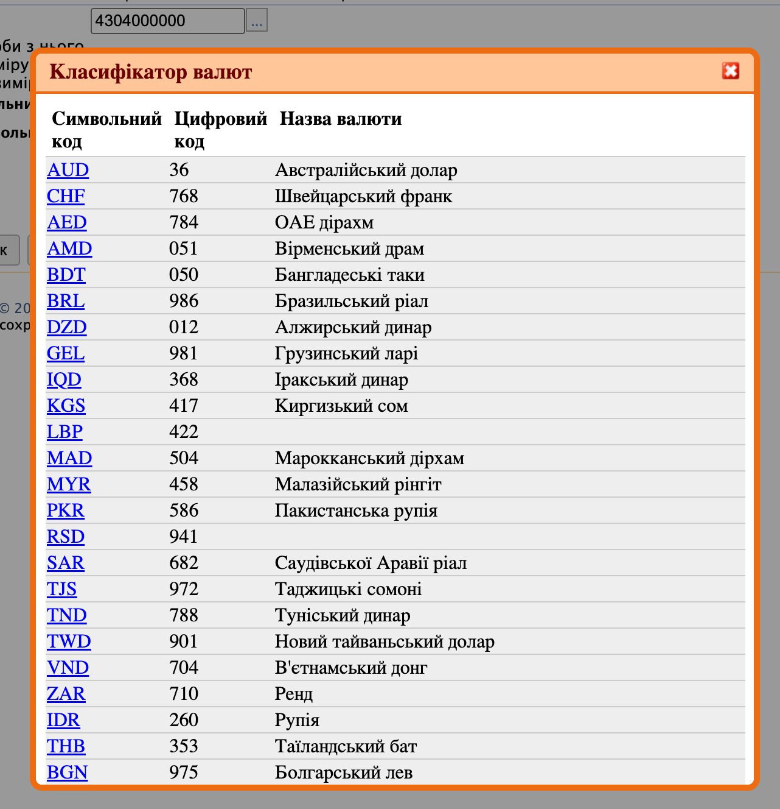

Fig. 4. Currency classifier

After that, you should enter the value of the selected goods in foreign currency in the “Value (in currency)” line. Then click “Perform calculation” (Fig. 5).

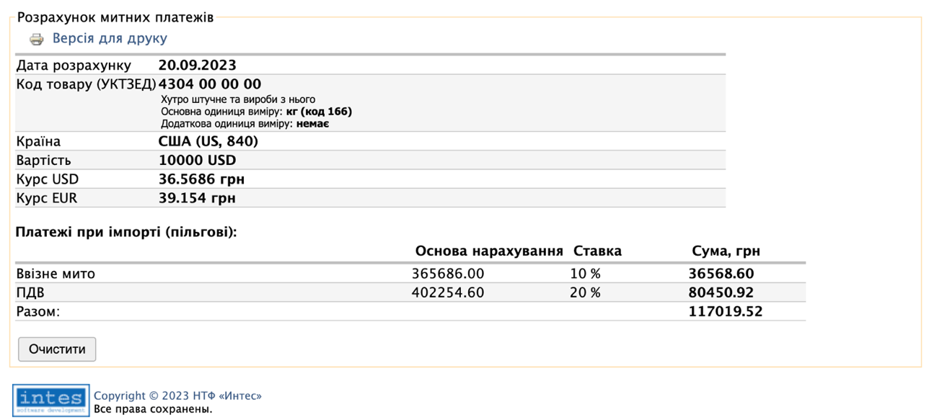

Fig. 5. The window with the calculation results

Use the same sequence of actions for the second country in the laboratory activity. Compare the data obtained as a result of the calculations.
2. SimplyDuty
Follow the link. The basic page for entering initial data is shown in Fig. 6.

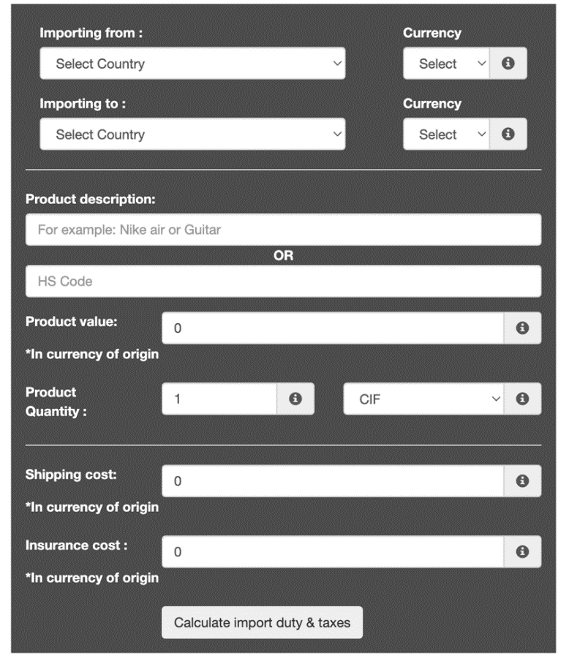

Fig. 6. Basic page for entering initial data
In the “Importing from” field, you need to select the country according to the task option provided (Tab. 1). After that, you need to define its currency by filling in the “Currency” field. In both cases, select Ukraine in the “Importing to” field. After that, find the national currency of Ukraine in the list of currencies by filling in the “Currency” section.
You can choose to leave these unselected and the system will automatically use the default currency of the selected countries.
After completing the previous steps, enter the product description or the HS code. The product is selected independently. Add the value of the items. Select the number of items if you wish to use a unit cost as product value. Select whether the products are being shipped free on board (FOB) or cost insurance & freight (CIF). CIF takes into account the insurance and shipping costs. These can be left as zero. If it is necessary, specify the values in the boxes "Shipping cost" and "Insurance cost".
An example of filling in is shown in Fig. 7.

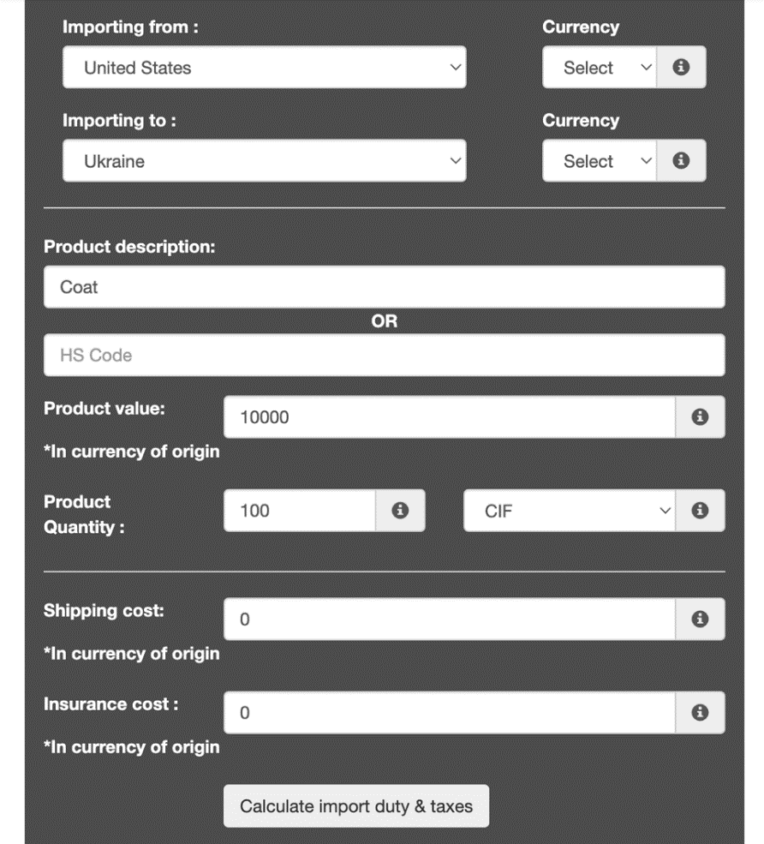

Figure 7. Window with filled in fields of the online calculator for calculating customs payments
Finally, click “Calculate import duty & taxes” (Fig. 8).

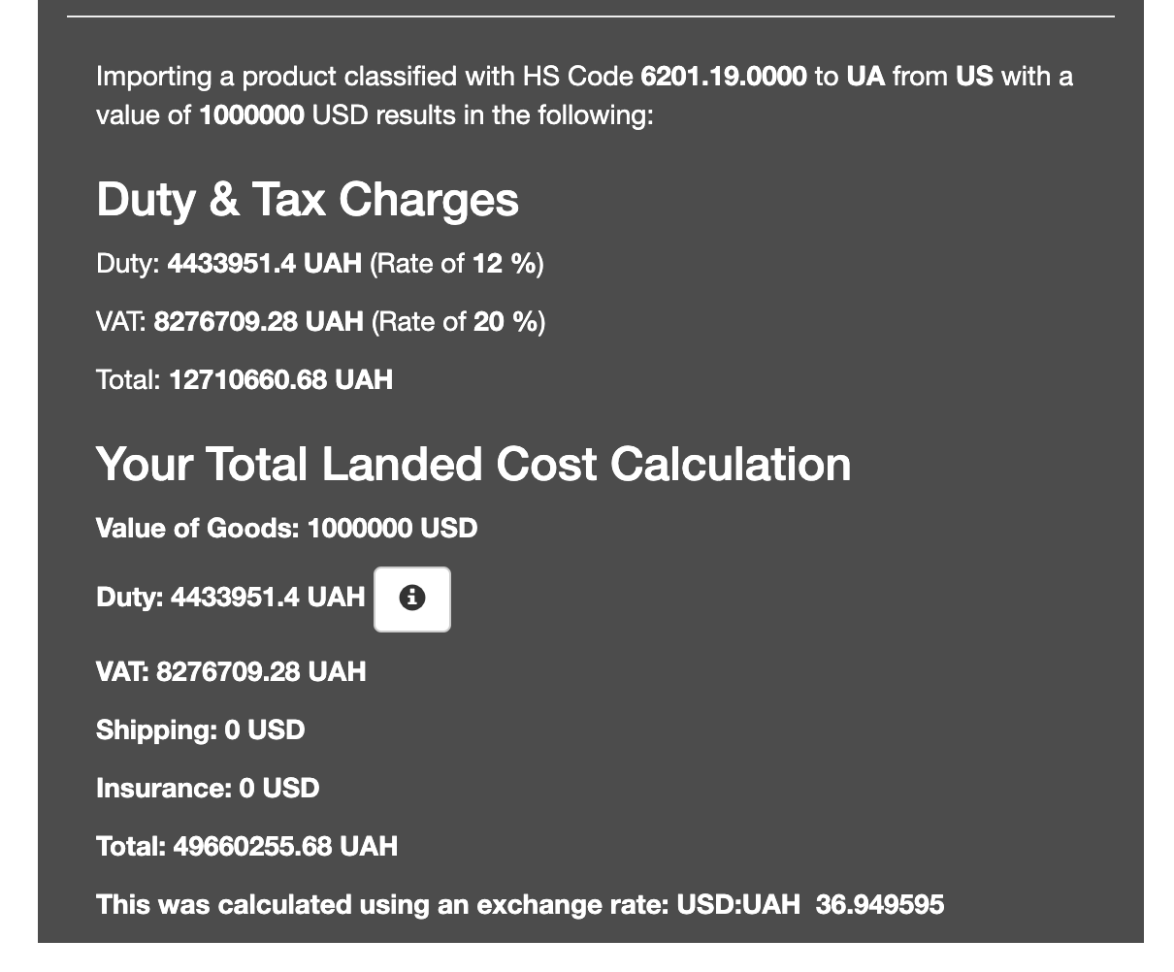

Fig. 8. The window with the calculation results

Use the same sequence of actions for the second country in the laboratory activity. Compare the data obtained as a result of the calculations.
Thus, the advantages of using online customs payment calculators are as follows:
1) accuracy and reliability of calculations;
2) ease of use;
3) computing speed;
4) automatic updating of exchange rates.
The importance and practical value of using this automated tool is that it helps to minimise the customs risks of underpayment of customs duties due to incorrect determination of the code, customs value and country of origin of goods.
Methodological recommendations for independent work of the applicant
In the course of independent work on this topic, it is necessary to get acquainted with the main issues of the lecture material, with the main and additional literature, legislative and regulatory materials, information from Internet resources, as well as to work through the questions for independent in-depth study and control questions for self-diagnosis, complete test tasks and individual assignments.

Questions for independent in-depth study
1. To consider the concept of customs risks in the context of a tool for optimising information interaction between Ukrainian business entities and customs authorities.
2. Digitalisation of customs control as a way to improve the customs risk management system.

Checklist for self-diagnosis
1. Describe the term "customs risks" in accordance with the causal approach.
2. Name the main functions of customs risks.
3. Disclose the types of customs risks at each stage of customs control.
4. Give examples of internal sources of customs risks.

Test tasks
1. What are customs risks primarily associated with in international trade?
a) Currency exchange rates
b) Legal disputes
c) Importing and exporting goods across borders
d) Supply chain optimisation
2. Which of the following is NOT a classification of customs risks?
a) Valuation Risks
b) Documentation Risks
c) Economic Risks
d) Origin Risks
3. Compliance risks in customs refer to:
a) Risks associated with customs documentation errors
b) Risks associated with failing to comply with customs regulations
c) Risks associated with incorrect valuation of goods
d) Risks related to the country of origin of goods
4. What is the main concern of valuation risks in customs?
a) Classification of goods
b) Compliance with origin rules
c) Discrepancy in the declared value of goods
d) Security threats
5. Which of the following is an example of a source of customs risks?
a) Accurate customs documentation
b) Frequent changes in customs regulations
c) Expert knowledge of customs laws
d) Well-optimised supply chain

