MINISTRY OF EDUCATION AND SCIENCE OF UKRAINE

SIMON KUZNETS KHARKIV NATIONAL UNIVERSITY OF ECONOMICS

Guidelines
to the thesis
for a master's degree
for students of the speciality 073 "Management"

Kharkiv, S. Kuznets KhNUE, 2023

Затверджено на засіданні кафедри менеджменту та бізнесу.
Протокол № від 2023 р.

Методичні рекомендації до написання дипломної роботи на здобуття освітнього ступеня «магістр» для студентів спеціальності 073 «Менеджмент» усіх форм навчання / Укл. Т. І. Лепейко. – Харків: ХНЕУ, 2023. с. (Укр. мов.)

Методичні рекомендації містять тематику дипломних робіт, вимоги до структури, змісту й оформлення дипломної роботи.
Рекомендовано для студентів спеціальності 073 «Менеджмент».
INTRODUCTION

The final stage of study, which gives the right to obtain a master's degree, is a thesis. It is the most active form of connection of theoretical training with practical experience of students on the basis of practice. Thesis is an independently performed work that contains theoretical research on a specific topic and has an applied nature. Its main purpose is to demonstrate the student's level of qualification and his ability to solve specific problems. In the process of preparing a thesis, students develop a breadth of thinking, acquire research skills, demonstrate the level of their professional training, which is a kind of report for the entire period of study.
The purpose of these guidelines is to establish general requirements for the organization of the process of preparation and writing of theses, their structure and content, the order of design and defense. In the appendices to the methodical recommendations the approximate subjects of diploma works, examples of registration of accompanying documentation are given.

1. PURPOSE AND OBJECTIVES OF THE THESIS

Completion of the thesis is the final stage of master's training in a higher educational institution and the final result of his independent studying and research activities, comprehensive work, which summarizes the study of students of various disciplines provided by the curriculum for master's degree in "Management" and practices. The graduate student must confirm the level of general theoretical and special training, and the thesis is a master's thesis, on the basis of which the state examination commission decides to award its author the qualification "Master in Management" and issue a master's degree.
The purpose of the thesis is:
deep understanding of the professional problem;
comprehensive mastery of material and methods of independent research and consistent teaching;
practical application of theoretical knowledge to solve specific problems of enterprise management.
In the process of completing the thesis, the student, in accordance with the qualification requirements, must identify:
knowledge of general theoretical, general economic, professionally-oriented and special disciplines, which reveal the theoretical foundations and practical issues of management;
ability to select, systematize and process information in accordance with the objectives of the study;
the ability to formulate sound conclusions and develop specific proposals for the organization or improvement of management of the real object under study;
ability to use the cause-and-effect relationships of processes and phenomena in the applied field.
Thesis must be logical, probative, argumentative in nature and meet the following requirements:
contain an in-depth comprehensive analysis of the research problem;
contain elements of independent research, calculations performed using computer technology;
contain substantiated proposals for the organization of management or improvement of activities at the object under study;
be properly designed;
have all the accompanying documents;
be completed and submitted to the graduating department within the period provided by the schedule of the educational process.

2. TOPICS OF DIPLOMA THESIS

The topic of the master's thesis should be one of the current problems of modern management, which meets the objectives and skills provided by the educational and qualification characteristics of the master and is related to the professional activities of the manager.
The topics of theses are developed annually, reviewed and supplemented by the Department of Management and Business in accordance with the approved programs of the studied disciplines. An oriented list of diploma theses is given in Appendix A. The student has the right to independently choose the topic of the thesis in accordance with the topics approved by the Department of Management and Business. The student, in agreement with the supervisor, may propose his / her research topic under the conditions of appropriate substantiation of the expediency of its development (according to his / her previous research work, opportunities to obtain the necessary information on the basis of research). Along with the choice of topic, the basis of the research on which the work will be performed is determined. It must be an enterprise of any form of ownership, which is a legal entity and has independent reporting. The activity of this enterprise should create an opportunity for information support of the research of the chosen problem.
To choose the topic of the thesis, students personally submit an application (Appendix B). The chosen topic is agreed and clarified with the supervisor, after which students develop a plan and calendar schedule of work, which should correspond to the calendar schedule approved by the graduating department.
The topic of the work should be considered at a meeting of the Department of Management and Business and approved by the order of the rector of the university.

- REQUIREMENTS FOR THE STRUCTURE AND CONTENTS OF THE DIPLOMA THESIS

General requirements
During the preparation of the master's thesis, the student must comply with certain requirements:
the thesis submitted for the master's degree in "Management" is performed in the state language of Ukraine or in English and must be typed by computer;
diploma thesis is performed by each student individually. If necessary, several theses that are part of one topic can be combined under one title and are separate components of a complex thesis;
thesis should contribute to the solution of specific managerial, economic, financial, social problems or a set of these problems aimed at solving the management of the organization;
it is necessary that the thesis reveals the student's ability to present the material in a concise, logical and argumentative manner. The text must be free of grammatical and stylistic errors, and the design ─ meet the requirements for works submitted for publication;
in the thesis the student must make a reference to the author and the source which the materials or individual results were taken from. In case of discovery of non-original material (text, tables, calculations, graphs, etc.) without reference to the author and source, the thesis defense is cancelled without the right to re-defense;
the practical tasks set in the thesis must be solved, including with the use of economic and mathematical methods;
the degree of uniqueness of the thesis text must be at least 50%;
the final grade for the defense of the thesis cannot be more than 81 points if the degree of uniqueness of the text of the thesis is less than 70%, or if there are no scientific publications of the student on the topic of the thesis (those that have been published or submitted).

Requirements for the structure of the thesis
Thesis is performed on the basis of pre-diploma practice, study of domestic and foreign literature in the specialty (monographs, periodicals, laws and regulations, special literature, to a lesser extent – textbooks, manuals, etc.), managerial and financial reports and consists of:
I. Explanatory note.
ІІ. Presentation, which may contain graphs, diagrams, tables, mathematical models and more.
The explanatory note of the thesis should contain the following components (in the order of their inclusion in the structure of the work):
1. Title page of the thesis. The topic of the thesis, indicated on the title page, must fully correspond to the topic specified in the order of the rector of the university.
2. Submission to the chairman of the state examination commission for the defense of the thesis.
The title page of the thesis and submission to the chairman of the state examination commission are drawn up in accordance with current standards of the university. The student personally receives a sample of the design of these components of the work from the responsible employee of the department.
3. Abstract of the thesis in Ukrainian and in English. The abstract contains the number of pages, tables, figures, the number of titles and pages in the bibliography, the number of appendices in the work and their total size in the pages. Next, the main results of the work should be summarized. Up to 10 keywords that reflect the content of the work are highlighted separately. The abstract also indicates the year of perorming and the year of defense of the thesis. Abstract size is up to 1 page in each language.
4. Content of the thesis.
5. Introduction.
6. The main part, which consists of theoretical, analytical and project chapters. Each chapter includes 2 subchapters. In one of subchapters, economic-mathematical modeling of economic and social processes at the enterprise should be performed, for which a consultant is appointed.
7 Conclusions.
8. List of references.
9. Appendices.
The structure of the explanatory note and the size of its individual chapters depend on the characteristics of the thesis topic, but it must be formed in compliance with the following conditions:
the size of the explanatory note is from 50 pages of typewritten text (excluding the list of references and appendices);
significant mathematical calculations, tables, economic and financial reporting, technological documentation, technical and regulatory maps, questionnaires, illustrations, especially those that do not completely meet the requirements for design or do not contain data originated by the student, it is advisable to include to the appendices;
the number of pages in some chapters is not clearly regulated, but must meet the requirements of sufficient information and validity of decisions and conclusions.
The explanatory note to the thesis consists of chapters and subchapters. Conclusions are formulated at the end of each chapter.
The content of each of the chapters largely depends on the topic of the thesis and the plan agreed with the supervisor. However, there are general requirements for each chapter, which are listed below.
The approximate number of pages in the chapters is as follows:
Introduction ─ 2 ─ 3 p.
Theoretical chapter ─ from 12 pages.
Analytical chapter ─ from 14 pages.
Project chapter ─ from 14 pages.
Conclusions ─ 2 ─ 3 pages.
The presentation is not part of the explanatory note and is intended to illustrate the main results of the work during its defense. The structure and composition of the materials presented in the presentation are agreed with the supervisor after the completion of work on the explanatory note, based on the topic of the thesis and the structure of the student's report in its defense. At the same time, the presentation must contain the following components (in the specified sequence):
title slide;
structural and logical scheme of the thesis (in case it is done);
slides illustrating the results obtained in the theoretical, analytical and project chapters of the work, respectively.
Recommended size of illustrative materials ─ from 5 slides. The presentation should clearly reflect the results obtained during the preparation of the thesis, and therefore, it is allowed to include material only in the form of tables, figures or formulas from those contained in the work.

Requirements for the content of chapters of the thesis

Introduction
The introduction contains a justification of the relevance and practical significance of the chosen topic of the master's thesis, defines the purpose and tasks of the thesis, the subject, the object of research and provides brief information about it; briefly characterizes the used methods and information sources of the research, names the basis of the research and outlines the structure of the work.
The introduction substantiates the relevance and feasibility of work for the development of the relevant field of science or business. Coverage of relevance should not be verbose. It is enough to express the main idea in a few sentences.
Also, in the introduction, as a rule, scientists are named who made a significant contribution to the development of economic science in the field covered by the topic of the master's thesis, and it is also briefly indicated what exactly the scientific achievements of the named scientists consist of.
The introduction contains the formulation of the purpose of the thesis and the tasks that need to be solved to achieve this goal. The goal should not be formulated as "research ...", "study ...", because these words indicate the means to an end, not the goal itself. For example, if the topic of the work is formulated as "Development of a business plan of an investment project", its purpose can be defined as the development of theoretical foundations of business planning, as well as development and justification of specific decisions in the business plan of an investment project.
The object of research is a process or phenomenon that creates a problem situation and is chosen for study. The object of the study should not be called a specific enterprise, organization, institution or public authority or its unit, on the example of which the work is performed, because it is the basis of the study.
The subject of research ─ a specific task contained within the object of study. The object and the subject of research are correlated as general and partial. In the object the part of it which is a subject of research is allocated, the attention of the student is directed to it as the subject of research defines a theme of the diploma work.
The introduction also provides a list of research methods used to achieve the goal. It is necessary to recalculate them not detached from the content of the work, but briefly and meaningfully, determining which problems were studied and which tasks were solved in one way or another.
At the end of the introduction there is information about the structure of the work.
The title of each chapter should reflect the essence of the issues to be addressed. It is NOT allowed to use the names "Theoretical chapter", "Analytical chapter", "Practical chapter".

Theoretical chapter
The theoretical chapter should contain 2 subchapters. In the subchapters of the first chapter of the thesis, the general theoretical and methodological approaches to the solution of the problem, which is the subject of research, are considered, using the analysis of literature sources on the subject, which must be referred and mentioned in the reference list of the thesis. It is advisable to reveal the content of key concepts of the study, to characterize their place in the management system of a higher level, to give their classification, structure and more. In addition, in the subchapters of the theoretical chapter, it may be appropriate to consider methods, algorithms, schemes, procedures, technologies, tools that can be used by the enterprise to implement its own tasks within the scope of the research.
It is desirable to compare different points of view, use available statistics with reference to sources.
It is mandatory to use tables of morphological analysis for key concepts of the research. In order to improve the quality of the thesis, it is advisable to summarize the provisions of the theoretical analysis in the form of analytical tables. It is desirable to illustrate the text with graphic material: diagrams, graphs, algorithms.

Analytical chapter
After considering the problems of the thesis in the theoretical aspect, the student proceeds to the analytical chapter of the work. It should be named "Comprehensive analysis of the activity of ... (name of the organization)". This chapter must be subdivided into two subchapters.
The first subchapter is named "General characteristics of the enterprise and financial analysis of its activities." When compiling the characteristics of the research base (enterprises, institutions, organizations, etc.), it is advisable to provide the following information about it: full name, main activities and products, its purpose, history of the enterprise, its organizational structure (if necessary), analysis of the management and production systems, and other features of the enterprise from the point of view of the existing management system.
This subchapter of the analytical chapter should contain a financial analysis of the company's activities in the main directions: horizontal and vertical analysis of the balance sheet, analysis of profit and profitability, financial stability and liquidity. The information basis of the financial analysis is the balance sheet, income statement and other financial reports of the enterprise if necessary. The reports itself are to be provided in the appendix named "Financial reports of… (name of the enterprise)" or "Financial and statistical reports of… (name of the enterprise)", and in the text of the chapter the calculations of indicators in form of tables (which, if necessary, can also be placed in a separate appendix), their interpretation and conclusions from the analysis must be provided.
It is advisable to analyze the financial situation using software. Tables with the results of the analysis of the financial condition can be provided as an appendix to the diploma thesis named " Financial analysis of the enterprise", which in this case is to be located directly after the appendix Financial reports of… (name of the enterprise)" or "Financial and statistical reports of… (name of the enterprise)"), as well as in the text of the subchapter itself. Formulas for calculations can also be specified in the subchapter and conclusions must be drawn based on the results of calculating individual indicators and groups of financial analysis indicators. At the same time, it is recommended to avoid providing general theoretical information from financial analysis, for example, name the types of financial stability of the enterprise, the procedure for determining the type of stability, etc.
An important component of the analytical chapter of the thesis is it’s second subchapter devoted to the analysis of the current state of the subject area at the enterprise (organization), which means to the analysis of particular issues in accordance with the topic of the thesis, in order to identify current strengths and weaknesses. The use of economic-mathematical methods and models, factor analysis in the performance of this part of the analytical chapter will allow to obtain more sound conclusions, although it is not mandatory.
In the same subchapter, it is advisable to analyze the business process, which is aimed at the performance of certain tasks within the subject area. The analysis of the business process should be carried out on the basis of its graphic model built in one of the generally accepted notations.
It is desirable to summarize the problems identified within the subject area in the form of a problem map, a fishbone diagram, SNW or SWOT analysis tables (if applicable), etc. The importance of this final stage of the analysis is due to the fact that its results serve as a basis for work at the next stage of the thesis ─ in preparing and justifying project recommendations to address existing shortcomings and improve the organization of thesis. Therefore, the student must pay special attention to the clarity of determining the composition and formulation of conclusions from the analysis.

Project chapter
The task of the third chapter of the thesis is to develop specific recommendations, proposals, models for managing the parameters of the organization on the basis of basic theoretical principles, methodological approaches, best practices set out in the first chapter, as well as conclusions based on the analysis conducted in the second chapter. The title of the chapter is usually formulated as follows: "Improving ... (subject of research) at ... (research base)" or "Ways to improve ... (subject of research) at ... (research base)" , and the chapter itself consists of two sub-chapters.
The first subchapter of the project chapter should contain the detailed proposals for improving the activity of research base (the enterprise) in accordance with the research area with descriptions and explanations, and is based on the conclusions of the analysis conducted in the second chapter, taking into account the identified deviations, problems and shortcomings. If necessary, this chapter of the thesis can include the justification of the proposed measures, the plan for their implementation, etc.
The second subchapter of the project chapter is devoted to estimating the economic effect of proposals developed by the student in the first subchapter. If such proposals also have a social effect, it should also be estimated. This subchapter must include a summary table with calculations of performance indicators for each of the measures proposed in the thesis, and / or for all measures as a whole. This subchapter is recommended to be called "Calculation of the economic effect of the proposed measures" or "Calculation of the economic and social effect of the proposed measures".
The analysis carried out in the thesis or the proposed improvements must be confirmed by calculation and quantitative justification with the use of economic and mathematical methods and models, which can be included either to the last subchapter of the second chapter or to any subchapter of the third chapter of the thesis.
Size of any separate subchapter in the theoretical, analytical or project chapters is not regulated, but it must be not less than 5 pages.

Conclusion
Conclusions are the final stage of the master's thesis. They summarize the most important theoretical and practical provisions, which contain an assessment of the results achieved in terms of compliance with the purpose of the master's thesis and the task set in the introduction, proposals for improving the research activities of the organization. The sequence of conclusions should correspond to the tasks set in the introduction.
The conclusions name the topic of the scientific article (articles) in case they are published by the student on the topic of the thesis. The articles themselves are cited in the latest appendix of the thesis.

List of references
The list of references is placed after the conclusions. It consists of sources that were used by the student while writing the thesis, namely: legislation, textbooks, manuals, monographs, articles in periodicals, websites, reference materials, etc. Unpublished sources (financial statements, technical documentation, other internal documentation of the company, lecture notes, compiled by the student, etc.) are not included in the list of references. The number of sources used depends on the degree of study of the problem and the degree of its regulatory settlement. Based on the experience of preparing master's theses, the recommended total number of sources in the list of references must be at least 40 items. Sources published not earlier than 5 years before the thesis preparation, must dominate in number.
The list of references and appendices are not included to the total size of the thesis, which is subject to restrictions (not less than 50 pages).

Appendices
Thesis must contain appendices that reflect the relevant information base of the analysis of the enterprise in full and must be properly designed.
It is also advisable to include in the appendices supporting material that is used to complete the perception of the thesis:
intermediate mathematical proofs, formulas and calculations;
large spreadsheets (two or more complete pages);
auxiliary digital data tables;
protocols, acts;
instructions and techniques, description of algorithms and programs for solving problems using a computer, which are developed in the course of the thesis;
auxiliary illustrations;
auxiliary materials that have applied value (tables, figures, regulations on the work of departments of the enterprise, organization).
In addition, a scientific article (articles), in case it is published by a student in the field of the thesis, must be included in the appendices. Copies of articles or their electronic versions (if the article is in print) are placed in the latest appendix in chronological order.
The material provided in the applications should correspond to the selected research topic and contain the necessary materials that were the basis for research and practical development.

4. REQUIREMENTS FOR THE THESIS FORMATTING

General requirements
Thesis is submitted bound in hardcover or in a hard folder specially designed for thesis design.
The paper is printed using a computer on one side of a sheet of white A4 paper (210 x 297 mm) at one and a half line spacing, up to thirty lines per page (except for the title page of the thesis and submission to chairman of the state examination commission, for which the line spacing is set in accordance with the standard). Tables and illustrations can be given on AZ sheets.
The text of the thesis should be printed, leaving fields of the following sizes: left ─ 25 mm, right ─ 15 mm, upper ─ 20 mm, lower ─ 20 mm.
Font of the main text - plain, Times New Roman, size - 14. It is not allowed to highlight individual words or parts of the text (except for headings and titles of tables, figures) in bold, italics, etc.
The paragraph protrusion should be 1.25 cm, the alignment of the main text - in width. "Hanging strings" are not allowed.
Numbers cannot be separated from units - they must be placed on one line. The last line of a paragraph cannot contain a word or part of it that is less than five characters long, or a number, a reference.
It is necessary to adhere to the uniform style of registration of the diploma thesis. The print font should be clear, the ribbon ─ black and medium bold. The density of the thesis text should be the same.
The use of interrogative and exclamatory signs in the text of the thesis is inadmissible. Typographical errors, mistakes and graphic inaccuracies that were found in the process of writing the thesis can be corrected by applying the corrected text (fragment of the picture) in the same place in typewritten (computer) way. Minor corrections may be made with a corrector and paste exclusively in black, with the font and density of the typed text should be close to the font and density of the main text.
Titles of structural parts of the thesis: abstracts, contents, introduction, chapters, list of references, etc. – are printed in capital letters (14 point) in bold symmetrically to the text, for example:

INTRODUCTION

Indent from the title in one line, and then place the head of the unit. Headings of subdivisions are printed in small letters (except the first ─ capital) from paragraph indentation in bold. One free line is left between the text of the previous chapter and the title of the current one. No indentation is made after the heading of the chapter immediately before the text. Do not put a period at the end of the headings.
Each chapter starts on a new page. Each new subchapter begins on the same page as the previous one, leaving a one-line indent.
The last page of each chapter must be filled with text at least 2/3. You cannot leave more than one free line at the end of pages that are not the last in the chapter. It is also not allowed to end a chapter (subchapter) with a table, figure, formula - they must be followed by text.

Contents
The content of the thesis should contain the name and numbering of the starting pages of all chapters and subchapters, including the introduction, general conclusions, list of references, appendices, etc. Items, if they are separated within some units, are not reflected in the content.
It is not necessary to single out each application in the table of contents, it is enough to indicate the number of the first page of applications.
When compiling the content of the sheet is divided into two columns: in the left (wider) numbering (if any) and the name of chapters and subchapters of the thesis, and in the right - respectively numbering of initial pages (do not specify the first and last pages). You should avoid extending the names of chapters and subchapters to the right column.
When numbering home pages, do not use the "C." or "Page." No full stop after page number.
The table of contents should not highlight the titles of chapters, subchapters or the numbering of their home pages in bold. It is allowed to write the name of the structural elements of the thesis in capital letters - as in the text.
It is necessary to make sure that the names of the structural elements of the diploma thesis in the content coincide with the names of these elements in the text of the thesis!

Numbering
The numbering of pages, chapters, subchapters, paragraphs, sub-paragraphs, figures, tables, formulas is given in Arabic numerals without the sign №.
The first page of the thesis is the title page, which is included in the general page numbering of the thesis. The page number is not affixed to the title page, the submission, the abstracts, the contents, the first page of the introduction.
Page numbers start from the second page of the introduction in the upper right corner without a dot at the end to the last page of the application. When numbering pages, use the font Times New Roman, size 12.
Before the title of the chapter put its number in Arabic numerals, followed by a period. The word "chapter" is not written.
Such structural components of the thesis as submission, abstract, content, introduction, conclusions, list of references do not have a number.
Subchapters are numbered within each chapter. The subdivision number consists of the chapter number and the serial number of the subdivision, between which a full stop is placed. At the end of the unit number should be a dot, for example: "2.3." (third subchapter of the second chapter). Then in the same line is the title of the unit.
Items, ie structural parts of subdivisions with their own numbering (for example, 1.3.2 - the second item of the third subchapter of the first chapter) are not highlighted in the thesis.

Lists
In the thesis, when listing certain objects, phenomena or their properties, it may be necessary to use lists (numbered or marked). General rules for using the following lists.
1. If the positions of the lists are large enough (consisting of several sentences), it is advisable to use a numbered list. Each position of the list begins with a new line with a capital letter, at the end of the position there is a full stop. The numbering is given in Arabic numerals, followed by a full stop. The closing parenthesis is not placed after the number. If the positions of the lists are very voluminous (consisting of several paragraphs), it is allowed to use numbering in Roman numerals or capital letters of the Ukrainian alphabet. Example:
1. We start with capital letter. We put full stop at the end of each item.
2. Then you continue with the next item. And so on.

2. If the logic of the thesis requires the numbering of list items with a small number of items, use a numbered list or a list with letters. Numbering is given in Arabic numerals or lowercase letters of the Latin alphabet. After the number is placed, a closing parenthesis is placed without a dot. Each position of the list begins with a new line with a lowercase letter, a semicolon is placed at the end of the position. A full stop is placed at the end of the last position. Example:
Investments can be:
- real;
- financial.

or
Investments can be:
- real;
- financial.

3. If it is necessary to use a multi-level list (if some or all items of the list contain "nested" lists), it is advisable to follow the same rules as for voluminous list items (paragraph 1).
4. In all other cases, a bulleted list is used. Each position of the list begins with a new line with a lowercase letter, a semicolon is placed at the end of the position. A full stop is placed at the end of the last position. The marker is either not used at all or a dash is used as a marker. You cannot use other types of markers (circle, flower, arrow, etc.). Examples:
Investments can be:
real, which means investments in buildings, machines and materials or equipment;
financial.

or
Investments can be:
- real;
- financial.
The style of design of lists of a certain type should be the same throughout the thesis.

Illustrations
Illustrations (diagrams, diagrams, graphs) must be submitted immediately after the text where they are mentioned for the first time, or on the next page if they do not fit immediately after the text. Illustrations that are placed on individual pages of the thesis are included in the general page numbering. An illustration larger than A4 is considered as one page and placed in appropriate places on A3 sheets after mention in the text or in the appendices.
Reference illustrations (photographs, drawings, diagrams, diagrams, graphs, maps) are placed in the appendices, be sure to refer to them in the text.
Each illustration must correspond to the text, and the text - illustrations. Each illustration given in the main text of the thesis or in the appendices must be referenced in the text.
All illustrations, regardless of whether they are graphs, charts, diagrams, etc., are marked with the word "Fig." in capital letters and numbered consecutively within the chapter, except for the illustrations given in the appendices. The number of the illustration must consist of the chapter number and the serial number of the illustration, between which a full stop is placed. The number of the illustration, its title and explanatory captions are placed consecutively exclusively under the illustration. A dot is placed between the number of the illustration and its title, for example: “Fig. 1.2. Classification of marketing plans of the enterprise ".
The quality of the illustration should ensure its clear reproduction (electrographic copying, printer). Illustrations must be computer-generated and in black and white. Color illustrations are only allowed in applications. The main text also does not allow the placement of illustrations with a gray or colored background of individual elements, except for illustrations made using MS Excel or specialized programs (eg, Statistica, Decision Explorer, etc.). In the case of using specialized software, it is allowed to illustrate the results in the format of a screen copy ("screenshot").
The title of the illustration is placed after its number. The number and the name of the illustration should be highlighted in bold, placing symmetrically to the text. It is important that the style of design of the titles of all illustrations in the thesis was the same (see Fig. 4.1).
The title of the illustration may contain an explication, which is constructed as follows: the details of the illustration are indicated by numbers that are signed, accompanied by text. It should be noted that the explication does not replace the general name of the illustration, but only explains it.
An illustration, its title and an explication cannot be torn apart or torn apart.
There should be one free line between the text and the illustration, between the illustration and its title, and between the title of the illustration and the following text.

Smaller fonts are possible (8 – 14)
White background only
The same font for all the figure
Fig. only
Black font and lines only
Empty lines before and after the figure and after the title

Production manager
Production staff
Accounting department
Production department
IT department
Human resources department
Marketing department
Sales department
Procurement department
Logistics department

Fig. 2.1. Organizational structure of LLC “Agro Capital Group LTD”

Tables
The tables are numbered sequentially (except for the tables in the appendices) within the chapter. Near the right field of the sheet, leaving a blank line after the text, above the appropriate name of the table is placed the inscription "Table" with its number. The table number must consist of a chapter number and a sequence number of the table, between which a period is placed. No full stop is placed after the table number, for example: "Table 3.2" is the second table of the third chapter.
The next line must include the name of the table, which is printed symmetrically to the text. The word "Table" and the name of the table begin with a capital letter. The name is not underlined and the full stop is not put. The word "Table", its number and title should be highlighted in bold. It is important that the style of design of the names of all tables in the thesis was the same.
Under the name of the table, without missing a free row, place the actual table. An example of the design of the table is given below.

Таble 2.1
Analysis of output and sales indicators of LLC “Agro Capital Group LTD” for years 2015 – 2016, ths UAH
Header font must be bold, centered vertically and horizontally | Value |  | Dynamics
 | 2015 | 2016 | Increase | Growth rate, %
Font size must be 10, 12 (most preferable) or 14,  Line spacing is single  No indent for the 1st line | 21 818 | Cells with numbers should be centered | -1 | 91,6
Text cells should be aligned by the left | 21 818 | 24 966 | 3 148 | 114,4
Empty cells you fill with dashes | 222 | 223 | - | -
Empty line before the title and after the table | 21 818 | 24 966 | 3 148 | 114,4

The table must contain a "header" with the name of the columns (sometimes - rows). If this is not possible (for example, a table is a matrix), it is better to design the table as an illustration. The table header is also highlighted in bold.
If the table provides homogeneous data, the unit of measurement of such data can be taken out of the name of the table, after the comma, for example: "Dynamics of enterprise profit in 2020 – 2021, thousand UAH" (without quotas). If the text that is repeated in the columns of the table consists of one word, it can be replaced by quotation marks; if from two or more words, then at the first repetition it is replaced by the words "Same", and then by quotation marks. It is not possible to put quotation marks instead of numbers, marks, signs, mathematical and chemical symbols. If digital or other data in some field of the table is not given, it is put a dash. It is not allowed to leave the table fields blank!
The table is submitted after the first mention of it in the text or, if this is not possible, on the next page. The table is placed so that it can be read without turning the bound block of the robot or by turning it clockwise.
All theses of the thesis must be referenced in the text!
When moving a table to another sheet, the word "Table" and its number, as well as the title, are placed only once above its first part, located on the first page. Above the other parts, placed on the following pages, near the right field of the sheet, write the words "Continuation of the table." and indicate the table number, for example: "Continuation of table 1.2” (with no quotas). The words "Continuation of the table" are highlighted in bold.
In addition, when moving a table on the first page under the "header" of the table contains a row with the ordinal numbers of columns, and on other pages such a row is placed instead of the "header".
It is not allowed to leave only the title, or the title and "cap" of the table on the page. Tables can be transferred to another sheet only in such a way that there are at least three semantic rows on the first and last page (excluding the "header" and the row with column serial numbers). If this is not possible, the table is not torn, but completely carried over to the next page.
Tables 14, 12 or 10 ppts Times New Roman are allowed for tables, the line spacing must be single.
If the size of the table is 2 full sheets or more, such a table is transferred to the appendices.
A chapter or subchapter cannot end with a table - it must be followed by text.

Formulas
The formulas in the thesis are performed using standard mathematical editors Microsoft Office (for example, Microsoft Equation 3.0) and numbered (if more than one) within the chapter. Formulas are symmetrical to the text; a comma may appear immediately after the formula, or a punctuation mark may be missing. The style of design of all formulas in the thesis should be the same.
The formula number consists of the chapter number and the ordinal number of the formula in the chapter, between which a full stop is placed. Formula numbers are written near the right margin of the sheet at the level of the corresponding formula in parentheses. No dots are placed between the formula and its number, as well as after the formula number, neither in parentheses nor outside the parentheses.
Directly below the formula, all explanations of the values of the symbols and numerical coefficients used in the formula (including the symbol indicating the value for which the formula is compiled) must be explained, in the order in which they are given in the formula. If a certain symbol or numerical coefficient has already been used in one of the previous formulas of the current chapter and the value of such a symbol has not changed, it is not necessary to submit its explanation a second time.
At the end of the explanation, after the comma, the unit of measurement of the explained indicator should be indicated.
The value of each symbol and numerical coefficient must be given on a new line. The first line of the explanation begins with the word "where" in lowercase without a colon. A semicolon is placed at the end of each line, and each new explanation begins with a lowercase letter.
It is not allowed to place two different formulas or equations on one line. Equations and formulas should be separated from the text by free lines, ie above and below each formula, as well as between the actual formula and the explanation, you need to leave one free line.
Small simple formulas that do not have independent meaning, enter inside the lines of text, ie do not highlight.
If the equation does not fit in one line, it should be transferred after the equal sign (=) or after the plus (+), minus (-), multiplication (x) and division (:). When transferring the equation, the corresponding sign is duplicated at the beginning of the next line. The number of the formula when it is transferred is placed at the level of the last line. The fraction formula number is given at the level of the main horizontal line of the formula. The number of the group of formulas, placed on separate lines and united by a curly brace, is placed to the right of the bracket. Example:

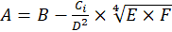 (3.5)

where A is profit, UAH;
B is revenue, UAH;
C… you must explain all the formula components, formula is made in MS Equation only.

According to the numbering, this is the fifth formula of the third chapter.
It is not allowed to use three-level numbering of illustrations, tables and formulas, for example: "Fig. 2.3.2" or "(3.1.4)".

References
When writing a thesis, the student must refer to the sources, materials or individual results of which are cited in the thesis (theoretical sources, reference materials, etc.), as well as tables, formulas, illustrations and appendices.
In the theoretical chapter of the thesis, using materials published by other authors, a separate reference is made for each given final opinion, which in the text can be highlighted by a paragraph, a separate sentence or quotation. The presence of on average one - two references to one page of the text of the theoretical chapter, citing several consecutive pages of text from one source indicate the low quality of theoretical research and may be the reason for not allowing the thesis to defend.
If you use information, materials from textbooks, monographs, review articles, other sources with a large number of pages, then the link must specify the page numbers, illustrations, tables, formulas from the source referenced in the thesis.
References to sources in the text should be indicated by a serial number in the list of references and separated by two square brackets, for example: "[5, p. 25 - 27] "(fifth number in the list of references, 25 - 27 pages), or" ... in the works [11; 23; 29] ... ». Do not put a dot in front of the closing bracket. After the bracket, a full stop is placed only if it is the end of the sentence. If the link is at the end of the title of the table or illustration, do not put a full stop.
References to the illustrations of the thesis indicate the serial number of the illustration, for example: "Fig. 1.2 ", in lower case.
References to formulas indicate the ordinal number of the formula in parentheses, for example: "... in formula (2.1)".
When referring to the table, the word "table" in the text is written abbreviated, in lower case, for example: "... in table. 1.2 ».
In repeated references to tables, illustrations and formulas, the word "see" should be abbreviated, for example: "see table 1.3 ».
References to appendices should be used in cases where all the materials of the appendix are in question or the appendix contains only one component (text, table, illustration, formula, etc.). In this case, the word "appendix" and its number are used, for example: "The scheme of the organizational structure of the enterprise is given in Appendix A". If the reference is made to a separate element of the application, you need to specify only this element, without naming the application number, for example, you need to write "... in table. B.4 ... "instead of ... ... in table. B.4 of Appendix B ... ».
In references to illustrations, formulas, tables, appendices, the corresponding symbols are written in lower case (except when they are at the beginning of the sentence). No full stop is placed after the reference (figure, table, appendix, formula bracket), except when the reference is at the end of the sentence.

List of references
The list of references is to be formatted in accordance with the requirements of DSTU 8302:2015 (Ukrainian – ДСТУ 8302:2015). An example of the formatting can be found by the link http://lib.znau.edu.ua/jirbis2/images/phocagallery/2017/Pryklady_DSTU_8302_2015.pdf.
Sources in the list of references are given in alphabetical order (in alphabetical order by the names of the first authors or by title in case of absence of authors). First, sources are provided in Ukrainian, and then - foreign-language sources. Numbering of sources in the list is continuous.
When adding individual sources to the list of references, it is necessary to provide all the initial data: name of the author (authors), title of the work, place and name of the publisher (the last is not mandatory), year of publication, total number of pages (for periodicals –range of pages for the article referred). In addition, when formatting a list of references, the following general requirements are to be followed:
the initials and surname of the author are not separated from each other, ie are always placed on the same line;
titles and other details of sources from foreign languages are NOT translated;
the abbreviation of the word "page" ("p.") is always placed on the same line with the corresponding number;
it is not allowed to indicate the issue of the magazine (newspaper) as a separate item in the bibliography – the position of the bibliography can be only a separate article;
similarly, it is not recommended to refer to the whole website: the position of the list of references should be a separate page, which is designed as an article (with some differences from the article in the paper edition). Exceptions may be sites with statistical, reference information - in the case of repeated references in the text of the thesis to different pages of such a site it may be issued as a separate item in the list of references;
The URL of the website, both in the main text of the work and in the list of references, cannot be given in an underlined font;
it is necessary to strictly adhere to the requirements for punctuation and font type (according to the sample), without replacing the dash with a hyphen, making the necessary deviations between the structural elements of the position of the bibliography and punctuation marks, using the italic font when it is required by the standard.
You can use the online references generator to create items in the list of references: https://www.grafiati.com/uk/blogs/dstu-8302-2015-referencing-generator/
An example of the design of literary sources by their types is given in Appendix C of the guidelines. It should be borne in mind that the list of references is drawn up.
An example is provided below.

REFERENCES

- Про Державну програму економічного і соціального розвитку України на 2010 рік: Закон України від 20.05.2010 р. № 2278-17. URL: http://zakon.rada.gov.ua/cgi-bin/laws/main.cgi?nreg=2278-17 (дата звернення: 12.10.2023).
- Anderson E., Simester D. Effects of $9 Price Endings on Retail Sales. Quantitative Marketing and Economics. 2003. Issue 1. P. 93–110.
- Arsel Z., Kirsi E., Moisander J. Introduction: theorising gender and gendering theory in marketing and consumer research. Journal of Marketing Management. 2015. Issue 31 (16). – P. 1553–1558.
- Barletta M. How Does Marketing for Women Differs from Marketing for Men. Michigan : Dearborn Trade, 2011. 288 p.
- Berggren J., Gonzalez R. Gender Difference in Financial Decision Making. Umea : Umea University. 2014. 184 p.
- Pushkar O., Zavgorodnia O. Decision support systems : summary of lectures. Kh. : Publishing House of KhNUE, 2012. 172 p.
- Bhasin H. Aaker Brand Equity Model. Marketing 91 : website. URL: https://www.marketing91.com/aaker-brand-equity-model (date of access: 03.11.2023).
- Chua N. Y., Lundbye J. Endovascular catheter as a rewarming method for accidental hypothermia. Therapeutic hypothermia and temperature management. 2012. Vol. 2, no. 2. P. 89–91. URL: https://doi.org/10.1089/ther.2012.0001 (date of access: 06.05.2020).
- Population, total. The Worlrd Bank : website. URL: https://data.worldbank.org/indicator/SP.POP.TOTL?view=chart (date of access: 15.10.2023).
- Porter M. E. Competitive Strategy: Techniques for Analyzing Industries and Competitors. 2nd ed. Amazon : website. URL: https://www.amazon.com/Competitive-Strategy-Techniques-Industries-Competitors/dp/0684841487 (date of access: 07.08.2023).

Appendices
Appendices are designed as a continuation of the master's thesis immediately after the list of references in the form of a separate part, and are placed in the order of reference to them in the text of the thesis. Appendices must begin with the title page, on which the word "APPENDICES" is printed symmetrically in large letters on the sheet. Each appendix should also begin with a title page on which the word "appendix" and the corresponding letter are written in bold symmetrically to the page. For example: "APPENDIX A". On the other line ─ its name in small letters in bold, for example: "Organizational structure of enterprise management". The words "APPENDICES", "APPENDIX", the application number and its name are not quoted.
Appendices should be indicated in consecutive capital letters of English alphabet, for example: "APPENDIX A", "APPENDIX B", etc.
Illustrations, tables and formulas, which are placed in the appendices, are numbered within each appendix, for example:”Fig. D.2”─ the second figure of Appendix D; (A.1) ─ the first formula of Appendix A. Elsewhere, the illustrations, tables and formulas contained in the Appendices are subject to the general design requirements.
Documents filled in on both sides of the sheet are counted as two pages, but the number is placed only on the first of them.
It is inadmissible to provide in the appendices any documents containing the seal of the enterprise or the signatures of its officials, in particular, financial statements. Financial statements of the enterprise - the internship and research base is given in the tables created using Microsoft Excel.
Articles that have not yet been published are submitted in the appendix in accordance with the requirements for their design in the publication to which they are submitted.

The formatting procedure for the diploma thesis is described in the appendix E.

Requirements for the formatting of the presentation
Presentation must contain at least 5 slides. Presentation includes graphs, diagrams, tables and formulas that must be in the thesis, which have a semantic load and which will be reported during the thesis defense. Slides are arranged in the order in which they are mentioned in the report during the defense.
The numbering of illustrations, tables and formulas in the presentation is thorough. Illustrations, tables and formulas in the presentation have their own one-level number, not the one they had in the robot, for example: “Fig. 1”.
In addition to the presentation, the student must submit to the commission the text or copy of the article published in the scientific journal on the topic of the thesis. A pre-published article and its electronic version (if it has not yet been published) are submitted to the graduating department.

5. SUPERVISION OF THESIS

In order to timely prepare for the master's thesis of students by order of the rector of the higher education institution in accordance with the submission of the department appointed supervisors of theses. In addition, consultants - teachers of relevant departments are appointed to consult on certain issues.
Thesis supevision is carried out by teachers of the highest level of qualification of the Department of Management and Business. The distribution of supervisors of the master's thesis by students is approved at the meeting of the department, taking into account the topics of thesis and wishes of students.
Thesis supervisor performs the following functions:
manages the preparation of the thesis;
controls the implementation of the schedule of the educational process by the student;
helps the student to formulate the final version of the topic of thesis, choose the right direction and methods of solving major problems, together with the student determines the tasks for the thesis and makes a plan;
assists in the development of a calendar schedule for the entire period of preparation of the thesis;
recommends the necessary sources to study the topic of the thesis: basic literature, reference materials, etc .;
conducts systematic, scheduled and scheduled consultations, conversations;
analyzes and controls the organization of independent student work;
monitors the performance of work (in parts and in general) in accordance with the developed calendar schedule;
checks the chapters of the thesis and work in general;
helps to prepare and publish a scientific article based on the thesis.

6. PREPARATION OF THESIS BY STUDENTS

Preparation of theses begins after the approval of the topic and the appointment of supervisors.
The work on preparation and writing of the master's thesis is carried out by students independently in accordance with the calendar schedule approved by the graduating department. In the process of work the student must follow all the recommendations of the supervisor.
Responsibility for the implementation of approved diploma preparation plans is due to the students and supervisors. In case of non-fulfillment of this plan, the supervisor reports on this isuue in the meeting of the Department of Management and Business.
After completing the master's thesis, the student must obtain all necessary signatures from the supervisor and consultants.
Completed thesis is submitted to supervisor not later than two weeks before the appointed date of defense. After studying and in case of approval of the work, the supervisor together returns the student's thesis to pass the procedure of norm control and its further approval by the head of the Department of Management and Business. The purpose of norm control, which is carried out by the teacher of the graduating department, is the final verification of compliance of the content and design of the work to the requirements of the department. In addition to the unbound explanatory note, the student must provide an article (with an electronic version) or a copy of the published article.
After approval by the head of the Department of Management and Business, the master's thesis is submitted for external review.
The electronic version on a diskette (disk) in a separate envelope (file) is submitted to the graduating department.
In case of a negative conclusion of the head or head of the graduating department, the student is not allowed to defend the thesis.
Before the defense, the student is obliged to read the review, analyze it and prepare responses to comments.
Students who have not completed the curriculum and at the time of submission of the thesis have academic debt are not allowed to defend.
Students who have not defended their dissertations are not eligible for a master's degree. Such students are issued a certificate of completion of the master's degree program.

7. EXTERNAL REVIEW OF THE THESIS

External reviewers may be leading specialists working at enterprises, research institutions, teachers of other higher education institutions. The review must be printed on the letterhead of the enterprise (institution) or have its seal, or or have another format approved by the Management and Business department. The external review should contain the following components:
conclusions on the relevance of the chosen topic, the practical significance of the thesis;
characteristics of the completeness of the task on the disclosure of the thesis, compliance with the content of the work to the task;
conclusions on the use of modern research methods, methodological approaches to improving the activities of the enterprise in accordance with the direction of the thesis;
evaluation of specific proposals, recommendations for improving the management of certain aspects of the enterprise, increasing its efficiency;
assessment of general impressions from the thesis (design, style and literacy of teaching, etc.);
the reviewer's conclusion on the compliance of the quality of the thesis with the requirements for such works, on the possibility of admitting it to the defense, the proposed assessment of the work on the stem scale and the national scale in parentheses and the possibility of awarding the student a master's degree in management.

8. PROCEDURE FOR DEFENSE OF THESIS

Thesis defense is held at an open meeting of the state examination commission.
Lists of students admitted to the defense are submitted to the state examination commission no later than one week before the defense.
At the same time, the members of the state examination commission will be acquainted with the diploma theses of the students that this commission will deserve.
The following documents are submitted to the State Examination Commission before the start of the defense:
summary of students' implementation of the curriculum and the grades they received;
external review.
The State Examination Commission may also be provided with other materials characterizing the scientific and practical value of the diploma work, ─ printed articles on the topic of the work, documents indicating its practical application, etc.
The thesis defense procedure is public and consists of the following stages:
a brief report from the author (determines the purpose, content, scientific and practical value of the work; issues submitted for defense, and the results of the thesis). Recommended duration of the student's report ─ 5 ─ 7 minutes;
answers to questions from members of the state examination commission and those present at the defense;
answers to comments from reviewer;
summarizing the results of the defense of the thesis (assessment of the thesis of each student).
Based on the review, the results of the thesis defense and average grade based on the grades obtained during training, the state examination commission makes a reasoned decision for each student to award a master's degree.
The decision of the state examination commission to assess the knowledge found during the preparation and defense of the thesis, as well as assigning a master's degree to a student and issuing a relevant state document is made by the state examination commission at a closed meeting by open voting participation in the meeting. With the same number of votes, the vote of the head is decisive.
The results of the defense of theses are announced on the same day after the minutes of the meeting of the state examination commission. Students whose work contains a significant amount of scientific novelty may be recommended by the State Examination Commission for admission to postgraduate studies.

APPENDICES

Appendix А
List of topics of master's theses
Decision making in management
1. Improvement of managerial decision making techniques at the enterprise
2. Improvement of managerial decision making techniques in manufacturing sphere
3. Improvement of managerial decision making process at the enterprise
4. Improvement of managerial decision making process in manufacturing and sales spheres
5. Formulation and Justification of managerial decisions considering enterprise efficiency improvement
6. Improvement of decision making process efficiency basing on time management techniques

Information and communication in management,
information supply and managerial decision making support
7. Information support of managerial decision making process at the enterprise
8. Management of information resources of enterprise
9. Development of electronic work flows in management of marketing (sales, logistics, operations, etc.) activities of the enterprise
10. Improvement of workflows systems at the enterprise
11. Justification of the corporate information system development at the enterprise
12. Justification of the business analytics system development at the enterprise
13. Justification of the ERP system development at the enterprise
14. Justification of the corporate social network development at the enterprise
15. Justification of industrial control system development at the enterprise
16. Knowledge management at the enterprise
17. Development of knowledge management enterprise information system
18. Introduction of procedures for enterprise knowledge management
19. Information support of external relations of the enterprise
20. Improvement of the internal communication process by usage of mobile applications
21. Re-organization of managerial communication system at the enterprise
22. Improvement of internal communication by development of corporate social network
23. Justification of enterprise efficiency improvement through IT
24. Justification of big data storage at the enterprise
25. Management of enterprise information resources development

Planning at the enterprise, development of business plan
26. Enterprise planning activity improvement
27. Adaptation of enterprise planning system to conditions of the economic instability
28. Enterprise production and commercial operations activities improvement
29. Enterprise operations planning system improvements
30. Enterprise goal-setting system improvement
31. Development of complex 1-year plan for small enterprise
32. Definition of the optimal capacity level at the enterprise and its justification
33. Justification of the production plan on defined period
34. Planning of manufacturing activity of an enterprise
35. Enterprise scheduling operative planning system improvement
36. Development of enterprise business-plan
37. Development of the business-plan for enterprise
38. Development of investments business-plan at the enterprise
39. Justification of business-plan of investment project
40. Development of business-plan for new product implementation
41. Development of business-plan for penetration of new market
42. Development of business-plan for products export
43. Development (improvement) of the business model of an enterprise

Enterprise strategy, including development strategy
43. Enterprise strategic planning mechanism improvement
44. Establishment of current strategic planning streams for the enterprise
45. Enterprise strategic planning system development
46. Enterprise growth strategy development
47. Enterprise business-unit growth strategy development
48. Justification of enterprise activity strategy options
49. Enterprise business improvement and its Justification
50. Enterprise development streams Justification
51. Development of catering business through franchising
52. Diversified enterprise growth management
53. Enterprise organization development strategy elaboration
54. Justification of key aspects of enterprise strategy
55. Enterprise strategic goals Justification
56. Enterprise strategic plan development
57. Enterprise diversification strategy development
58. Development and evaluation of enterprise strategic resources
59. Establishment of balanced scorecard system of the enterprise
60. Establishment of balanced scorecard system of the agricultural enterprise
61. Balanced scorecard system implementation to the enterprise strategic management system
62. Enterprise strategic partnership directions Justification
63. Enterprise strategic alliances system development
64. Business-unit development strategy Justification

Managing the enterprise and products competitiveness, quality of products
65. Enterprise competitiveness management
66. Enterprise competitiveness management mechanisms improvement
67. Enterprise competitiveness strategy Justification
68. Justification of means for enterprise competitiveness improvement
69. Development of the complex of activities for enterprise competitiveness improvement
70. Enterprise competitiveness improvement through marketing instruments
71. Trade enterprise competitiveness improvement through logistics subsystems improvement
72. Enterprise competitiveness improvement through expansion of the range of services
73. Enterprise products competitiveness management
74. Development of the complex of activities for enterprise products competitiveness improvement
75. Products competitiveness improvement through development of the service support
76. Enterprise competitiveness provision in globalization conditions
77. Management formation of enterprise competitive advantages
78. Enterprise competitive advantages formation strategy development
79. Enterprise competitive advantages formation and development
80. Development of means for enterprise competitiveness enhancement
81. Enterprise competitiveness potential management
82. Enterprise products quality management
83. General quality assurance methodology implementation at the enterprise
84. Enterprise quality management system certification project in accordance to the international standard ISO 9001:2015
85. Enterprise products quality improvement complex program Justification
86. Enterprise quality management system improvement
87. Enterprise performance improvement through quality management system development
88. Enterprise products quality management system project Justification

Managing the enterprise potential
89. Improvement of the strategic management of enterprise’s potential
90. Development of strategies for management of enterprise production potential
91. Development of enterprise’s marketing potential
92. Enterprise’s marketing potential efficiency improvement

Business-processes management
93. Establishment of the process approach in enterprise management
94. Justification of process approach project Establishment in enterprise management
95. Integration of enterprise supply chain on electronic data exchange technology
96. Integration of enterprise business processes trough Establishment of ERP-systems
97. IT sphere enterprise business processes improvement
98. Transportation enterprise distribution business process improvement
99. Customer service business process improvement through usage of mobile devices
100. Bank customer service business process improvement
101. Enterprise lean production concept Establishment
102. Establishment of “six sigma” approach in catering sphere
103. Enterprise continuous business processes improvement system implementation.
104. Development of the continuous business processes improvement enterprise management system project.
105. Kaizen methodology implementation for catering business
106. Enterprise integral business processes automation
107. Enterprise business processes monitoring system setup
108. Enterprise business processes reengineering
109. Enterprise distribution business process reengineering
110. Development and Establishment of enterprise business processes regulations
111. Enterprise business processes simulation and improvement

Organization of management, organizational structure
112. Justification of enterprise’s organizational structure improvement project
113. Enterprise organizational structure improvement
114. Establishment of project management at the enterprise
115. Enterprise management through project management principles and methods
116. IT company project management process improvement
117. Enterprise internal consulting department establishment
118. Enterprise organization and regulation of strategic audit department
119. Enterprise corporate management practices improvement
120. Establishment of up-to-date standards of enterprise corporate management

Restructuring of enterprise, change management
121. Management of organizational changes of the enterprise
122. Enterprise change management
123. Enterprise restructuring program management
124. Improvement of enterprise business model through outsourcing
125. Justification of outsourcing of auxiliary activities for production enterprise
126. Justification of enterprise IT outsourcing project

Crisis management
127. Development and Justification of anti-crisis program for organization activity
128. Justification of enterprise anti-crisis program
129. Formation of enterprise anti-crisis personnel management system

Risk management, economic safety of enterprise
130. Improvement of enterprise manufacturing risk management mechanism
131. Enterprise risk management and Justification of means for its minimization
132. Establishment of risk management system for trade organizations
133. Management of commercial risks at production enterprise
134. Establishment of enterprise risk monitoring and early prevention systems
135. Managerial decision making by enterprise risk assessment
136. Strategic management of enterprise economic safety in crisis conditions
137. Justification of means for improvement of enterprise economic safety performance
138. Establishment of economic safety for sales and distribution activities of trade organizations

Managing the investment activities of enterprise
139. Development of enterprise international investment leverage activities
140. Management of enterprise investment activities
141. Establishment of enterprise investment program
142. Enterprise’s investment portfolio management
143. Establishment of enterprise investment planning activities
144. Development of enterprise investment strategy
145. Enterprise investment activities optimization
146. Establishment of enterprise investment resources management
147. Management of enterprise growth investment coverage
148. Management of enterprise investment projects
149. Justification of enterprise investment project establishment
150. Enterprise investment project efficiency assessment system improvement
151. Justification of investment project for production enterprise technological revamping

Managing the innovation activities of enterprise, technological development of production, manufacturing of new products, technological preparation of production
152. Enterprise innovation activities management
153. Management of enterprise innovation activity through “continuous improvement” concept
154. Development of enterprise innovation activity management concept
155. Establishment of innovation policies of enterprise
156. Production enterprise innovation activities planning
157. Strategic management of enterprise (organization) innovation activities
158. Establishment of enterprise innovation development strategy
159. Organization-economical provision of innovation development of enterprise
160. Management of enterprise innovations projects
161. Improvement of enterprise innovation management process
162. Development of technical development strategy of enterprise
163. Management of technical-technological development of enterprise
164. Justification of enterprise new products manufacturing
165. Justification of enterprise new means of products manufacturing
166. Justification of innovation project establishment on the enterprise
167. Justification of manufacturing process innovation on the enterprise
168. Marketing provision of enterprise innovation activities

Production organization
169. Management of operation activity of enterprise
170. Development of enterprise manufacturing potential
171. Justification of the industrial control system for enterprise technological processes
172. Justification of mechanic assembling processes automation for engineering plant
173. Improvement of enterprise manufacturing organization system
174. Identification and Justification of enterprise optimal manufacturing volume
175. Organization and planning of technical preparation of manufacturing
176. Organization and service provision for enterprise production

Resource management and energy saving
177. Enterprise production waste handling procedures improvement
178. Enterprise approach to waste management
179. Development of enterprise energy saving strategies
180. Justification of the enterprise energy saving project
181. Justification of material consumption reduction for the textile enterprise products

Managing the fixed assets (funds) of enterprise, production capacity
182. Enterprise production capacity optimization
183. Enterprise production capacity planning
184. Enterprise production capacity load management
185. Enterprise production capacity load optimization
186. Enterprise production capacity management
187. Establishment and utilization of enterprise fixed assets
188. Planning and organization of enterprise manufacturing support

Managing the marketing and sales activity of enterprise
189. Enterprise marketing activity organization
190. Enterprise marketing activity organization with usage of internet technologies
191. Organizational marketing activities coverage of enterprise
192. Justification of managerial decision upon marketing activities of enterprise
193. Enterprise marketing system improvement
194. Trade enterprise marketing system improvement in crisis conditions
195. Trade enterprise marketing activities improvement by using internet technologies
196. Establishment of enterprise management systems by marketing concepts
197. Development of marketing activity of enterprise through application of up-to-date marketing tools
198. Development of marketing activity plan of enterprise
199. Development of marketing activity plan of enterprise in crisis conditions
200. Development of marketing plan of enterprise
201. Enterprise marketing strategy formation
202. Development of enterprise marketing strategy
203. Justification of enterprise marketing strategy
204. Development of marketing strategy for enterprise strategic business unit
205. Development of marketing diversification strategy of enterprise
206. Formation of enterprise marketing strategy for external economic activity of enterprise
207. Justification of managerial decision of enterprise marketing communication improvement
208. Management of marketing communications of enterprise
209. Enterprise communications policy formulation
210. Justification of complex managerial decisions on forming enterprise product policy
211. Justification of managerial decision for enterprise service assortment expansion
212. Justification of managerial decisions of costing at the enterprise
213. Justification of enterprise price policy
214. Development of products market promotion strategy of an enterprise
215. Justification of managerial decision of market promotion of organization’s products
216. Organizational-managerial coverage of exposition activity of enterprise
217. Development of master-plan of enterprise image formation
218. Justification of complex of managerial decision considering enterprise image
219. Development of enterprise image as a mean of competitive improvement
220. Marketing activity efficiency improvement by formation and development of brand
221. Justification of managerial decision on development of enterprise brand (product)
222. Development of strategies of enterprise brand (product) promotion
223. Justification of CRM system implementation at the enterprise
224. Development of market product promotion strategies through usage of internet technologies.
225. Development of marketing activity of enterprise via mobile applications
226. Justification of e-marketing project introduction at the enterprise
227. Justification of e-commerce project introduction at the enterprise
228. Justification of kind of enterprise partnership relations with counterparts
229. Enterprise sales activities organization
230. Enterprise sales activities improvement
231. Enterprise sales activities improvement by usage of internet technology
232. Organization of sales activity of enterprise with application of information technology
233. Marketing coverage of enterprise sales activities
234. Justification of re-organization of enterprise dealer system
235. Introduction of active sales technologies at the enterprise
236. Justification of enterprise distribution networks expansion project
237. Justification of enterprise distribution networks expansion project through franchising
238. Formation and support of partnership in enterprise’s distribution network
239. Justification of client relations management system at small enterprise
240. Development of client loyalty relations strategy of an enterprise
241. Justification of managerial decision considering customer loyalty improvement
242. Planning and organization of marketing research at the enterprise

Managing the logistics activity of the enterprise
243. Organization of logistics activity of the enterprise
244. Justification of SCM system introduction at the enterprise
245. Optimization of enterprise supply chain
246. Management of technical-material provision of enterprise
247. Improvement of distribution activity of manufacturing process through introduction of electronic data exchange systems
248. Management of procumbent activity of enterprise
249. Optimization of enterprise warehousing
250. Optimization of procurement network if enterprise
251. Means of improvement of inventories management
252. Management of material inventories of enterprise
253. Management of material resources and manufacturing inventories of enterprise
254. Operations management of transport-warehousing activity of enterprise
255. Integrated introduction of logistics innovation to the practical activity of enterprise

Managing the financial activity of the enterprise
256. Management of formation and distribution of enterprise income
257. Managerial decision making in process of formation and distribution of income
258. Justification of engineering enterprise profitability means of improvement
259. Justification of means of formation and usage of enterprise income
260. Management of enterprise economical-financial potential
262. Development and introduction of budgeting process of enterprise

Cost management
263. Cost management of enterprise as a mean of gaining competitiveness
264. Introduction of process cost accounting system at the enterprise
265. Optimization of enterprise’s expenses structure
266. Cost management and costing at the enterprise
267. Production costs planning at the enterprise

Personnel management (labor organization, motivation, evaluation, training)
268. Justification of means of enterprise labor productivity improvement
269. Economical-technical Justification of enterprise labor productivity improvement means
270. Improvement of labor productivity of staff through socialization of enterprise labor relations
271. Improvement of personnel management system of the enterprise
272. Enterprise project team management
273. Organizational coverage of project team management
274. Management of social capital of organization
275. Improvement of labor organization of the enterprise
276. Introduction of new means of labor organization at the enterprise
277. Improvement of labor organization at the enterprise through introduction of automation
278. Development of labor motivation system of enterprise
279. Improvement of labor motivation system of enterprise’s staff
280. Improvement of labor motivation system of sales personnel of enterprise
281. Introduction of labor motivation system at result-oriented enterprise
282. Staff labor motivation system reengineering through key performance indicators
283. Improvement of wages and salaries basing on efficiency evaluation
284. Justification of enterprise’s staff motivation means
285. Development of personnel motivation means for catering business
286. Improvement of non-material labor motivation system of enterprise
287. Establishment of non-material labor motivation for enterprise’s employees
288. Introduction of collective methods of labor motivation of enterprise staff
289. Introduction of individual methods of labor motivation of enterprise staff
290. Improvement of enterprise staff labor stimulation system
291. Improvement of labor stimulation system considering staff qualification
292. Improvement of enterprise wages and salaries payment system
293. Improvement of organization of enterprise wages and salaries payment system considering crisis conditions
294. Establishment of grading system of wages and salaries at insurance business
295. Improvement of staff labor evaluation of the enterprise
296. Introduction of managerial employees’ labor evaluation system of the enterprise
297. Introduction of new means for evaluation of enterprise’s staff
298. Improvement process of recruiting and adaptation of staff at the enterprise
299. Improvement of staff development management at the enterprise
300. Establishment of personnel development program in production enterprise
301. Establishment of staff development program through couching at the manufacturing enterprise
302. Development of managerial staff of organization through self-management
303. Implementation of distant learning & couching system at the enterprise
304. Justification of staff development project through mentoring
305. Advanced training system enhancement for staff qualification improvement
306. Management of employee’s business career of the enterprise
307. Organization of personnel leasing at the enterprise
308. Management of organization’s intellectual resources and the directions of its improvement
309. Organization of remote work at the IT-organization
310. Organization of labor at the virtual organization
311. Conflict management at manufacturing enterprise

Leadership, organizational culture
312. Transformation of organizational culture within enterprise owner change
313. Transformation of organizational culture of enterprise in IT stream
314. Formation of organizational culture of the enterprise
315. Development if organizational culture of the organization
316. Conflict management of the organization
317. Establishment of socio-psychological climate in working collective
318. Development of socio-psychological climate in working collective

Corporate social responsibility, social protection of employees
319. Justification of corporate social responsibility strategy of the enterprise
320. Development and implementation of social responsibility principles of the organization
321. Development of sustainability education program of the enterprise

Managing the enterprise international economic activity
322. Improvement of organization export-import potential management
323. Formation of enterprise international economic activity strategy through license agreements
324. Formation of enterprise international economic activity strategy
325. Management of export activity of the organization

Control of enterprise activity
326. Modification of managerial decision execution control mechanism of the enterprise
327. Organization of procurement & utilization of material resources control of the enterprise
328. Implementation of marketing activity analysis & control system of an enterprise
329. Improvement (establishment) of enterprise strategic control system
330. Justification of means for enterprise operations control improvement

Appendix B
Sample of the application form for choosing the topic of the thesis

Зав. кафедрою менеджменту та бізнесу
д.е.н., проф. Лепейко Т. І.
студентки 4 курсу
групи 8.03.073.040.22.1
спеціальності 073 «Менеджмент»
Шевченко Тетяни Олександрівни

ЗАЯВА

Прошу затвердити мені тему дипломної роботи: «Розробка бізнес-плану інвестиційного проекту».

База практики: ТОВ «Омега».

Керівник: к.е.н., доц. Красноносова О. М. (підпис)

Дата Підпис студента

Appendix C
Formatting of references by their types

Keep in mind that the list of references used in the thesis is not a table, as given below, but a numbered list!

Table C.1
Examples of design of sources in the list of references
Type of source | Examples of formatting
1 | 2
Laws, bylaws | - Господарський Кодекс України від 16.01.2003 р. № 436-IV. Відомості Верховної Ради України. 2003. № 18, № 19–20, № 21–22. Ст. 144.  - Про Державну програму економічного і соціального розвитку України на 2010 рік: Закон України від 20.05.2010 р. № 2278-17. Відомості Верховної Ради України. 2010. № 33. Ст. 470.  - Про схвалення Державної програми розвитку промисловості на 2003–2011 роки: Постанова Кабінету Міністрів України від 28.06.2003 р. № 1174. Офіційний вісник України. 2003. № 31. Ст. 1628.
State standards | - ДСТУ ISO 9001: 2001. Системи управління якістю. [Чинний від 2001-06-27]. Київ, 2001. 24 с. (Інформація та документація).
Laws, bylaws, standards posted on the Internet | - Про Державну програму економічного і соціального розвитку України на 2010 рік: Закон України від 20.05.2010 р. № 2278-17. URL: http://zakon.rada.gov.ua/cgi-bin/laws/main.cgi?nreg=2278-17 (дата звернення: 12.10.2023).
Books: monographs, textbooks, manuals, dictionaries (one author) | - Близнюк Т. П. Вплив циклічності розвитку економіки на інноваційну діяльність підприємства : Монографія. Х. : ФОП Александрова К. М., 2008. 352 с.  - Parker J. Principles of scientific research. 7th ed. London : Editorial, 2017. 301 p.
Books: monographs, textbooks, manuals, dictionaries (2–3 authors) | - Лепейко Т. І., Котлик А. В. Процесний підхід до управління конкурентоспроможністю підприємства : монографія. Харків : Вид. ХНЕУ, 2012. 316 с.  - Wilson D., Lister P., Andrews A. Modern surgery. Manchester : MAN, 2011. 240 p.  - Білоус С. І., Корнійчук В. П. Філософія освіти. Переяслав-Хмельницький, 2016. 176 с.
Books: monographs, textbooks, manuals, dictionaries (4 authors) | - Організація маркетингового управління діяльністю підприємств машинобудівного кластера в умовах глобалізації : монографія / Лепейко Т. І., Пилипенко А. А., Пушкар О. І., Березовський К. М. Х. : ТОВ «Золоті сторінки», 2015. 664 с.  - Referencing styles / G. R. Edwards et al. Los Angeles : International Publishing, 2010. 280 p.

Продовження табл. В.1
1 | 2
Books: monographs, textbooks, manuals, dictionaries (over 4 authors) | - Концептуальні засади менеджменту в інформаційній економіці : монографія / Лепейко Т. І. та ін.; під заг. ред. Т. І. Лепейко. Харків : Вид. ХНЕУ, 2010. 252 с.  - Referencing styles / G. R. Edwards et al. Los Angeles : International Publishing, 2010. 280 p.  - Менеджмент у структурах видавничо-поліграфічного комплексу : навчальний посібник / Лепейко Т. І. та ін. Х. : Вид. ХНЕУ, 2011. 352 с.
Without author | - Міжнародні відносини : монографія / за ред. М. А. Березовського. Київ : ЦУЛ, 2016. 162 с.  - Routledge handbook of international statebuilding / ed. by D. Chandler, T. D. Sisk. London : Routledge, 2013. 448 p.
Part of the publication (monograph) | - Лепейко Т. І., Котлик А. В. Сучасні підходи до виділення підсистем підприємства. Концептуальні засади управління підприємством як економічною системою : Монографія / за ред. В. О. Коюда. Харків : Вид. ХНЕУ, 2007. С. 26–47.  - Goehr L. The concept of opera. The Oxford handbook of opera / ed. by H. M. Greenwald. Oxford, 2014. P. 92–136.
Multi-volume editions | - Бондаренко В. Г., Канівська І. Ю., Парамонова С. М. Теорія ймовірностей і математична статистика. У 2 ч. К.: НТУУ «КПІ», 2006. Ч. 1. 125 с.  - Енциклопедія рослин / редкол.: І. М. Деркач та ін. Київ : ЦУЛ, 2016. Т. 8. 812 с.  - Котлик А. В. Критика застосування методу радару для оцінки конкурентоспроможності підприємства. Актуальні проблеми економічного та соціального розвитку виробничої сфери : матеріали VI Міжнародної науково-теоретичної конференції молодих вчених і студентів, м. Донецьк, 21–22 травня 2009 р. Донецьк : ДВНЗ ДонНТУ, 2009. Т. 1. С. 291–294.  - Бюджетна система України: історія, стан та перспективи : у 3 т. / Акад. прав. наук України. Львів : Право, 2012. Т. 2 : Бюджетний менеджмент / заг. ред. Ю. П. Бубряка. 476 с.
Translated editions | - Брігхем Є. В. Основи фінансового менеджменту / пер. з англ. В. Біленького та ін. Київ : Молодь, 1997. 998 с.
Продовження табл. В.1
1 | 2
Articles in periodicals (magazines, newspapers) | - Котлик А. В. Побудова системи показників для оцінки конкурентоспроможності бізнес-процесів підприємства. Управління розвитком. 2011. № 21 (118). С. 30–32.  - Котлик А. В. Цілеорієнтований підхід до ідентифікації бізнес-процесів підприємства. Бізнес Інформ. 2013. № 2. С. 193–196.  - Масловська Л. Ц., Савчук В. А. Оцінка результативності і ефективності виробництва органічної агропродовольчої продукції. Агросвіт. 2016. № 6. С. 23–28.  - Якобчук В. П. Стратегічні пріоритети інноваційного розвитку підприємництва в аграрній сфері. Вісник Київського національного університету ім. Т. Шевченка. Сер. Економіка. 2013. Вип. 148. С. 31–34.  - Dankevych Ye. M., Dankevych V. Ye., Chaikin O. V. Ukraine agricultural land market formation preconditions. Acta Universitatis Agriculturae et Silviculturae Mendelianae Brunensis. 2017. Vol. 65, №. 1. P. 259–271.  - Монаєнко А. Поза чергою не рахується? Особливості звільнення суддів за порушення присяги. Юридична газета. 2017. 17 січ. С. 28–29.
Collections of scientific works | - Наумов О. Б., Мартинова О. В. Концептуальні підходи до формування механізму адаптаційних систем управління якістю текстильної продукції. Економіка: проблеми теорії та практики : зб. наук. праць. Дніпропетровськ, 2008. Вип. 238. Т. 4. С. 968–977.
Theses of reports at conferences | - Грузіна І. А. Інформатизація як передумова соціально-економічного розвитку регіону. Актуальні проблеми розвитку галузевої економіки та логістики : матеріали II наук.-практ. конф. Харків : Вид-во НФаУ, 2013. С. 108–110.  - Котлик А. В. Критика застосування методу радару для оцінки конкурентоспроможності підприємства. Актуальні проблеми економічного та соціального розвитку виробничої сфери : матеріали VI Міжнародної науково-теоретичної конференції молодих вчених і студентів, м. Донецьк, 21–22 травня 2009 р. Донецьк : ДВНЗ ДонНТУ, 2009. Т. 1. С. 291–294.  - Скидан О. В., Судак Г. В. Розвиток сільськогосподарського підприємництва на кооперативних засадах. Кооперативні читання : матеріали Всеукр. наук.-практ. конф., 4–6 квіт. 2013 р. Житомир : ЖНАЕУ, 2013. С. 87–91.
Abstracts of dissertations | - Барабась Д. О. Управління конкурентними перевагами підприємства (на прикладі підприємств швейної галузі) : автореф. дис… канд. економ. наук : 08.06.01. К., 2003. 18 с.
Dissertations | - Беседовський О. М. Прийняття управлінських рішень: процесний підхід : дис... канд. економ. наук : 08.06.01. Харків, 2004. 241 с.
Закінчення табл. В.1
1 | 2
Internet resources: books, articles, including those without an author, company websites | - Ілляшенко С. М., Шипуліна Ю. С. Товарна інноваційна політика : підручник. Суми : Університетська книга, 2007. 281 с. URL: ftp://lib.sumdu.edu.ua/Books/1539.pdf (дата звернення: 10.11. 2023).  - Chua N. Y., Lundbye J. Endovascular catheter as a rewarming method for accidental hypothermia. Therapeutic hypothermia and temperature management. 2012. Vol. 2, no. 2. P. 89–91. URL: https://doi.org/10.1089/ther.2012.0001 (date of access: 06.05.2020).  - Інформаційне суспільство: глобальне, європейське, українське. E-Ukraine : веб-сайт. URL: http://www.e-ukraine.org.ua/book (дата звернення: 15.08. 2023).  - Що таке органічні продукти і чим вони кращі за звичайні? Екологія життя : веб-сайт. URL: http://www.eco-live.com.ua (дата звернення: 12.07.2023).  - Капітальні інвестиції за січень–вересень 2010 року : Експрес-випуск № 263 від 15.11.2010 р. Державний комітет статистики України : веб-сайт. URL: https://ukrstat.gov.ua/operativ/operativ2010/ibd/kindj/infin_u/infin03_ 10u.htm (дата звернення: 05.03. 2023).  - Проект «Рейтинг». URL: http://alt.com.ua/ukr (дата звернення: 05.03. 2023).  - Toyota. URL: https://www.toyota.com/ (date of access: 05.03. 2023).

Appendix D

Example of the design of the title page and the first broadsheet of illustrative material

МІНІСТЕРСТВО ОСВІТИ І НАУКИ УКРАЇНИ

ХАРКІВСЬКИЙ НАЦІОНАЛЬНИЙ ЕКОНОМІЧНИЙ УНІВЕРСИТЕТ

ІМЕНІ СЕМЕНА КУЗНЕЦЯ

Кафедра менеджменту та бізнесу

ІЛЮСТРАТИВНИЙ МАТЕРІАЛ

ДО ДИПЛОМНОЇ РОБОТИ МАГІСТРА

на тему: Удосконалення процесів управління проектами ІТ-компанії

Керівник дипломної роботи Андрій КОТЛИК
(Ім’я, прізвище)

Студентка 2 курсу, групи 8.03.073.040.21.1
факультету менеджменту і маркетингу Тетяна ШЕВЧЕНКО
(Ім’я, прізвище)

Харків, 2022
Planning the marketing activity at the enterprise
The most important function of marketing management is marketing planning, which, basing on the analysis of the company's capabilities, reliable information on the state of assets and liabilities of production, and on the analysis of the external marketing environment, allows to develop the marketing goals and the ways of their achievement. A systematic approach to the organization of management and development of marketing strategy and tactics is a scientifically sound way to increase profitability, save costs and improve the company's position in the market.
Actuality
summarizing theoretical aspects of planning marketing activity at the enterprise and developing the practical recommendations on the development of marketing plans for the trading enterprise
Goal
to theoretically substantiate the essence of planning the marketing activities of the enterprise;
to review the algorithm of planning the marketing activities of the enterprise;
to provide the general characteristics of LLC “Syrnyi Dim”;
to conduct technical, economic and financial analysis of LLC “Syrnyi Dim”;
to analyze marketing activities of LLC “Syrnyi Dim” and current practices of its planning;
to develop recommendations for improving the planning of marketing activities of the LLC “Syrnyi Dim”
Tasks
the process of planning the marketing activities of the enterprise
Object of the thesis
the algorithm, tools and methods of planning the marketing activities of the enterprise
Subject of the thesis
morphological analysis, graphical method, logical generalization, vertical and horizontal analysis, Fishbone diagram, Internal Factor Evaluation Matrix, portfolio analysis, project evaluation and review technique
Research methods
laws and regulations of Ukraine, materials and data of periodicals, monographs and other scientific literature on the topic of marketing management and marketing planning, financial, statistical and managerial reports of the base of research
Information base
1. THEORETICAL ASPECTS OF PLANNING MARKETING ACTIVITIES1.1. The essence of marketing planning1.2. The algorithm of marketing planning2. СOMPREHENSIVE ANALYSIS OF LLC “SYRNYI DIM” ACTIVITIES2.1. General characteristics of the enterprise and FINANCIAL analysis of its activities2.2. Analysis of planning the marketing activities in LLC “Syrnyi Dim”3. WAYS TO IMPROVE THE MARKETING PLANNING AT LLC “SYRNYI DIM”3.1. Recommendations to improve the marketing activity of an enterprise3.2. Calculation of economic effect of recommended measures
Thesis structure
recommendations developed in the thesis will help LLC “Syrnyi Dim” to improve the procedure of marketing planning and to develop sound marketing plan to achieve its strategic goals
Results
Kotlyk A. The essence of the term “marketing planning” for an enterprise / A. Kotlyk, O. Zubriev // Менеджмент ХХІ століття: глобалізаційні виклики: матеріали VІ Міжнародної науково-практичної конференції, 19 травня 2022 р., Полтава: ПДАУ, 2022. 1310 с. – C. 1038 – 1041.
Publications
Topic
BROASHEET 1

Fig. 1. Scheme of a logical structure of the thesis

Appendix E

The thesis formatting procedure

Setting margins:
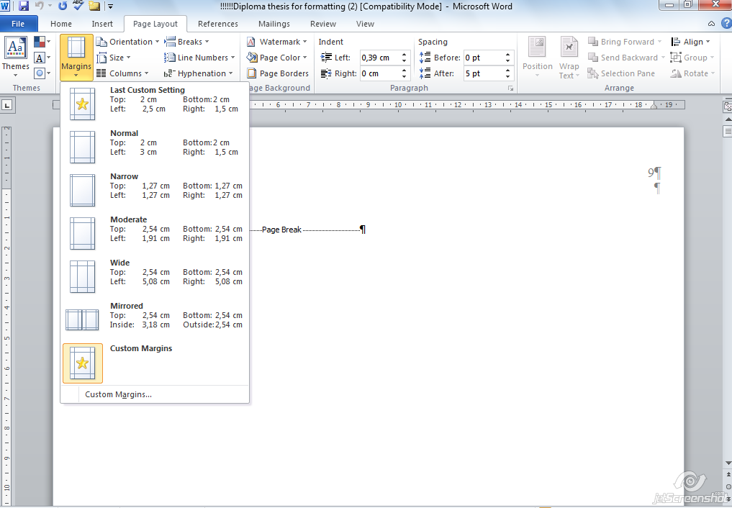

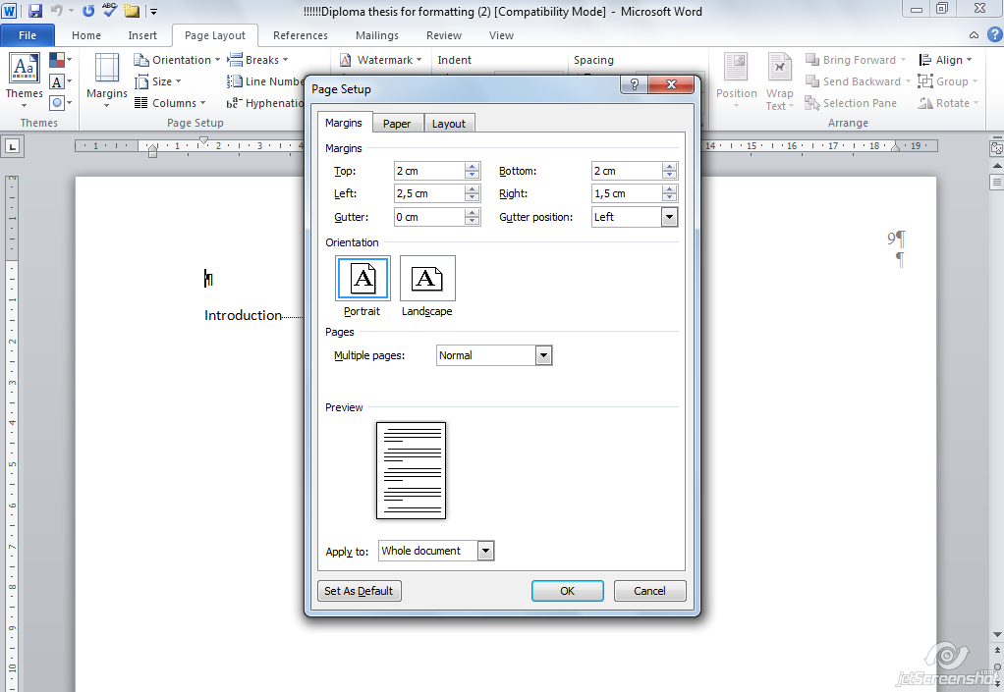
Setting up the Normal style:


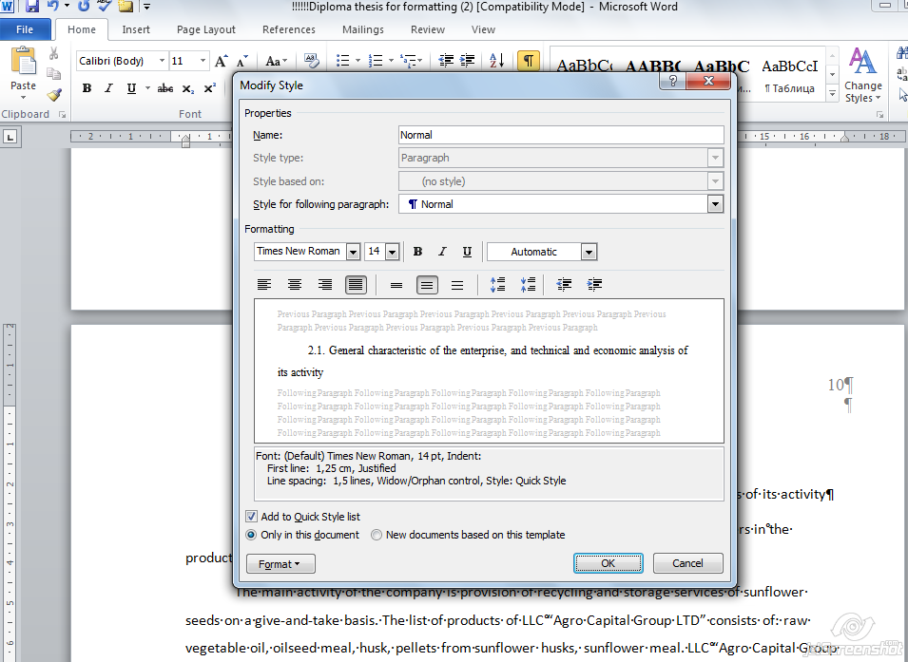

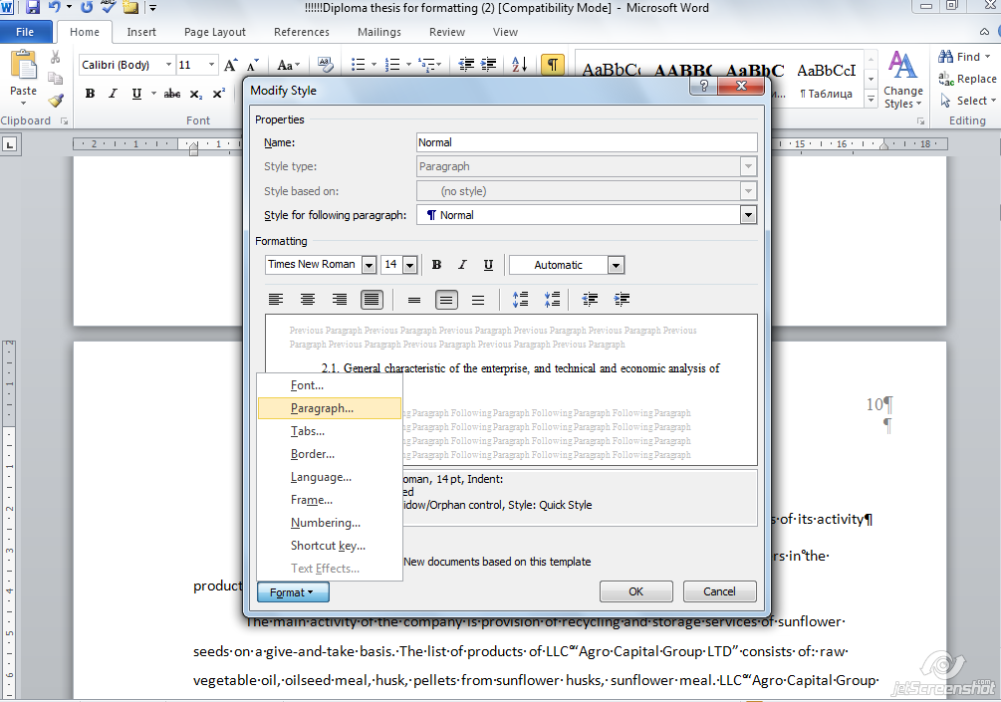

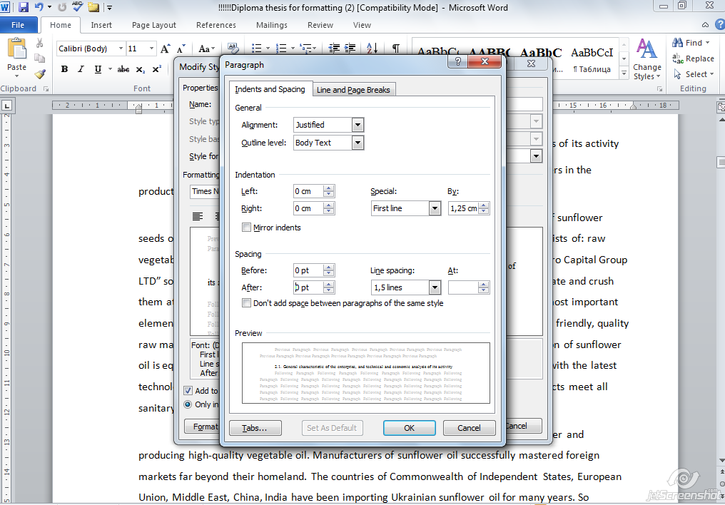
Applying the Normal style to the text:
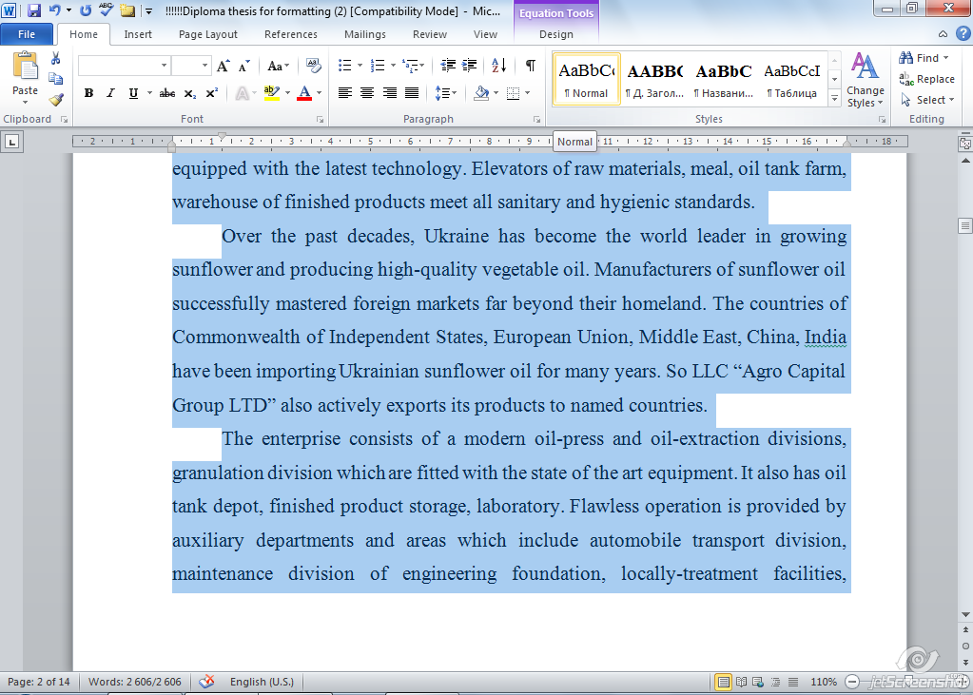

Setting up the Heading 1 (for chapters’ titles) and Heading 2 (for subchapters’ titles) styles:
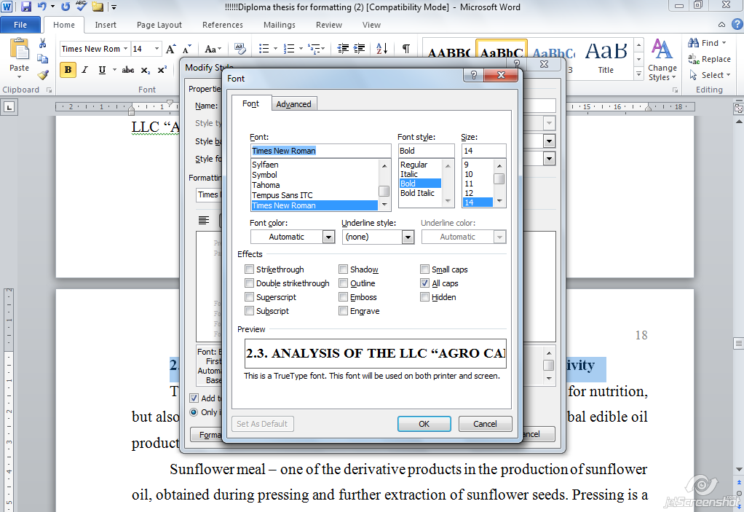


Making a table of contents:

Table of contents can be updated any time:
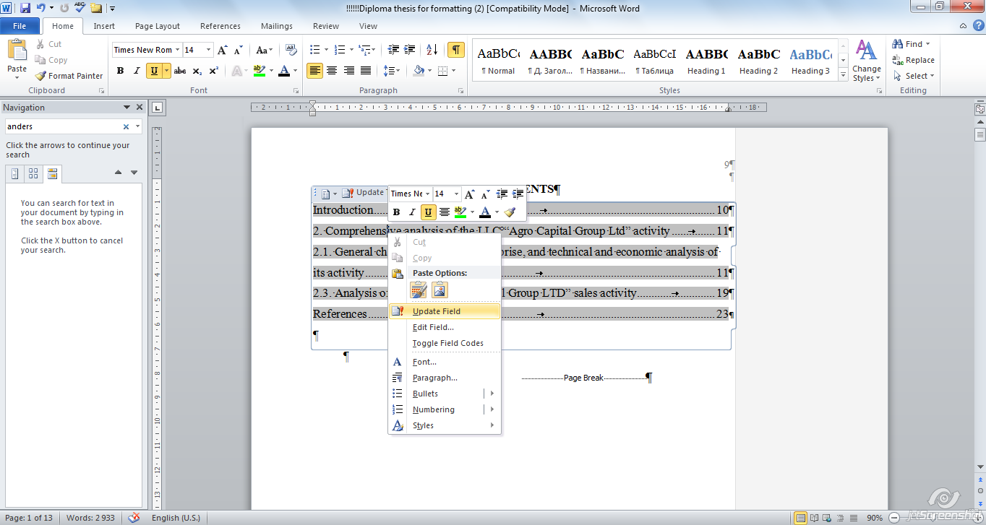

Activate the hidden symbols mode:


Tables formatting:
Font:
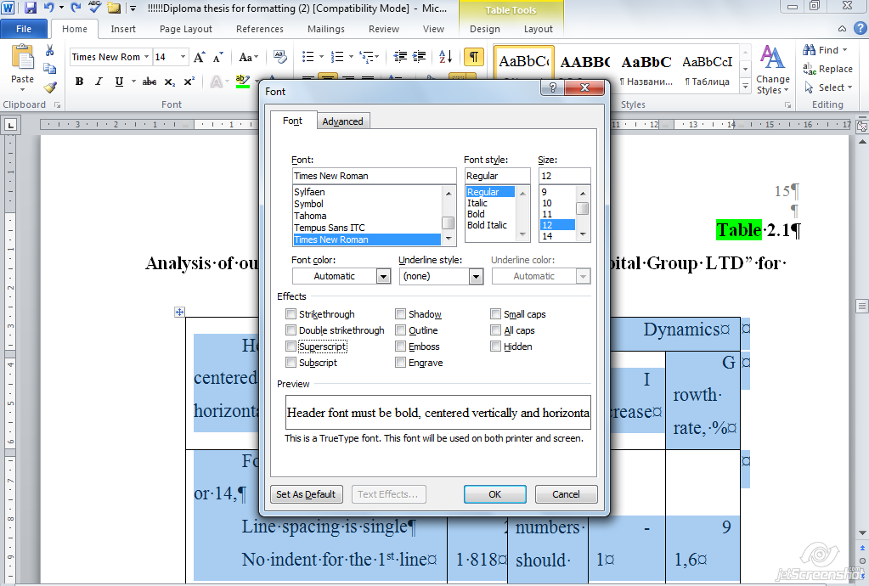
Paragraph for a table body:
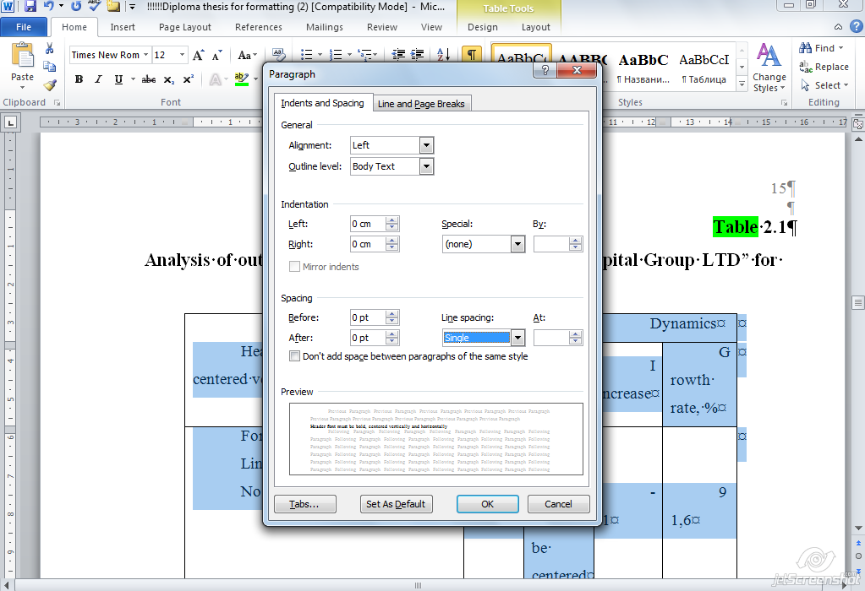
Header font:
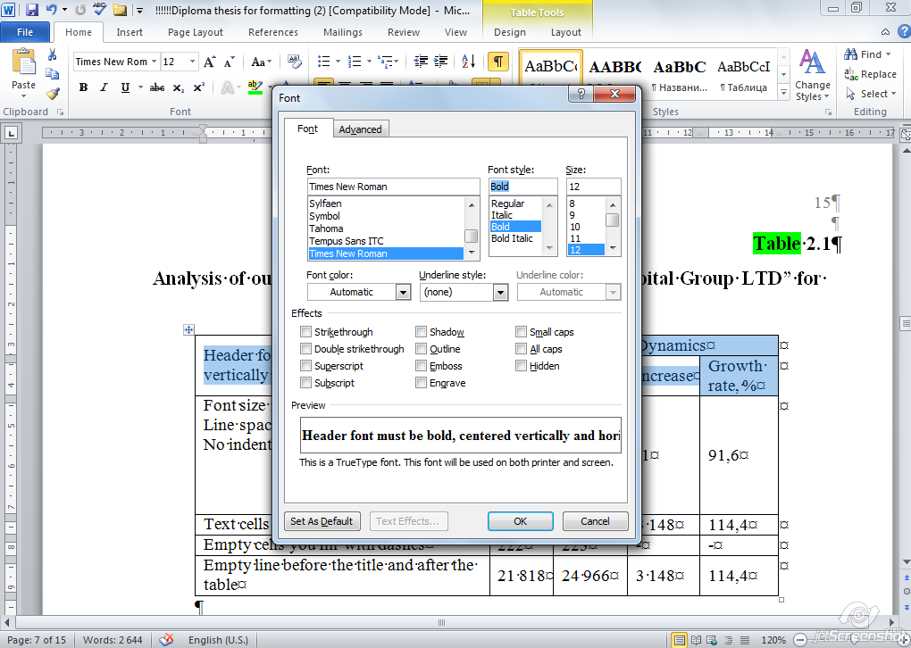
Header layout:
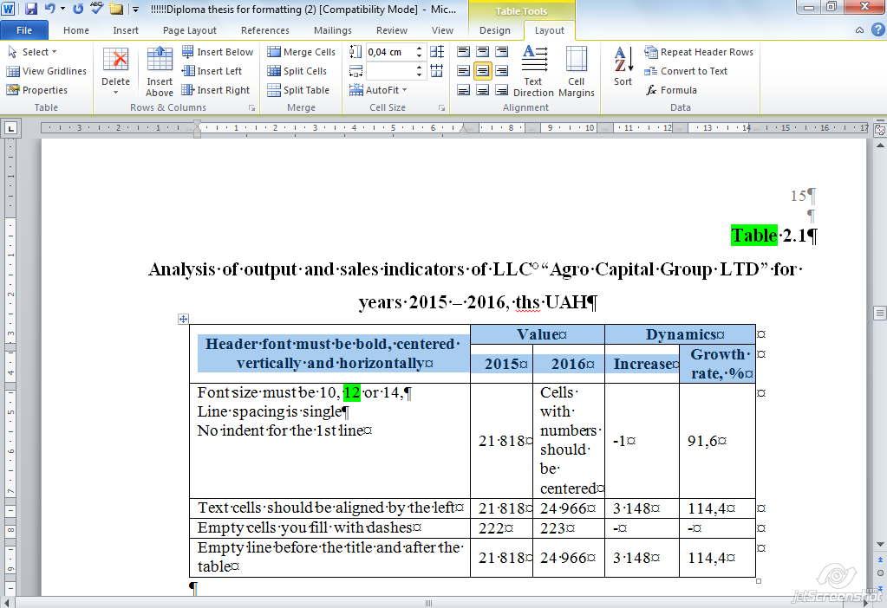
Figures is better to make in drawing canvas:
Insert – Shapes – New Drawing Canvas

Formulas:
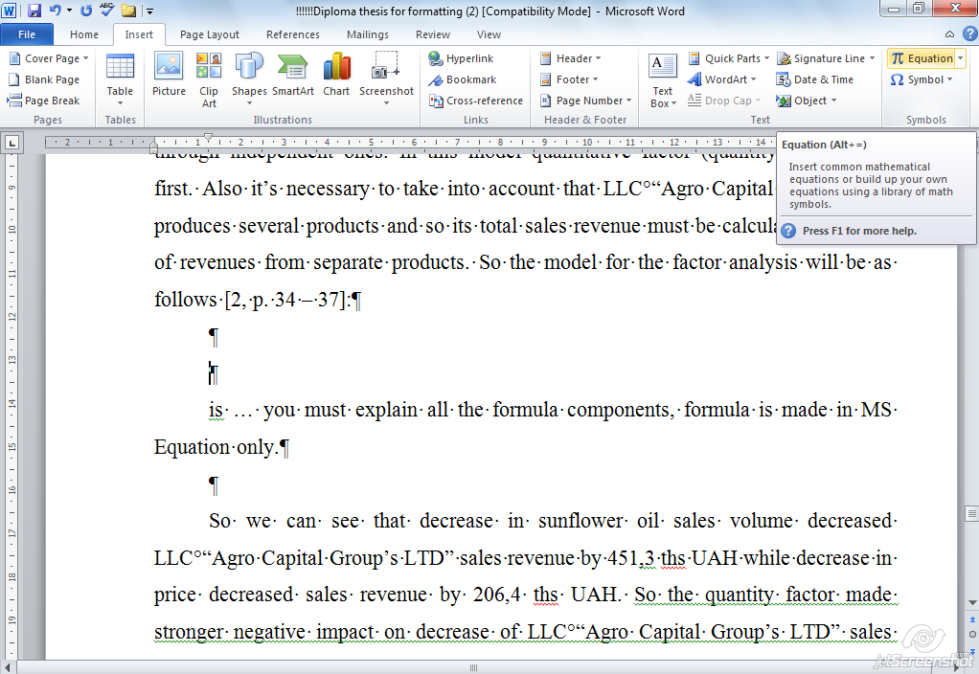

References (make reference list numbered):


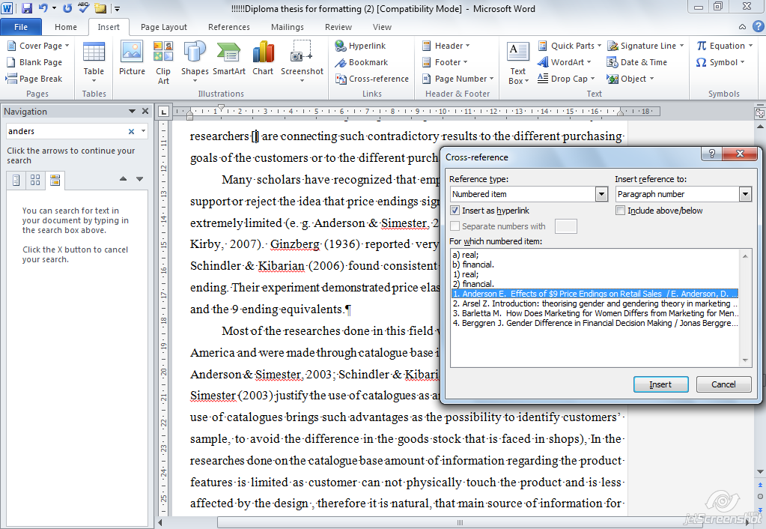

Appendix F
Sample of the referense letter from the research base (organization)

Довідка
видана студентці ХНЕУ Шевченко Тетяні Олександрівні в тому, що в її дипломній роботі на тему «Розробка бізнес-плану інвестиційного проекту» використані достовірні дані, а запропоновані рекомендації можуть бути використані в діяльності підприємства.

Директор ТОВ «Омега» Петро ПЕТРЕНКО
Печатка
НАВЧАЛЬНЕ ВИДАННЯ

Методичні рекомендації до написання дипломної роботи на здобуття освітнього ступеня «магістр» для студентів спеціальності 073 «Менеджмент» усіх форм навчання

Укладач Лепейко Тетяна Іванівна

Відповідальний за випуск Лепейко Т. І.

Редактор

Коректор

План 2023 р., Поз. №

Підп. до друку Формат 60х90 1/16.
Папір ТАТRA. Друк офсетний.

Ум.-друк. арк. Обл.-вид. арк.
Тираж прим. Зам № Безкоштовно

Свідоцтво про внесення до Державного реєстру суб’єктів видавничої справи Дк №481 від 13.06.2001 р.
Видавець і виготівник – видавництво ХНЕУ, 61001, м. Харків,
пр. Леніна, 9а

