MINISTRY OF EDUCATION AND SCIENCE OF UKRAINE

SIMON KUZNETS KHARKIV NATIONAL UNIVERSITY OF ECONOMICS

Guidelines
to the thesis
for a bachelor's degree
for students of the speciality 073 "Management"

Kharkiv, S. Kuznets KhNUE, 2023

Затверджено на засіданні кафедри менеджменту та бізнесу.
Протокол № від 2023 р.

Методичні рекомендації до написання дипломної роботи на здобуття освітнього ступеня «бакалавр» для студентів спеціальності 073 «Менеджмент» усіх форм навчання / Укл. Т. І. Лепейко. – Харків: ХНЕУ, 2023. с. (Укр. мов.)

Методичні рекомендації містять тематику дипломних робіт, вимоги до структури, змісту й оформлення дипломної роботи.
Рекомендовано для студентів спеціальності 073 «Менеджмент».
INTRODUCTION

The final stage of study, which gives the right to obtain a bachelor's degree, is a thesis. It is the most active form of connection of theoretical training with practical experience of students on the basis of practice. Thesis is an independently performed work that contains theoretical research on a specific topic and has an applied nature. Its main purpose is to demonstrate the student's level of qualification and his ability to solve specific problems. In the process of preparing a thesis, students develop a breadth of thinking, acquire research skills, demonstrate the level of their professional training, which is a kind of report for the entire period of study.
The purpose of these guidelines is to establish general requirements for the organization of the process of preparation and writing of theses, their structure and content, the order of design and defense. In the appendices to the methodical recommendations the approximate topics of diploma thesis, examples of registration of accompanying documentation are given.

- THE PURPOSE AND OBJECTIVES OF THESIS
Completion of the thesis is the final stage of bachelor's training in a higher educational institution and the final result of his independent studying and research activities, comprehensive work, which summarizes the study of students of various disciplines provided by the curriculum for bachelor's degree in "Management" and practices. The graduate student must confirm the level of general theoretical and special training, and the thesis is a bachelor's thesis, on the basis of which the state examination commission decides to award its author the qualification "Bachelor in Management" and issue a bachelor's degree.
The purpose of the thesis is:
deep understanding of the professional problem;
comprehensive mastery of material and methods of independent research and consistent teaching;
practical application of theoretical knowledge to solve specific problems of enterprise management.
In the process of completing the thesis, the student, in accordance with the qualification requirements, must identify:
knowledge of general theoretical, general economic, professionally-oriented and special disciplines, which reveal the theoretical foundations and practical issues of management;
ability to select, systematize and process information in accordance with the objectives of the study;
the ability to formulate sound conclusions and develop specific proposals for the organization or improvement of management of the real object under study;
ability to use the cause-and-effect relationships of processes and phenomena in the applied field.
Thesis must be logical, probative, argumentative in nature and meet the following requirements:
contain an in-depth comprehensive analysis of the research problem;
contain elements of independent research, calculations performed using computer technology;
contain substantiated proposals for the organization of management or improvement of activities at the object under study;
be properly designed;
have all the accompanying documents;
be completed and submitted to the graduating department within the period provided by the schedule of the educational process.

2. TOPICS OF DIPLOMA THESIS

The topic of the bachelor's thesis should be one of the current problems of modern management, which meets the objectives and skills provided by the educational and qualification characteristics of the bachelor and is related to the professional activities of the manager.
The topics of theses are developed annually, reviewed and supplemented by the Department of Management and Business in accordance with the approved programs of the studied disciplines. An oriented list of diploma theses is given in Appendix A. The student has the right to independently choose the topic of the thesis in accordance with the topics approved by the Department of Management and Business. The student, in agreement with the supervisor, may propose his / her research topic under the conditions of appropriate substantiation of the expediency of its development (according to his / her previous research work, opportunities to obtain the necessary information on the basis of research). Along with the choice of topic, the basis of the research on which the work will be performed is determined. It must be an enterprise of any form of ownership, which is a legal entity and has independent reporting. The activity of this enterprise should create an opportunity for information support of the research of the chosen problem.
To choose the topic of the thesis, students personally submit an application (Appendix B). The chosen topic is agreed and clarified with the supervisor, after which students develop a plan and calendar schedule of work, which should correspond to the calendar schedule approved by the graduating department.
The topic of the thesis should be considered at a meeting of the Department of Management and Business and approved by the order of the rector of the university.

- REQUIREMENTS FOR THE STRUCTURE AND CONTENTS OF THE DIPLOMA THESIS

General requirements
During the preparation of the bachelor's thesis the student must comply with certain requirements:
the thesis submitted for the bachelor's degree in "Management" is performed in the state language of Ukraine or in English and must be typed by computer;
diploma thesis is performed by each student individually. If necessary, several theses that are part of one topic can be combined under one title and are separate components of a complex thesis;
thesis should contribute to the solution of specific managerial, economic, financial, social problems or a set of these problems aimed at solving the management of the organization;
it is necessary that the thesis reveals the student's ability to present the material in a concise, logical and argumentative manner. The text must be free of grammatical and stylistic errors, and the design ─ meet the requirements for works submitted for publication;
in the thesis the student must make a reference to the author and the source which the materials or individual results were taken from. In case of discovery of non-original material (text, tables, calculations, graphs, etc.) without reference to the author and source, the thesis defense is cancelled without the right to re-defense;
the degree of uniqueness of the thesis text must be at least 50%;
the final grade for the defense of the thesis cannot be more than 81 points if the degree of uniqueness of the text of the thesis is less than 70%, or if there are no scientific publications of the student on the topic of the thesis (those that have been published or submitted).

Requirements for the structure of the thesis
Thesis is performed on the basis of pre-diploma practice, study of domestic and foreign literature in the specialty (monographs, periodicals, laws and regulations, special literature, to a lesser extent – textbooks, manuals, etc.), managerial and financial reports and consists of:
I. Explanatory note.
ІІ. Presentation, which may contain graphs, diagrams, tables, mathematical models and more.
The explanatory note of the thesis should contain the following components (in the order of their inclusion in the structure of the thesis):
1. Title page of the thesis. The topic of the thesis, indicated on the title page, must fully correspond to the topic specified in the order of the rector of the university.
2. Submission to the chairman of the state examination commission for the defense of the thesis.
The title page of the thesis and submission to the chairman of the state examination commission are drawn up in accordance with current standards of the university. The student personally receives a sample of the design of these components of the thesis from the responsible employee of the department.
3. Abstract of the thesis in Ukrainian and in English. The abstract contains the number of pages, tables, figures, the number of titles and pages in the bibliography, the number of appendices in the thesis and their total size in the pages. Next, the main results of the thesis should be summarized. Up to 10 keywords that reflect the content of the thesis are highlighted separately. The abstract also indicates the year of perorming and the year of defense of the thesis. Abstract size is up to 1 page in each language.
4. Content of the thesis.
5. Introduction.
6. The main part, which consists of theoretical, analytical and design chapters. In turn, each chapter is divided into 2 subchapters.
7. Conclusions.
8. List of references.
9. Appendices.
The structure of the explanatory note and the size of its individual chapters depend on the characteristics of the thesis topic, but it must be formed in compliance with the following conditions:
the size of the explanatory note is from 40 pages of typewritten text (excluding the list of references and appendices);
significant mathematical calculations, tables, economic and financial reporting, technological documentation, technical and regulatory maps, questionnaires, illustrations, especially those that do not completely meet the requirements for design or do not contain data originated by the student, it is advisable to include to the appendices;
the number of pages in some chapters is not clearly regulated, but must meet the requirements of sufficient information and validity of decisions and conclusions.
The explanatory note to the thesis consists of chapters and subchapters. Conclusions are formulated at the end of each chapter.
The content of each of the chapters largely depends on the topic of the thesis and the plan agreed with the supervisor. However, there are general requirements for each chapter, which are listed below.
The approximate number of pages in the chapters is as follows:
Introduction ─ 2 ─ 3 pages.
Theoretical chapter ─ 10 ─ 25 pages.
Analytical chapter ─ 10 ─ 25 pages.
Project chapter ─ 12 ─ 30 p.
Conclusions ─ 2 ─ 3 p.
The presentation is not part of the explanatory note and is intended to illustrate the main results of the work during its defense. The structure and composition of the materials presented in the presentation are agreed with the supervisor after the completion of work on the explanatory note, based on the topic of the thesis and the structure of the student's report in its defense. At the same time, the presentation must contain the following components (in the specified sequence):
title slide;
structural and logical scheme of the thesis (in case it is done);
slides illustrating the results obtained in the theoretical, analytical and project chapters of the thesis, respectively.
Recommended size of illustrative materials ─ from 5 slides. The presentation should clearly reflect the results obtained during the preparation of the thesis, and therefore, it is allowed to include material only in the form of tables, figures or formulas from those contained in the thesis.

Requirements for the content of chapters of the thesis

Introduction
The introduction contains a justification of the relevance and practical significance of the chosen topic of the bachelor's thesis, defines the purpose and tasks of the thesis, subject, object of study and provides brief information about it; briefly characterizes the used methods and information sources of research, names the basis of research and outlines the structure of the thesis.
The introduction substantiates the relevance and feasibility of thesis for the development of the relevant field of science or business. Coverage of relevance should not be verbose. It is enough to express the main idea in a few sentences.
The introduction contains the formulation of the purpose of the thesis and the tasks that need to be solved to achieve this goal. The goal should not be formulated as "research ...", "study ...", because these words indicate the means to an end, not the goal itself. For example, if the topic of the thesis is formulated as "Development of a business plan of an investment project", its purpose can be defined as the development of theoretical foundations of business planning, as well as development and justification of specific decisions in the business plan of an investment project.
The object of research is a process or phenomenon that creates a problem situation and is chosen for study. The object of the study should not be called a specific enterprise, organization, institution or public authority or its unit, on the example of which the work is performed, because it is the basis of the study.
The subject of research ─ a specific task contained within the object of study. The object and the subject of research are correlated as general and partial. In the object the part of it which is a subject of research is allocated, the attention of the student is directed to it as the subject of research defines a theme of the diploma thesis.
The introduction also provides a list of research methods used to achieve the goal. It is necessary to recalculate them not detached from the content of the thesis, but briefly and meaningfully, determining which problems were studied and which tasks were solved in one way or another.
At the end of the introduction there is information about the structure of the thesis.
The title of each chapter should reflect the essence of the issues to be addressed. It is NOT allowed to use the names "Theoretical chapter", "Analytical chapter", "Practical chapter".

Theoretical chapter
The theoretical chapter of the thesis must have the following structure. The first subchapter of the theoretical chapter of the thesis, which is entitled as "Theoretical foundations of... (object of research)", considers the general theoretical aspects of the problem, which is the subject of research, using the analysis of literature sources on the subject, which must be referred and mentioned in the reference list of the thesis. It is advisable to reveal the content of key concepts of the study, to characterize their place in the management system of a higher level, to give their classification, structure and more. It is desirable to compare different points of view, use available statistics with reference to sources.
It is mandatory to use tables of morphological analysis for key concepts of the research. In order to improve the quality of the thesis, it is advisable to summarize the provisions of the theoretical analysis in the form of analytical tables. It is desirable to illustrate the text with graphic material: diagrams, graphs, algorithms.
The second subchapter of the theoretical chapter, which is entitled "Modern practices of... (object of research)", can be devoted to the modern methodical provision for solving the problem, which is central to the thesis, or to highlighting the world's leading experience (best practices) in solving it. It can consider methods, algorithms, schemes, procedures, technologies, tools that can be used by the company to implement its own tasks within the object of study. In this case, it is advisable to build this part of the work on the basis of a summary table or figure (for example, strategy development procedures, competitiveness assessment methods, recruitment algorithm, etc.) followed by a detailed description of its components.
According to another approach to the content of the second subchapter the theoretical chapter, it can consider specific examples from the practice of leading global companies, as well as interstate, industry standards, analyze current trends, including through statistics. In this case, the purpose of this subchapter of the thesis is to identify and summarize the world's best achievements, best practices that can be implemented in the activities of domestic enterprises.

Analytical chapter
After considering the problems of the thesis in the theoretical aspect, the student proceeds to the analytical chapter of the thesis. It should be named "Comprehensive analysis of activities of ... (name of organization)". This chapter must be subdivided into two subchapters.
The first subchapter of the analytical chapter is entitled "General characteristics of the enterprise and technical and economic analysis of its activities". When compiling the characteristics of the research base (enterprise, institution, organization, etc.) it is advisable to provide the following information about it: full name, main activities and products, its purpose, history of the enterprise, its organizational structure (if necessary), etc. In the same subchapter on the basis of financial and statistical reporting of the research base it is necessary to provide economic and functional characteristics of its activities. Technical and economic analysis of the results of the enterprise can be carried out in the following main areas: summary indicators of the enterprise, material resources, labor resources, fixed assets and more.
The information basis of technical and economic analysis is the balance sheet, icome statement, statistical report on labor, etc. The reports itself are to be provided in the appendix named "Financial and statistical reports of the enterprise" or "Financial reports of the enterprise", and in the text of the chapter the calculations of indicators in form of tables (which, if necessary, can also be placed in a separate appendix), their interpretation and conclusions from the analysis must be provided.
An important component of the analytical chapter of the thesis is it’s second subchapter devoted to the analysis of the current state of the subject area at the enterprise (organization), which means to the analysis of particular issues in accordance with the topic of the thesis, in order to identify current strengths and weaknesses. The use of economic-mathematical methods and models, factor analysis in the performance of this part of the analytical chapter will allow to obtain more sound conclusions, although it is not mandatory.
It is desirable to summarize the problems identified within the subject area in the form of a problem map, a fishbone diagram, SNW or SWOT analysis tables (if applicable), etc. The importance of this final stage of the analysis is due to the fact that its results serve as a basis for work at the next stage of the thesis ─ in preparing and justifying project recommendations to address existing shortcomings and improve the organization of thesis. Therefore, the student must pay special attention to the clarity of determining the composition and formulation of conclusions from the analysis.

Project chapter
The task of the third chapter of the thesis is to develop specific recommendations, proposals, models for managing the parameters of the organization on the basis of basic theoretical principles, methodological approaches, best practices set out in the first chapter, as well as conclusions based on the analysis conducted in the second chapter. The title of the chapter is usually formulated as follows: "Improving ... (subject of research) at ... (research base)" or "Ways to improve ... (subject of research) at ... (research base)" , and the chapter itself consists of two sub-chapters.
The first subchapter of the project chapter should contain the detailed proposals for improving the activity of research base (the enterprise) in accordance with the research area with descriptions and explanations, and is based on the conclusions of the analysis conducted in the second chapter, taking into account the identified deviations, problems and shortcomings.
The second subchapter of the project chapter is devoted to planning the implementation of proposals developed by the student in the first subchapter. Its title must be formulated as "Justification of the plan for the implementation of measures to (subject of study)". This part of the project chapter must be based on a formalized planning tool (eg. PERT chart, Gantt chart, flowchart, process diagram) or decision justification (analytical hierarchy process, decision tree, decision matrix, RACI matrix, tabular calculations of expected economic or social effect, etc.). The used graphical of tabular tools must be accompanied by the necessary explanations, calculations of time parameters of the plan (if necessary); individual components of the plan should be detailed, responsible persons can be assigned, chart can be optimized, etc.
Size of any separate subchapter in the theoretical, analytical or project chapters must be not less than 5 pages.

Conclusions
Conclusions are the final stage of the bachelor's thesis. They summarize the most important theoretical and practical provisions, which contain an assessment of the results achieved in terms of compliance with the purpose of the bachelor's thesis and the task set in the introduction, proposals for improving the research activities of the organization. The sequence of conclusions should correspond to the tasks set in the introduction.
The conclusions name the topic of the scientific article (articles) in case they are published by the student on the topic of the thesis. The articles themselves are cited in the latest appendix of the thesis.

List of references
The list of references is placed after the conclusions. It consists of sources that were used by the student while writing the thesis, namely: legislation, textbooks, manuals, monographs, articles in periodicals, websites, reference materials, etc. Unpublished sources (financial statements, technical documentation, other internal documentation of the company, lecture notes, compiled by the student, etc.) are not included in the list of references. The number of sources used depends on the degree of study of the problem and the degree of its regulatory settlement. Based on the experience of preparing bachelor's theses, the recommended total number of sources in the list of references must be at least 30 items. Sources published not earlier than 5 years before the thesis preparation, must dominate in number.
The list of references and appendices are not included to the total size of the thesis, which is subject to restrictions (not less than 40 pages).

Appendices
Thesis must contain appendices that reflect the relevant information base of the analysis of the enterprise in full and must be properly designed.
It is also advisable to include in the appendices supporting material that is used to complete the perception of the thesis:
intermediate mathematical proofs, formulas and calculations;
large spreadsheets (two or more complete pages);
auxiliary digital data tables;
protocols, acts;
instructions and techniques, description of algorithms and programs for solving problems using a computer, which are developed in the course of the thesis;
auxiliary illustrations;
auxiliary materials that have applied value (tables, figures, regulations on the work of departments of the enterprise, organization).
In addition, a scientific article (articles), in case it is published by a student in the field of the thesis, must be included in the appendices. Copies of articles or their electronic versions (if the article is in print) are placed in the latest appendix in chronological order.

4. REQUIREMENTS FOR THE THESIS FORMATTING

General requirements
Thesis is submitted bound in hardcover or in a hard folder specially designed for thesis design.
The paper is printed using a computer on one side of a sheet of white A4 paper (210 x 297 mm) at one and a half line spacing, up to thirty lines per page (except for the title page of the thesis and submission to chairman of the state examination commission, for which the line spacing is set in accordance with the standard). Tables and illustrations can be given on AZ sheets.
The text of the thesis should be printed, leaving fields of the following sizes: left ─ 25 mm, right ─ 15 mm, upper ─ 20 mm, lower ─ 20 mm.
Font of the main text - plain, Times New Roman, size - 14. It is not allowed to highlight individual words or parts of the text (except for headings and titles of tables, figures) in bold, italics, etc.
The paragraph protrusion should be 1.25 cm, the alignment of the main text - in width. "Hanging strings" are not allowed.
Numbers cannot be separated from units - they must be placed on one line. The last line of a paragraph cannot contain a word or part of it that is less than five characters long, or a number, a reference.
It is necessary to adhere to the uniform style of registration of the diploma thesis. The print font should be clear, the ribbon ─ black and medium bold. The density of the thesis text should be the same.
The use of interrogative and exclamatory signs in the text of the thesis is inadmissible. Typographical errors, mistakes and graphic inaccuracies that were found in the process of writing the thesis can be corrected by applying the corrected text (fragment of the picture) in the same place in typewritten (computer) way. Minor corrections may be made with a corrector and paste exclusively in black, with the font and density of the typed text should be close to the font and density of the main text.
Titles of structural parts of the thesis: abstracts, contents, introduction, chapters, list of references, etc. – are printed in capital letters (14 point) in bold symmetrically to the text, for example:

INTRODUCTION

Indent from the title in one line, and then place the head of the unit. Headings of subdivisions are printed in small letters (except the first ─ capital) from paragraph indentation in bold. One free line is left between the text of the previous chapter and the title of the current one. No indentation is made after the heading of the chapter immediately before the text. Do not put a period at the end of the headings.
Each chapter starts on a new page. Each new subchapter begins on the same page as the previous one, leaving a one-line indent.
The last page of each chapter must be filled with text at least 2/3. You cannot leave more than one free line at the end of pages that are not the last in the chapter. It is also not allowed to end a chapter (subchapter) with a table, figure, formula - they must be followed by text.

Contents
The content of the thesis should contain the name and numbering of the starting pages of all chapters and subchapters, including the introduction, general conclusions, list of references, appendices, etc. Items, if they are separated within some units, are not reflected in the content.
It is not necessary to single out each application in the table of contents, it is enough to indicate the number of the first page of applications.
When compiling the content of the sheet is divided into two columns: in the left (wider) numbering (if any) and the name of chapters and subchapters of the thesis, and in the right - respectively numbering of initial pages (do not specify the first and last pages). You should avoid extending the names of chapters and subchapters to the right column.
When numbering home pages, do not use the "C." or "Page." No full stop after page number.
The table of contents should not highlight the titles of chapters, subchapters or the numbering of their home pages in bold. It is allowed to write the name of the structural elements of the thesis in capital letters - as in the text.
It is necessary to make sure that the names of the structural elements of the diploma thesis in the content coincide with the names of these elements in the text of the thesis!

Numbering
The numbering of pages, chapters, subchapters, paragraphs, sub-paragraphs, figures, tables, formulas is given in Arabic numerals without the sign №.
The first page of the thesis is the title page, which is included in the general page numbering of the thesis. The page number is not affixed to the title page, the submission, the abstracts, the contents, the first page of the introduction.
Page numbers start from the second page of the introduction in the upper right corner without a dot at the end to the last page of the application. When numbering pages, use the font Times New Roman, size 12.
Before the title of the chapter put its number in Arabic numerals, followed by a period. The word "chapter" is not written.
Such structural components of the thesis as submission, abstract, content, introduction, conclusions, list of references do not have a number.
Subchapters are numbered within each chapter. The subdivision number consists of the chapter number and the serial number of the subdivision, between which a full stop is placed. At the end of the unit number should be a dot, for example: "2.3." (third subchapter of the second chapter). Then in the same line is the title of the unit.
Items, ie structural parts of subdivisions with their own numbering (for example, 1.3.2 - the second item of the third subchapter of the first chapter) are not highlighted in the thesis.

Lists
In the thesis, when listing certain objects, phenomena or their properties, it may be necessary to use lists (numbered or marked). General rules for using the following lists.
1. If the positions of the lists are large enough (consisting of several sentences), it is advisable to use a numbered list. Each position of the list begins with a new line with a capital letter, at the end of the position there is a full stop. The numbering is given in Arabic numerals, followed by a full stop. The closing parenthesis is not placed after the number. If the positions of the lists are very voluminous (consisting of several paragraphs), it is allowed to use numbering in Roman numerals or capital letters of the Ukrainian alphabet. Example:
1. We start with capital letter. We put full stop at the end of each item.
2. Then you continue with the next item. And so on.

2. If the logic of the thesis requires the numbering of list items with a small number of items, use a numbered list or a list with letters. Numbering is given in Arabic numerals or lowercase letters of the Latin alphabet. After the number is placed, a closing parenthesis is placed without a dot. Each position of the list begins with a new line with a lowercase letter, a semicolon is placed at the end of the position. A full stop is placed at the end of the last position. Example:
Investments can be:
- real;
- financial.

or
Investments can be:
- real;
- financial.

3. If it is necessary to use a multi-level list (if some or all items of the list contain "nested" lists), it is advisable to follow the same rules as for voluminous list items (paragraph 1).
4. In all other cases, a bulleted list is used. Each position of the list begins with a new line with a lowercase letter, a semicolon is placed at the end of the position. A full stop is placed at the end of the last position. The marker is either not used at all or a dash is used as a marker. You cannot use other types of markers (circle, flower, arrow, etc.). Examples:
Investments can be:
real, which means investments in buildings, machines and materials or equipment;
financial.

or
Investments can be:
- real;
- financial.
The style of design of lists of a certain type should be the same throughout the thesis.

Illustrations
Illustrations (diagrams, diagrams, graphs) must be submitted immediately after the text where they are mentioned for the first time, or on the next page if they do not fit immediately after the text. Illustrations that are placed on individual pages of the thesis are included in the general page numbering. An illustration larger than A4 is considered as one page and placed in appropriate places on A3 sheets after mention in the text or in the appendices.
Reference illustrations (photographs, drawings, diagrams, diagrams, graphs, maps) are placed in the appendices, be sure to refer to them in the text.
Each illustration must correspond to the text, and the text - illustrations. Each illustration given in the main text of the thesis or in the appendices must be referenced in the text.
All illustrations, regardless of whether they are graphs, charts, diagrams, etc., are marked with the word "Fig." in capital letters and numbered consecutively within the chapter, except for the illustrations given in the appendices. The number of the illustration must consist of the chapter number and the serial number of the illustration, between which a full stop is placed. The number of the illustration, its title and explanatory captions are placed consecutively exclusively under the illustration. A dot is placed between the number of the illustration and its title, for example: “Fig. 1.2. Classification of marketing plans of the enterprise ".
The quality of the illustration should ensure its clear reproduction (electrographic copying, printer). Illustrations must be computer-generated and in black and white. Color illustrations are only allowed in applications. The main text also does not allow the placement of illustrations with a gray or colored background of individual elements, except for illustrations made using MS Excel or specialized programs (eg, Statistica, Decision Explorer, etc.). In the case of using specialized software, it is allowed to illustrate the results in the format of a screen copy ("screenshot").
The title of the illustration is placed after its number. The number and the name of the illustration should be highlighted in bold, placing symmetrically to the text. It is important that the style of design of the titles of all illustrations in the thesis was the same (see Fig. 4.1).
The title of the illustration may contain an explication, which is constructed as follows: the details of the illustration are indicated by numbers that are signed, accompanied by text. It should be noted that the explication does not replace the general name of the illustration, but only explains it.
An illustration, its title and an explication cannot be torn apart or torn apart.
There should be one free line between the text and the illustration, between the illustration and its title, and between the title of the illustration and the following text.

Smaller fonts are possible (8 – 14)
White background only
The same font for all the figure
Fig. only
Black font and lines only
Empty lines before and after the figure and after the title

Production manager
Production staff
Accounting department
Production department
IT department
Human resources department
Marketing department
Sales department
Procurement department
Logistics department

Fig. 2.1. Organizational structure of LLC “Agro Capital Group LTD”

Tables
The tables are numbered sequentially (except for the tables in the appendices) within the chapter. Near the right field of the sheet, leaving a blank line after the text, above the appropriate name of the table is placed the inscription "Table" with its number. The table number must consist of a chapter number and a sequence number of the table, between which a period is placed. No full stop is placed after the table number, for example: "Table 3.2" is the second table of the third chapter.
The next line must include the name of the table, which is printed symmetrically to the text. The word "Table" and the name of the table begin with a capital letter. The name is not underlined and the full stop is not put. The word "Table", its number and title should be highlighted in bold. It is important that the style of design of the names of all tables in the thesis was the same.
Under the name of the table, without missing a free row, place the actual table. An example of the design of the table is given below.

Таble 2.1
Analysis of output and sales indicators of LLC “Agro Capital Group LTD” for years 2015 – 2016, ths UAH
Header font must be bold, centered vertically and horizontally | Value |  | Dynamics
 | 2015 | 2016 | Increase | Growth rate, %
Font size must be 10, 12 (most preferable) or 14,  Line spacing is single  No indent for the 1st line | 21 818 | Cells with numbers should be centered | -1 | 91,6
Text cells should be aligned by the left | 21 818 | 24 966 | 3 148 | 114,4
Empty cells you fill with dashes | 222 | 223 | - | -
Empty line before the title and after the table | 21 818 | 24 966 | 3 148 | 114,4

The table must contain a "header" with the name of the columns (sometimes - rows). If this is not possible (for example, a table is a matrix), it is better to design the table as an illustration. The table header is also highlighted in bold.
If the table provides homogeneous data, the unit of measurement of such data can be taken out of the name of the table, after the comma, for example: "Dynamics of enterprise profit in 2020 – 2021, thousand UAH" (without quotas). If the text that is repeated in the columns of the table consists of one word, it can be replaced by quotation marks; if from two or more words, then at the first repetition it is replaced by the words "Same", and then by quotation marks. It is not possible to put quotation marks instead of numbers, marks, signs, mathematical and chemical symbols. If digital or other data in some field of the table is not given, it is put a dash. It is not allowed to leave the table fields blank!
The table is submitted after the first mention of it in the text or, if this is not possible, on the next page. The table is placed so that it can be read without turning the bound block of the robot or by turning it clockwise.
All theses of the thesis must be referenced in the text!
When moving a table to another sheet, the word "Table" and its number, as well as the title, are placed only once above its first part, located on the first page. Above the other parts, placed on the following pages, near the right field of the sheet, write the words "Continuation of the table." and indicate the table number, for example: "Continuation of table 1.2” (with no quotas). The words "Continuation of the table" are highlighted in bold.
In addition, when moving a table on the first page under the "header" of the table contains a row with the ordinal numbers of columns, and on other pages such a row is placed instead of the "header".
It is not allowed to leave only the title, or the title and "cap" of the table on the page. Tables can be transferred to another sheet only in such a way that there are at least three semantic rows on the first and last page (excluding the "header" and the row with column serial numbers). If this is not possible, the table is not torn, but completely carried over to the next page.
Tables 14, 12 or 10 ppts Times New Roman are allowed for tables, the line spacing must be single.
If the size of the table is 2 full sheets or more, such a table is transferred to the appendices.
A chapter or subchapter cannot end with a table - it must be followed by text.

Formulas
The formulas in the thesis are performed using standard mathematical editors Microsoft Office (for example, Microsoft Equation 3.0) and numbered (if more than one) within the chapter. Formulas are symmetrical to the text; a comma may appear immediately after the formula, or a punctuation mark may be missing. The style of design of all formulas in the thesis should be the same.
The formula number consists of the chapter number and the ordinal number of the formula in the chapter, between which a full stop is placed. Formula numbers are written near the right margin of the sheet at the level of the corresponding formula in parentheses. No dots are placed between the formula and its number, as well as after the formula number, neither in parentheses nor outside the parentheses.
Directly below the formula, all explanations of the values of the symbols and numerical coefficients used in the formula (including the symbol indicating the value for which the formula is compiled) must be explained, in the order in which they are given in the formula. If a certain symbol or numerical coefficient has already been used in one of the previous formulas of the current chapter and the value of such a symbol has not changed, it is not necessary to submit its explanation a second time.
At the end of the explanation, after the comma, the unit of measurement of the explained indicator should be indicated.
The value of each symbol and numerical coefficient must be given on a new line. The first line of the explanation begins with the word "where" in lowercase without a colon. A semicolon is placed at the end of each line, and each new explanation begins with a lowercase letter.
It is not allowed to place two different formulas or equations on one line. Equations and formulas should be separated from the text by free lines, ie above and below each formula, as well as between the actual formula and the explanation, you need to leave one free line.
Small simple formulas that do not have independent meaning, enter inside the lines of text, ie do not highlight.
If the equation does not fit in one line, it should be transferred after the equal sign (=) or after the plus (+), minus (-), multiplication (x) and division (:). When transferring the equation, the corresponding sign is duplicated at the beginning of the next line. The number of the formula when it is transferred is placed at the level of the last line. The fraction formula number is given at the level of the main horizontal line of the formula. The number of the group of formulas, placed on separate lines and united by a curly brace, is placed to the right of the bracket. Example:

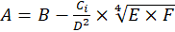 (3.5)

where A is profit, UAH;
B is revenue, UAH;
C… you must explain all the formula components, formula is made in MS Equation only.

According to the numbering, this is the fifth formula of the third chapter.
It is not allowed to use three-level numbering of illustrations, tables and formulas, for example: "Fig. 2.3.2" or "(3.1.4)".

References
When writing a thesis, the student must refer to the sources, materials or individual results of which are cited in the thesis (theoretical sources, reference materials, etc.), as well as tables, formulas, illustrations and appendices.
In the theoretical chapter of the thesis, using materials published by other authors, a separate reference is made for each given final opinion, which in the text can be highlighted by a paragraph, a separate sentence or quotation. The presence of on average one - two references to one page of the text of the theoretical chapter, citing several consecutive pages of text from one source indicate the low quality of theoretical research and may be the reason for not allowing the thesis to defend.
If you use information, materials from textbooks, monographs, review articles, other sources with a large number of pages, then the link must specify the page numbers, illustrations, tables, formulas from the source referenced in the thesis.
References to sources in the text should be indicated by a serial number in the list of references and separated by two square brackets, for example: "[5, p. 25 - 27] "(fifth number in the list of references, 25 - 27 pages), or" ... in the works [11; 23; 29] ... ». Do not put a dot in front of the closing bracket. After the bracket, a full stop is placed only if it is the end of the sentence. If the link is at the end of the title of the table or illustration, do not put a full stop.
References to the illustrations of the thesis indicate the serial number of the illustration, for example: "Fig. 1.2 ", in lower case.
References to formulas indicate the ordinal number of the formula in parentheses, for example: "... in formula (2.1)".
When referring to the table, the word "table" in the text is written abbreviated, in lower case, for example: "... in table. 1.2 ».
In repeated references to tables, illustrations and formulas, the word "see" should be abbreviated, for example: "see table 1.3 ».
References to appendices should be used in cases where all the materials of the appendix are in question or the appendix contains only one component (text, table, illustration, formula, etc.). In this case, the word "appendix" and its number are used, for example: "The scheme of the organizational structure of the enterprise is given in Appendix A". If the reference is made to a separate element of the application, you need to specify only this element, without naming the application number, for example, you need to write "... in table. B.4 ... "instead of ... ... in table. B.4 of Appendix B ... ».
In references to illustrations, formulas, tables, appendices, the corresponding symbols are written in lower case (except when they are at the beginning of the sentence). No full stop is placed after the reference (figure, table, appendix, formula bracket), except when the reference is at the end of the sentence.

List of references
The list of references is to be formatted in accordance with the requirements of DSTU 8302:2015 (Ukrainian – ДСТУ 8302:2015). An example of the formatting can be found by the link http://lib.znau.edu.ua/jirbis2/images/phocagallery/2017/Pryklady_DSTU_8302_2015.pdf.
Sources in the list of references are given in alphabetical order (in alphabetical order by the names of the first authors or by title in case of absence of authors). First, sources are provided in Ukrainian, and then - foreign-language sources. Numbering of sources in the list is continuous.
When adding individual sources to the list of references, it is necessary to provide all the initial data: name of the author (authors), title of the work, place and name of the publisher (the last is not mandatory), year of publication, total number of pages (for periodicals –range of pages for the article referred). In addition, when formatting a list of references, the following general requirements are to be followed:
the initials and surname of the author are not separated from each other, ie are always placed on the same line;
titles and other details of sources from foreign languages are NOT translated;
the abbreviation of the word "page" ("p.") is always placed on the same line with the corresponding number;
it is not allowed to indicate the issue of the magazine (newspaper) as a separate item in the bibliography – the position of the bibliography can be only a separate article;
similarly, it is not recommended to refer to the whole website: the position of the list of references should be a separate page, which is designed as an article (with some differences from the article in the paper edition). Exceptions may be sites with statistical, reference information - in the case of repeated references in the text of the thesis to different pages of such a site it may be issued as a separate item in the list of references;
The URL of the website, both in the main text of the thesis and in the list of references, cannot be given in an underlined font;
it is necessary to strictly adhere to the requirements for punctuation and font type (according to the sample), without replacing the dash with a hyphen, making the necessary deviations between the structural elements of the position of the bibliography and punctuation marks, using the italic font when it is required by the standard.
You can use the online references generator to create items in the list of references: https://www.grafiati.com/uk/blogs/dstu-8302-2015-referencing-generator/
An example of the design of literary sources by their types is given in Appendix C of the guidelines. It should be borne in mind that the list of references is drawn up.
An example is provided below.

REFERENCES

- Про Державну програму економічного і соціального розвитку України на 2010 рік: Закон України від 20.05.2010 р. № 2278-17. URL: http://zakon.rada.gov.ua/cgi-bin/laws/main.cgi?nreg=2278-17 (дата звернення: 12.10.2023).
- Anderson E., Simester D. Effects of $9 Price Endings on Retail Sales. Quantitative Marketing and Economics. 2003. Issue 1. P. 93–110.
- Arsel Z., Kirsi E., Moisander J. Introduction: theorising gender and gendering theory in marketing and consumer research. Journal of Marketing Management. 2015. Issue 31 (16). – P. 1553–1558.
- Barletta M. How Does Marketing for Women Differs from Marketing for Men. Michigan : Dearborn Trade, 2011. 288 p.
- Berggren J., Gonzalez R. Gender Difference in Financial Decision Making. Umea : Umea University. 2014. 184 p.
- Pushkar O., Zavgorodnia O. Decision support systems : summary of lectures. Kh. : Publishing House of KhNUE, 2012. 172 p.
- Bhasin H. Aaker Brand Equity Model. Marketing 91 : website. URL: https://www.marketing91.com/aaker-brand-equity-model (date of access: 03.11.2023).
- Chua N. Y., Lundbye J. Endovascular catheter as a rewarming method for accidental hypothermia. Therapeutic hypothermia and temperature management. 2012. Vol. 2, no. 2. P. 89–91. URL: https://doi.org/10.1089/ther.2012.0001 (date of access: 06.05.2020).
- Population, total. The Worlrd Bank : website. URL: https://data.worldbank.org/indicator/SP.POP.TOTL?view=chart (date of access: 15.10.2023).
- Porter M. E. Competitive Strategy: Techniques for Analyzing Industries and Competitors. 2nd ed. Amazon : website. URL: https://www.amazon.com/Competitive-Strategy-Techniques-Industries-Competitors/dp/0684841487 (date of access: 07.08.2023).

Appendices
Appendices are designed as a continuation of the bachelor's thesis immediately after the list of references in the form of a separate part, and are placed in the order of reference to them in the text of the thesis. Appendices must begin with the title page, on which the word "APPENDICES" is printed symmetrically in large letters on the sheet. Each appendix should also begin with a title page on which the word "appendix" and the corresponding letter are written in bold symmetrically to the page. For example: "APPENDIX A". On the other line ─ its name in small letters in bold, for example: "Organizational structure of enterprise management". The words "APPENDICES", "APPENDIX", the application number and its name are not quoted.
Appendices should be indicated in consecutive capital letters of English alphabet, for example: "APPENDIX A", "APPENDIX B", etc.
Illustrations, tables and formulas, which are placed in the appendices, are numbered within each appendix, for example:”Fig. D.2”─ the second figure of Appendix D; (A.1) ─ the first formula of Appendix A. Elsewhere, the illustrations, tables and formulas contained in the Appendices are subject to the general design requirements.
Documents filled in on both sides of the sheet are counted as two pages, but the number is placed only on the first of them.
It is inadmissible to provide in the appendices any documents containing the seal of the enterprise or the signatures of its officials, in particular, financial statements. Financial statements of the enterprise - the internship and research base is given in the tables created using Microsoft Excel.
Articles that have not yet been published are submitted in the appendix in accordance with the requirements for their design in the publication to which they are submitted.

The formatting procedure for the diploma thesis is described in the appendix E.

Requirements for the formatting of the presentation
Presentation must contain at least 5 slides. Presentation includes graphs, diagrams, tables and formulas that must be in the thesis, which have a semantic load and which will be reported during the thesis defense. Slides are arranged in the order in which they are mentioned in the report during the defense.
The numbering of illustrations, tables and formulas in the presentation is thorough. Illustrations, tables and formulas in the presentation have their own one-level number, not the one they had in the robot, for example: "Fig. 1”.
In addition to the presentation, the student must submit to the commission the text or copy of the article published in the scientific journal on the topic of the thesis. A pre-published article and its electronic version (if it has not yet been published) are submitted to the graduating department.

5. SUPERVISION OF THESIS

In order to timely prepare for the bachelor's thesis of students by order of the rector of the higher education institution in accordance with the submission of the department appointed supervisors of theses. In addition, consultants - teachers of relevant departments are appointed to consult on certain issues.
Thesis supervision is carried out by teachers of the highest level of qualification of the Department of Management and Business. The distribution of supervisors of the bachelor's thesis by students is approved at the meeting of the department, taking into account the topics of thesis and wishes of students.
Thesis supervisor performs the following functions:
manages the preparation of the thesis;
controls the implementation of the schedule of the educational process by the student;
helps the student to formulate the final version of the topic of thesis, choose the right direction and methods of solving major problems, together with the student determines the tasks for the thesis and makes a plan;
assists in the development of a calendar schedule for the entire period of preparation of the thesis;
recommends the necessary sources to study the topic of the thesis: basic literature, reference materials, etc .;
conducts systematic, scheduled and scheduled consultations, conversations;
analyzes and controls the organization of independent student work;
monitors the performance of work (in parts and in general) in accordance with the developed calendar schedule;
checks the chapters of the thesis and work in general;
helps to prepare and publish a scientific article based on the thesis.

6. PREPARATION OF THESIS BY STUDENTS

Preparation of theses begins after the approval of the topic and the appointment of supervisors.
The work on preparation and writing of the bachelor's thesis is carried out by students independently in accordance with the calendar schedule approved by the graduating department. In the process of work the student must follow all the recommendations of the supervisor.
Responsibility for the implementation of approved diploma preparation plans is due to the students and supervisors. In case of non-fulfillment of this plan, the supervisor reports on this isuue in the meeting of the Department of Management and Business.
After completing the bachelor's thesis, the student must obtain all necessary signatures from the supervisor and consultants.
Completed thesis is submitted to supervisor not later than two weeks before the appointed date of defense. After studying and in case of approval of the thesis, the supervisor together returns the student's thesis to pass the procedure of norm control and its further approval by the head of the Department of Management and Business. The purpose of norm control, which is carried out by the teacher of the graduating department, is the final verification of compliance of the content and design of the work to the requirements of the department. In addition to the unbound explanatory note, the student must provide an article (with an electronic version) or a copy of the published article.
After approval by the head of the Department of Management and Business, the bachelor's thesis is submitted for external review.
The electronic version on a diskette (disk) in a separate envelope (file) is submitted to the graduating department.
In case of a negative conclusion of the head or head of the graduating department, the student is not allowed to defend the thesis.
Before the defense, the student is obliged to read the review, analyze it and prepare responses to comments.
Students who have not completed the curriculum and at the time of submission of the thesis have academic debt are not allowed to defend.
Students who have not defended their dissertations are not eligible for a bachelor's degree. Such students are issued a certificate of completion of the bachelor's degree program.

7. EXTERNAL REVIEW OF THE THESIS

External reviewers may be leading specialists working at enterprises, research institutions, teachers of other higher education institutions. The review must be printed on the letterhead of the enterprise (institution) or have its seal, or or have another format approved by the Management and Business department. The external review should contain the following components:
conclusions on the relevance of the chosen topic, the practical significance of the thesis;
characteristics of the completeness of the task on the disclosure of the thesis, compliance with the content of the work to the task;
conclusions on the use of modern research methods, methodological approaches to improving the activities of the enterprise in accordance with the direction of the thesis;
evaluation of specific proposals, recommendations for improving the management of certain aspects of the enterprise, increasing its efficiency;
assessment of general impressions from the thesis (design, style and literacy of teaching, etc.);
the reviewer's conclusion on the compliance of the quality of the thesis with the requirements for such works, on the possibility of admitting it to the defense, the proposed assessment of the work on the stem scale and the national scale in parentheses and the possibility of awarding the student a bachelor's degree in management.

8. PROCEDURE FOR DEFENSE OF THESIS

Thesis defense is held at an open meeting of the state examination commission.
Lists of students admitted to the defense are submitted to the state examination commission no later than one week before the defense.
At the same time, the members of the state examination commission will be acquainted with the diploma theses of the students that this commission will deserve.
The following documents are submitted to the State Examination Commission before the start of the defense:
summary of students' implementation of the curriculum and the grades they received;
external review.
The State Examination Commission may also be provided with other materials characterizing the scientific and practical value of the diploma work, ─ printed articles on the topic of the work, documents indicating its practical application, etc.
The thesis defense procedure is public and consists of the following stages:
a brief report from the author (determines the purpose, content, scientific and practical value of the work; issues submitted for defense, and the results of the thesis). Recommended duration of the student's report ─ 5 ─ 7 minutes;
answers to questions from members of the state examination commission and those present at the defense;
answers to comments from reviewer;
summarizing the results of the defense of the thesis (assessment of the thesis of each student).
Based on the review, the results of the thesis defense and average grade based on the grades obtained during training, the state examination commission makes a reasoned decision for each student to award a bachelor's degree.
The decision of the state examination commission to assess the knowledge found during the preparation and defense of the thesis, as well as assigning a bachelor's degree to a student and issuing a relevant state document is made by the state examination commission at a closed meeting by open voting participation in the meeting. With the same number of votes, the vote of the head is decisive.
The results of the defense of theses are announced on the same day after the minutes of the meeting of the state examination commission. Students whose work contains a significant amount of scientific novelty may be recommended by the state examination commission for admission to the master's program.

APPENDICES

Appendix А
List of topics of bachelor's theses
Decision-making in management
1. Improvement of the process of making management decisions at the enterprise
2. Improvement of the technology of management decision-making at the enterprise
3. Development of a project to increase the profitability of the enterprise
4. Justification of the directions of formation and use of the company's profit
5. Justification of the outsourcing of individual functions of the enterprise
6. Making decisions regarding the structure of stocks at the enterprise
7. Development of measures to support management decision-making at the enterprise
8. Improvement of the existing technology of management decision-making regarding the labor motivation system at the enterprise
9. Improvement of the decision-making process in the field of production and sale of goods
10. Improvement of the process of making managerial decisions at the enterprise in the production sphere
11. Improvement of the process of making management decisions regarding product differentiation at the enterprise

Information and communications in management, information support and management decision-making support
12. Improvement of management information support based on new information technologies at the enterprise
13. Development of measures for the formation of the company's communication policy
14. Formation of an effective management information support system.
15. Information support of the enterprise management system
16. Justification of the choice of an automated management system for the enterprise
17. Improvement of intra-company communications in the management of business processes of the enterprise
18. Improvement of document flow at the enterprise

Planning at the enterprise, development of a business plan
19. Development of a business plan for the release of new products (services) at the enterprise
20. Development of a business plan for the development of the enterprise
21. Development of measures to implement the controlling system at the enterprise
22. Development of a project to improve the planning system at the enterprise
23. Justification of the update of the company's product range based on the marketing approach
24. Planning of production and economic activities of the enterprise
25. Justification of the strategic plan of the enterprise
26. Project planning at the enterprise
27. Organization and planning of construction and assembly works

Development of enterprise strategy
28. Justification of diversification of production activity at the enterprise
29. Development of measures to differentiate products produced at the enterprise
30. Making management decisions regarding the choice of the company's competitive strategy
31. Development of the production strategy of the enterprise
32. Making strategic decisions at the enterprise
33. Justification of the knowledge management strategy at the enterprise
34. Justification of the business unit development strategy

Competitiveness of the enterprise and products, product quality
35. Development of the company's competitive policy
36. Implementation (improvement) of the product (service) quality management system at the enterprise
37. Improvement of enterprise activity due to quality management
38. Evaluation and planning of increasing the competitiveness of the company's products
39. Development of measures to improve the quality of the company's products
40. Justification of measures to ensure the competitiveness of the enterprise
41. Justification of measures to increase the competitiveness of the enterprise
42. Increasing the competitiveness of a trading enterprise
43. Evaluation of the competitiveness of the enterprise
44. Improving the competitiveness of a commercial enterprise

Managing the the potential of the enterprise
45. Assessment of the enterprise's potential and development of recommendations for its improvement
46. Evaluation and formation of the production potential of the enterprise
47. Justification of measures regarding the formation and use of the production potential of the enterprise

Management of organization, organizational structure
48. Improvement of the organizational structure of enterprise management
49. Implementation of new management technologies at the enterprise
50. Organization and planning of the activity of structural units of the enterprise
51. Justification of measures to improve the enterprise management system

Anti-crisis management
52. Organization of anti-crisis management of the enterprise
53. Improvement of the remuneration system at the enterprise in the conditions of anti-crisis activity
54. Justification of the anti-crisis program at the enterprise
55. Justification of the anti-crisis personnel management system at the enterprise

Managing the innovative activity of the enterprise, technical development of production, production of new products, technical preparation of production
56. Formation and implementation of the innovative potential of the enterprise
57. Organization of innovative activities at the enterprise
58. Justification of ways to improve the efficiency of the enterprise's innovative activity
59. Technical and economic justification of the introduction of innovations at the enterprise
60. Development of measures for the formation of innovative activity of the enterprise

Managing the investment activity of the enterprise
61. Organization of investment activities of the enterprise
62. Justification of the economic assessment of the enterprise's investment project
63. Evaluation of the investment attractiveness of the enterprise
64. Justification of measures to improve the efficiency of investment activity of the enterprise
65. Development of a business plan for an investment project
66. Development of the investment activity plan of the enterprise
67. Organization of planning of investment activity of the enterprise

Organization of production
68. Improvement of production organization at the enterprise
69. Justification of ways of effective use of production funds at the enterprise
70. Justification of the production program of the enterprise
71. Development of a project to improve the organization of the production process at the enterprise
72. Justification of directions for increasing the efficiency of production activity
73. Organization of the production process at the enterprise
74. Planning of production activities of the enterprise
75. Planning the loading of production facilities of the enterprise

Cost management
76. Development of measures to reduce costs for the production and sale of the company's products
77. Improvement of the cost management system at the enterprise
78. Planning production costs at the enterprise
79. Planning to reduce the cost of production as one of the factors of increasing its competitiveness

Managing the marketing, sales and logistics activities of the enterprise
80. Organization of marketing activities at the enterprise
81. Organizational design of the marketing service and its activities at the enterprise
82. Justification of the product strategy at the enterprise
83. Planning of marketing activities at the enterprise
84. Organization of sales activities of the enterprise
85. Organization of sales activities of the enterprise using information technologies
86. Justification of the implementation of the marketing information system at the enterprise
87. Implementation of brand management in the management activities of the enterprise
88. Marketing support and management decision-making.
89. Organization of marketing activities using Internet technologies
90. Justification of measures regarding the introduction of branding at the enterprise
91. Justification of the marketing policy improvement project based on the use of the brand
92. Organization of logistics activities of the enterprise
93. Justification of the project of implementation of electronic marketing at the enterprise
94. Organization of sales of advertising products at the enterprise

Personnel management (work organization, motivation, assessment, training)
95. Justification of directions for ensuring the efficiency of management of the working time of the company's employees
96. Development of measures to increase the labor productivity of the enterprise's management personnel
97. Evaluation of personnel activity at the enterprise in modern conditions
98. Formation of a favorable social and psychological climate in the collective organization
99. Development of measures for the development of the company's personnel
100. Justification of measures to increase labor productivity at the enterprise
101. Justification of measures to reduce the level of conflict at the enterprise.
102. Evaluation and development of the company's personnel
103. Organization of remuneration at the enterprise
104. Improvement of the labor incentive system taking into account the qualifications of personnel
105. Justification of the labor incentive system of the company's personnel
106. Technical and economic justification of measures to increase labor productivity at the enterprise
107. Justification of the staff development project based on coaching
108. Optimization of personnel planning as an improvement of business planning systems
109. Evaluation of the work of the company's personnel
110. Development of measures to motivate personnel at the enterprise
111. Justification of the labor organization system of the company's personnel
112. Justification of measures to motivate the company's personnel

Leadership, organizational culture
113. Formation of the organizational culture of the enterprise
114. Improvement of the corporate management system at the enterprise
115. Formation of organizational culture and image of the enterprise
116. Formation and development of organizational culture at the enterprise

Corporate social responsibility, social aspects of management
117. Development of social responsibility measures at the enterprise
118. Justification of the introduction of corporate social responsibility at the enterprise
119. Development of measures to support corporate social responsibility at the enterprise
Other
120. Organization of foreign economic activity of the enterprise

Appendix B
Sample of the application form for choosing the topic of the thesis

Зав. кафедрою менеджменту та бізнесу
д.е.н., проф. Лепейко Т. І.
студентки 4 курсу
групи 6.03.073.040.17.3
спеціальності 073 «Менеджмент»
Шевченко Тетяни Олександрівни

ЗАЯВА

Прошу затвердити мені тему дипломної роботи: «Розробка бізнес-плану інвестиційного проекту».

База практики: ТОВ «Омега».

Керівник: к.е.н., доц. Красноносова О. М. (підпис)

Дата Підпис студента

Appendix C
Formatting of references by their types

Keep in mind that the list of references used in the thesis is not a table, as given below, but a numbered list!

Table C.1
Examples of design of sources in the list of references
Type of source | Examples of formatting
1 | 2
Laws, bylaws | - Господарський Кодекс України від 16.01.2003 р. № 436-IV. Відомості Верховної Ради України. 2003. № 18, № 19–20, № 21–22. Ст. 144.  - Про Державну програму економічного і соціального розвитку України на 2010 рік: Закон України від 20.05.2010 р. № 2278-17. Відомості Верховної Ради України. 2010. № 33. Ст. 470.  - Про схвалення Державної програми розвитку промисловості на 2003–2011 роки: Постанова Кабінету Міністрів України від 28.06.2003 р. № 1174. Офіційний вісник України. 2003. № 31. Ст. 1628.
State standards | - ДСТУ ISO 9001: 2001. Системи управління якістю. [Чинний від 2001-06-27]. Київ, 2001. 24 с. (Інформація та документація).
Laws, bylaws, standards posted on the Internet | - Про Державну програму економічного і соціального розвитку України на 2010 рік: Закон України від 20.05.2010 р. № 2278-17. URL: http://zakon.rada.gov.ua/cgi-bin/laws/main.cgi?nreg=2278-17 (дата звернення: 12.10.2023).
Books: monographs, textbooks, manuals, dictionaries (one author) | - Близнюк Т. П. Вплив циклічності розвитку економіки на інноваційну діяльність підприємства : Монографія. Х. : ФОП Александрова К. М., 2008. 352 с.  - Parker J. Principles of scientific research. 7th ed. London : Editorial, 2017. 301 p.
Books: monographs, textbooks, manuals, dictionaries (2–3 authors) | - Лепейко Т. І., Котлик А. В. Процесний підхід до управління конкурентоспроможністю підприємства : монографія. Харків : Вид. ХНЕУ, 2012. 316 с.  - Wilson D., Lister P., Andrews A. Modern surgery. Manchester : MAN, 2011. 240 p.  - Білоус С. І., Корнійчук В. П. Філософія освіти. Переяслав-Хмельницький, 2016. 176 с.
Books: monographs, textbooks, manuals, dictionaries (4 authors) | - Організація маркетингового управління діяльністю підприємств машинобудівного кластера в умовах глобалізації : монографія / Лепейко Т. І., Пилипенко А. А., Пушкар О. І., Березовський К. М. Х. : ТОВ «Золоті сторінки», 2015. 664 с.  - Referencing styles / G. R. Edwards et al. Los Angeles : International Publishing, 2010. 280 p.

Продовження табл. В.1
1 | 2
Books: monographs, textbooks, manuals, dictionaries (over 4 authors) | - Концептуальні засади менеджменту в інформаційній економіці : монографія / Лепейко Т. І. та ін.; під заг. ред. Т. І. Лепейко. Харків : Вид. ХНЕУ, 2010. 252 с.  - Referencing styles / G. R. Edwards et al. Los Angeles : International Publishing, 2010. 280 p.  - Менеджмент у структурах видавничо-поліграфічного комплексу : навчальний посібник / Лепейко Т. І. та ін. Х. : Вид. ХНЕУ, 2011. 352 с.
Without author | - Міжнародні відносини : монографія / за ред. М. А. Березовського. Київ : ЦУЛ, 2016. 162 с.  - Routledge handbook of international statebuilding / ed. by D. Chandler, T. D. Sisk. London : Routledge, 2013. 448 p.
Part of the publication (monograph) | - Лепейко Т. І., Котлик А. В. Сучасні підходи до виділення підсистем підприємства. Концептуальні засади управління підприємством як економічною системою : Монографія / за ред. В. О. Коюда. Харків : Вид. ХНЕУ, 2007. С. 26–47.  - Goehr L. The concept of opera. The Oxford handbook of opera / ed. by H. M. Greenwald. Oxford, 2014. P. 92–136.
Multi-volume editions | - Бондаренко В. Г., Канівська І. Ю., Парамонова С. М. Теорія ймовірностей і математична статистика. У 2 ч. К.: НТУУ «КПІ», 2006. Ч. 1. 125 с.  - Енциклопедія рослин / редкол.: І. М. Деркач та ін. Київ : ЦУЛ, 2016. Т. 8. 812 с.  - Котлик А. В. Критика застосування методу радару для оцінки конкурентоспроможності підприємства. Актуальні проблеми економічного та соціального розвитку виробничої сфери : матеріали VI Міжнародної науково-теоретичної конференції молодих вчених і студентів, м. Донецьк, 21–22 травня 2009 р. Донецьк : ДВНЗ ДонНТУ, 2009. Т. 1. С. 291–294.  - Бюджетна система України: історія, стан та перспективи : у 3 т. / Акад. прав. наук України. Львів : Право, 2012. Т. 2 : Бюджетний менеджмент / заг. ред. Ю. П. Бубряка. 476 с.
Translated editions | - Брігхем Є. В. Основи фінансового менеджменту / пер. з англ. В. Біленького та ін. Київ : Молодь, 1997. 998 с.
Продовження табл. В.1
1 | 2
Articles in periodicals (magazines, newspapers) | - Котлик А. В. Побудова системи показників для оцінки конкурентоспроможності бізнес-процесів підприємства. Управління розвитком. 2011. № 21 (118). С. 30–32.  - Котлик А. В. Цілеорієнтований підхід до ідентифікації бізнес-процесів підприємства. Бізнес Інформ. 2013. № 2. С. 193–196.  - Масловська Л. Ц., Савчук В. А. Оцінка результативності і ефективності виробництва органічної агропродовольчої продукції. Агросвіт. 2016. № 6. С. 23–28.  - Якобчук В. П. Стратегічні пріоритети інноваційного розвитку підприємництва в аграрній сфері. Вісник Київського національного університету ім. Т. Шевченка. Сер. Економіка. 2013. Вип. 148. С. 31–34.  - Dankevych Ye. M., Dankevych V. Ye., Chaikin O. V. Ukraine agricultural land market formation preconditions. Acta Universitatis Agriculturae et Silviculturae Mendelianae Brunensis. 2017. Vol. 65, №. 1. P. 259–271.  - Монаєнко А. Поза чергою не рахується? Особливості звільнення суддів за порушення присяги. Юридична газета. 2017. 17 січ. С. 28–29.
Collections of scientific works | - Наумов О. Б., Мартинова О. В. Концептуальні підходи до формування механізму адаптаційних систем управління якістю текстильної продукції. Економіка: проблеми теорії та практики : зб. наук. праць. Дніпропетровськ, 2008. Вип. 238. Т. 4. С. 968–977.
Theses of reports at conferences | - Грузіна І. А. Інформатизація як передумова соціально-економічного розвитку регіону. Актуальні проблеми розвитку галузевої економіки та логістики : матеріали II наук.-практ. конф. Харків : Вид-во НФаУ, 2013. С. 108–110.  - Котлик А. В. Критика застосування методу радару для оцінки конкурентоспроможності підприємства. Актуальні проблеми економічного та соціального розвитку виробничої сфери : матеріали VI Міжнародної науково-теоретичної конференції молодих вчених і студентів, м. Донецьк, 21–22 травня 2009 р. Донецьк : ДВНЗ ДонНТУ, 2009. Т. 1. С. 291–294.  - Скидан О. В., Судак Г. В. Розвиток сільськогосподарського підприємництва на кооперативних засадах. Кооперативні читання : матеріали Всеукр. наук.-практ. конф., 4–6 квіт. 2013 р. Житомир : ЖНАЕУ, 2013. С. 87–91.
Abstracts of dissertations | - Барабась Д. О. Управління конкурентними перевагами підприємства (на прикладі підприємств швейної галузі) : автореф. дис… канд. економ. наук : 08.06.01. К., 2003. 18 с.
Dissertations | - Беседовський О. М. Прийняття управлінських рішень: процесний підхід : дис... канд. економ. наук : 08.06.01. Харків, 2004. 241 с.
Закінчення табл. В.1
1 | 2
Internet resources: books, articles, including those without an author, company websites | - Ілляшенко С. М., Шипуліна Ю. С. Товарна інноваційна політика : підручник. Суми : Університетська книга, 2007. 281 с. URL: ftp://lib.sumdu.edu.ua/Books/1539.pdf (дата звернення: 10.11. 2023).  - Chua N. Y., Lundbye J. Endovascular catheter as a rewarming method for accidental hypothermia. Therapeutic hypothermia and temperature management. 2012. Vol. 2, no. 2. P. 89–91. URL: https://doi.org/10.1089/ther.2012.0001 (date of access: 06.05.2020).  - Інформаційне суспільство: глобальне, європейське, українське. E-Ukraine : веб-сайт. URL: http://www.e-ukraine.org.ua/book (дата звернення: 15.08. 2023).  - Що таке органічні продукти і чим вони кращі за звичайні? Екологія життя : веб-сайт. URL: http://www.eco-live.com.ua (дата звернення: 12.07.2023).  - Капітальні інвестиції за січень–вересень 2010 року : Експрес-випуск № 263 від 15.11.2010 р. Державний комітет статистики України : веб-сайт. URL: https://ukrstat.gov.ua/operativ/operativ2010/ibd/kindj/infin_u/infin03_ 10u.htm (дата звернення: 05.03. 2023).  - Проект «Рейтинг». URL: http://alt.com.ua/ukr (дата звернення: 05.03. 2023).  - Toyota. URL: https://www.toyota.com/ (date of access: 05.03. 2023).

Appendix D

Example of the design of the title page and the first broadsheet of illustrative material

МІНІСТЕРСТВО ОСВІТИ І НАУКИ УКРАЇНИ

ХАРКІВСЬКИЙ НАЦІОНАЛЬНИЙ ЕКОНОМІЧНИЙ УНІВЕРСИТЕТ

ІМЕНІ СЕМЕНА КУЗНЕЦЯ

Кафедра менеджменту та бізнесу

ІЛЮСТРАТИВНИЙ МАТЕРІАЛ

ДО ДИПЛОМНОЇ РОБОТИ БАКАЛАВРА

на тему: Удосконалення процесів управління проектами ІТ-компанії

Керівник дипломної роботи Андрій КОТЛИК
(Ім’я, прізвище)

Студентка 4 року навчання, групи 6.03.073.040.19.1 Тетяна ШЕВЧЕНКО
факультету менеджменту і маркетингу (Ім’я, прізвище)

Харків, 2023

Planning the marketing activity at the enterprise
The most important function of marketing management is marketing planning, which, basing on the analysis of the company's capabilities, reliable information on the state of assets and liabilities of production, and on the analysis of the external marketing environment, allows to develop the marketing goals and the ways of their achievement. A systematic approach to the organization of management and development of marketing strategy and tactics is a scientifically sound way to increase profitability, save costs and improve the company's position in the market.
Actuality
summarizing theoretical aspects of planning marketing activity at the enterprise and developing the practical recommendations on the development of marketing plans for the trading enterprise
Goal
to theoretically substantiate the essence of planning the marketing activities of the enterprise;
to review the algorithm of planning the marketing activities of the enterprise;
to provide the general characteristics of LLC “Syrnyi Dim”;
to conduct technical, economic and financial analysis of LLC “Syrnyi Dim”;
to analyze marketing activities of LLC “Syrnyi Dim” and current practices of its planning;
to develop recommendations for improving the planning of marketing activities of the LLC “Syrnyi Dim”
Tasks
the process of planning the marketing activities of the enterprise
Object of the thesis
the algorithm, tools and methods of planning the marketing activities of the enterprise
Subject of the thesis
morphological analysis, graphical method, logical generalization, vertical and horizontal analysis, Fishbone diagram, Internal Factor Evaluation Matrix, portfolio analysis, project evaluation and review technique
Research methods
laws and regulations of Ukraine, materials and data of periodicals, monographs and other scientific literature on the topic of marketing management and marketing planning, financial, statistical and managerial reports of the base of research
Information base
1. THEORETICAL ASPECTS OF PLANNING MARKETING ACTIVITIES1.1. The essence of marketing planning1.2. The algorithm of marketing planning2. СOMPREHENSIVE ANALYSIS OF LLC “SYRNYI DIM” ACTIVITIES2.1. General characteristics of the enterprise and technical and economic analysis of its activities2.2. Analysis of planning the marketing activities in LLC “Syrnyi Dim”3. WAYS TO IMPROVE THE MARKETING PLANNING AT LLC “SYRNYI DIM”
Thesis structure
recommendations developed in the thesis will help LLC “Syrnyi Dim” to improve the procedure of marketing planning and to develop sound marketing plan to achieve its strategic goals
Results
Kotlyk A. The essence of the term “marketing planning” for an enterprise / A. Kotlyk, O. Zubriev // Менеджмент ХХІ століття: глобалізаційні виклики: матеріали VІ Міжнародної науково-практичної конференції, 19 травня 2023 р., Полтава: ПДАУ, 2023. 1310 с. – C. 1038 – 1041.
Publications
Topic

Fig. 1. Scheme of a logical structure of the thesis

Appendix E

The formatting procedure

Setting margins:
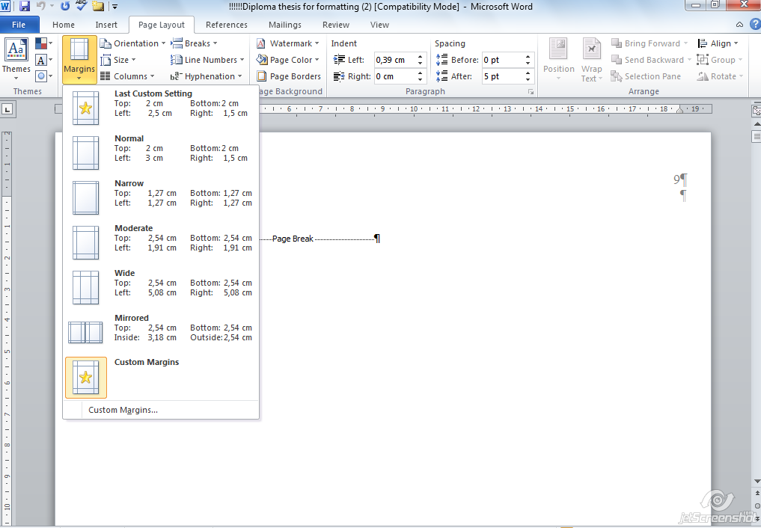

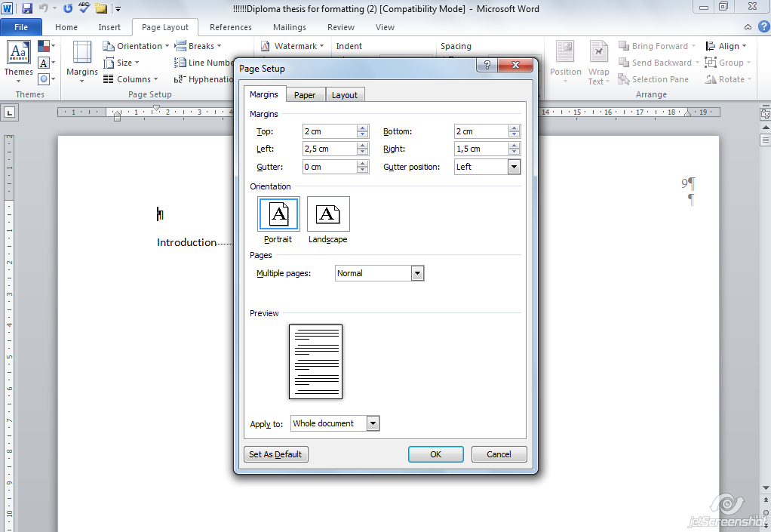
Setting up the Normal style:
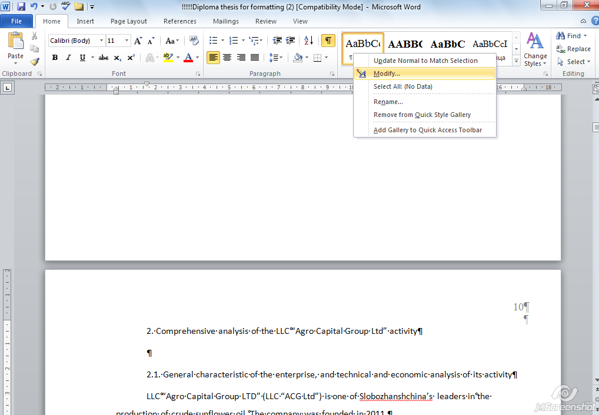

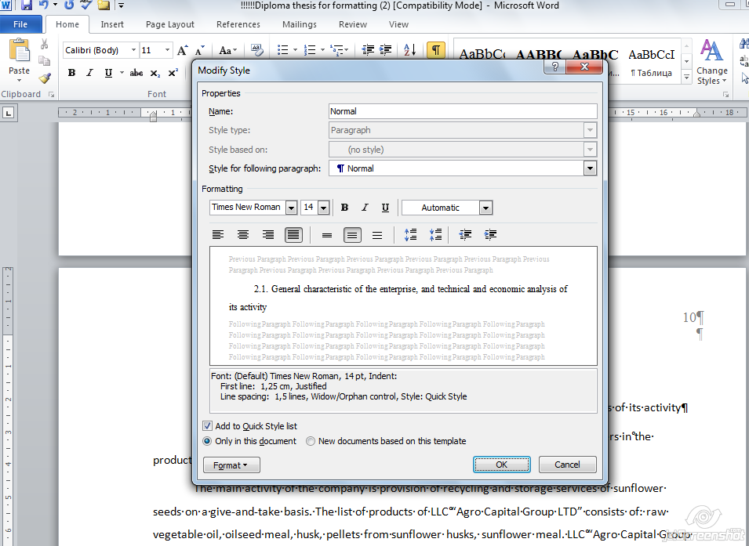

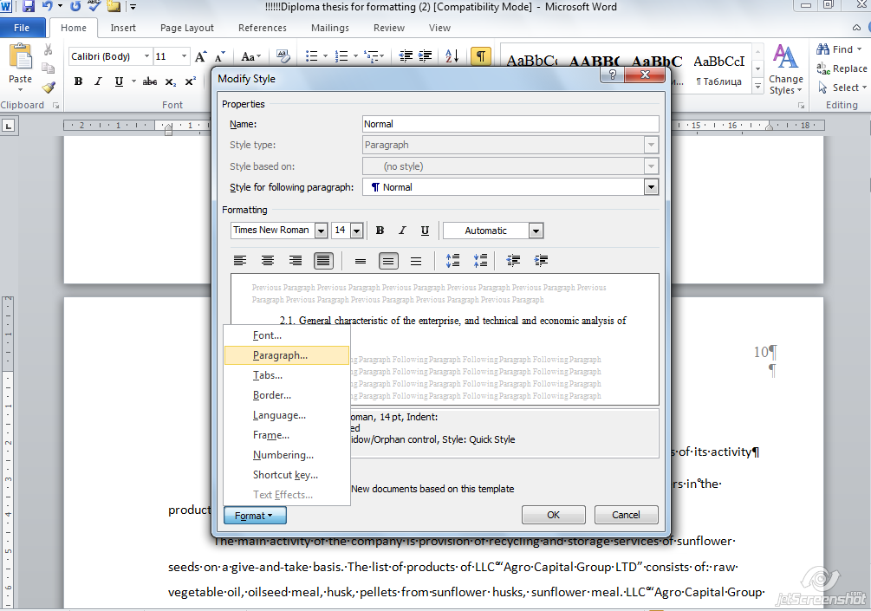

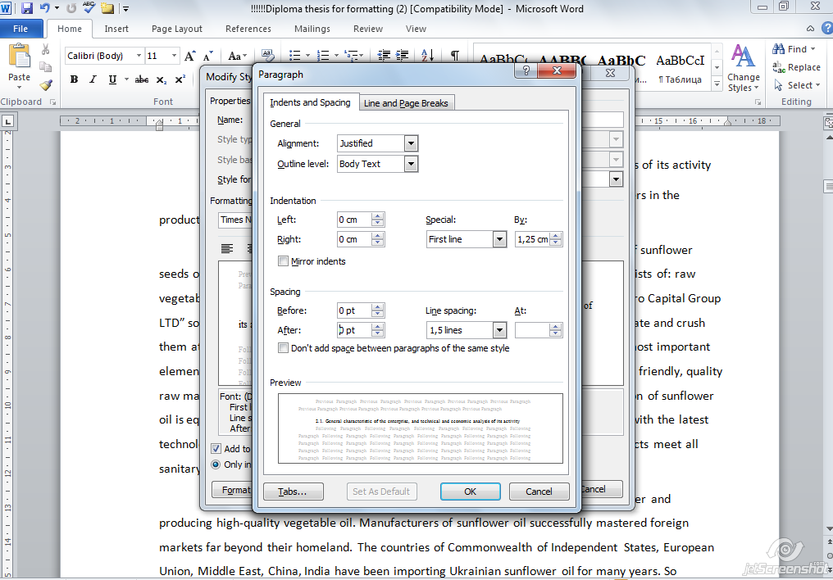
Applying the Normal style to the text:
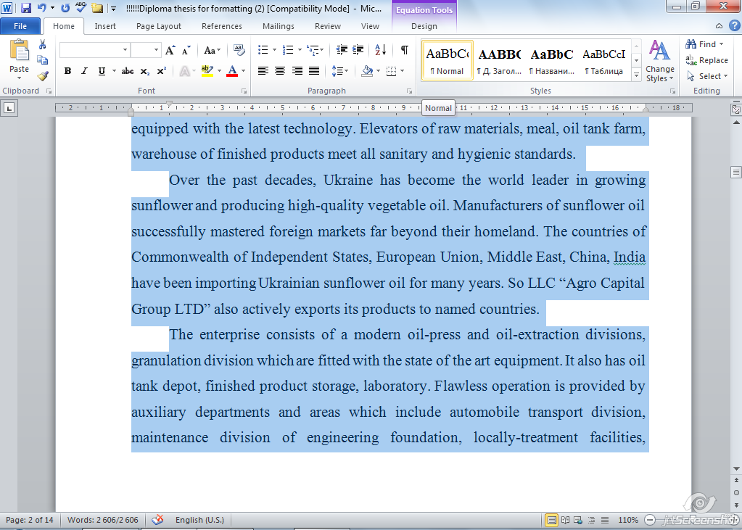

Setting up the Heading 1 (for chapters’ titles) and Heading 2 (for subchapters’ titles) styles:
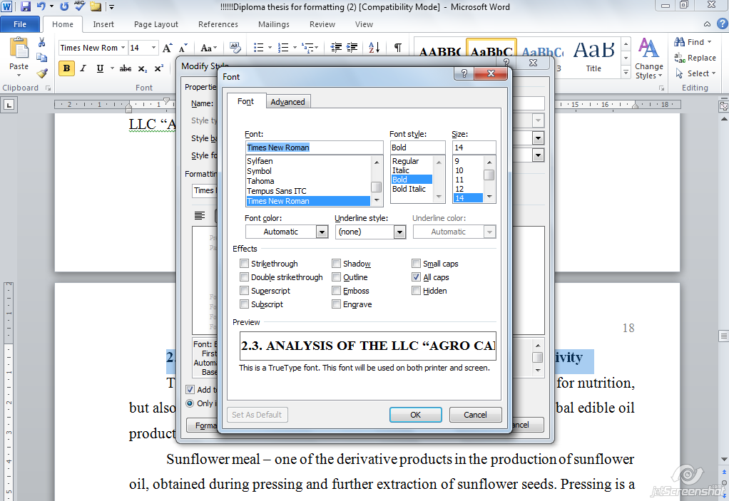


Making a table of contents:
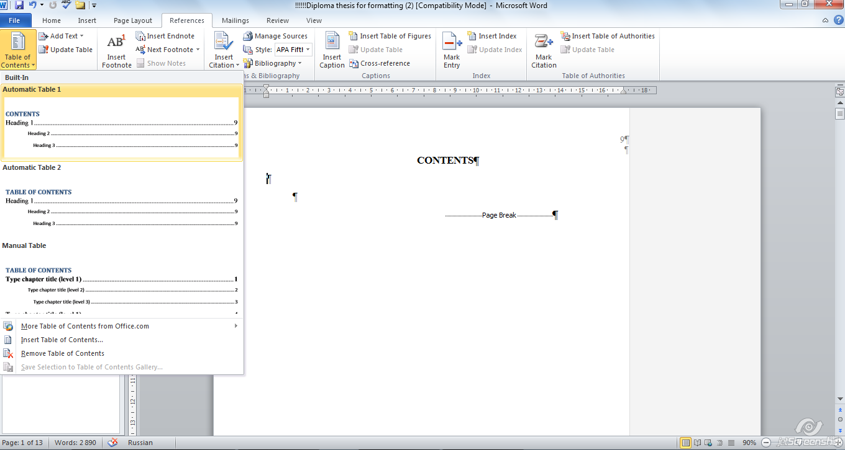
Table of contents can be updated any time:
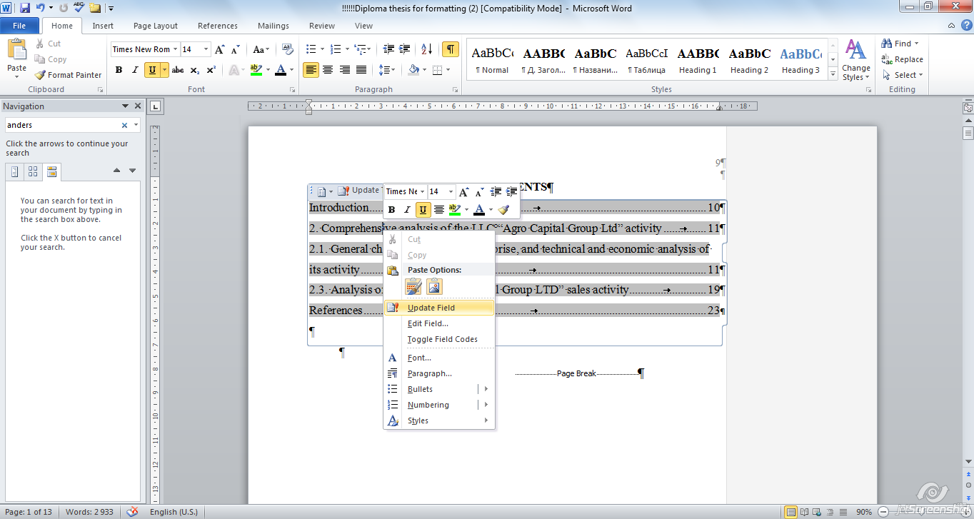

Activate the hidden symbols mode:


Tables formatting:
Font:
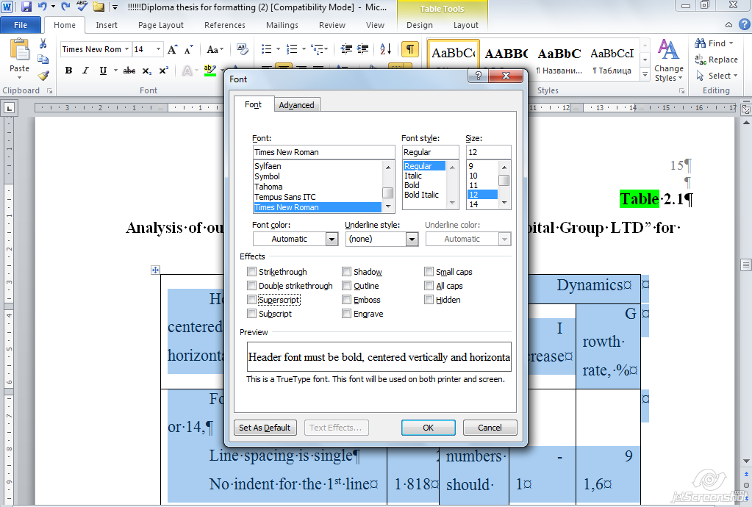
Paragraph for a table body:
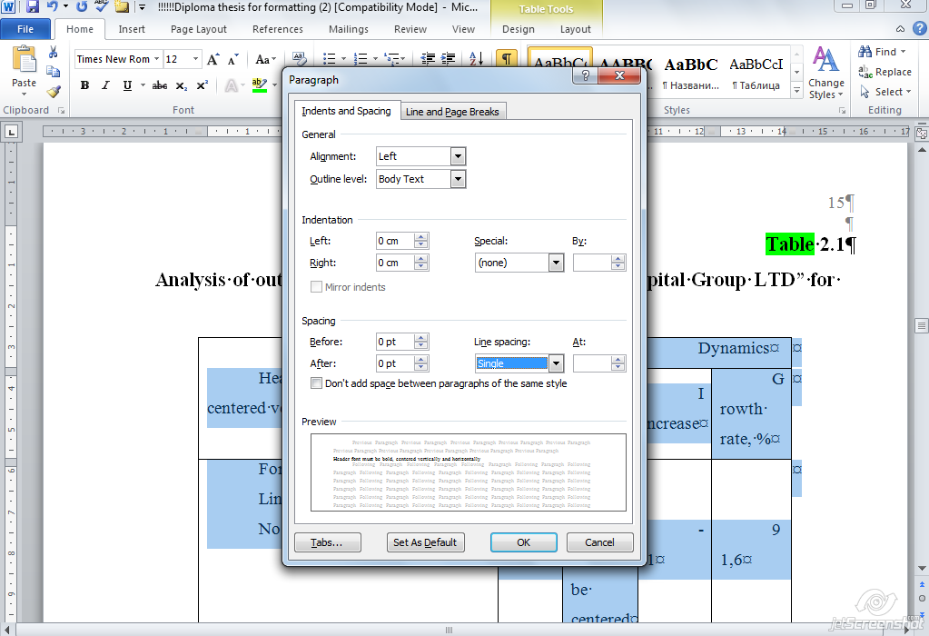
Header font:
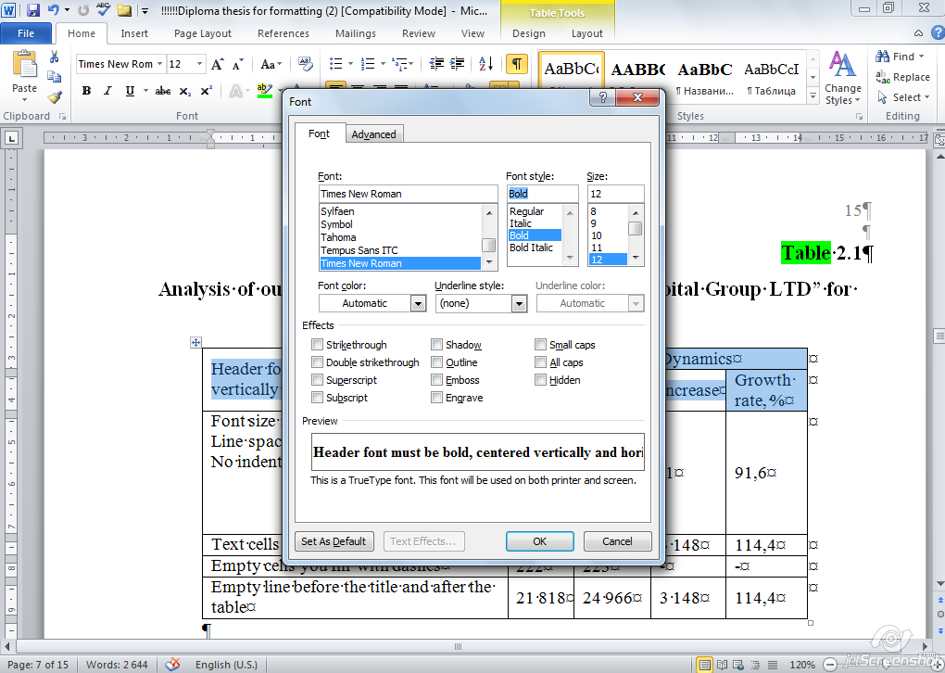
Header layout:
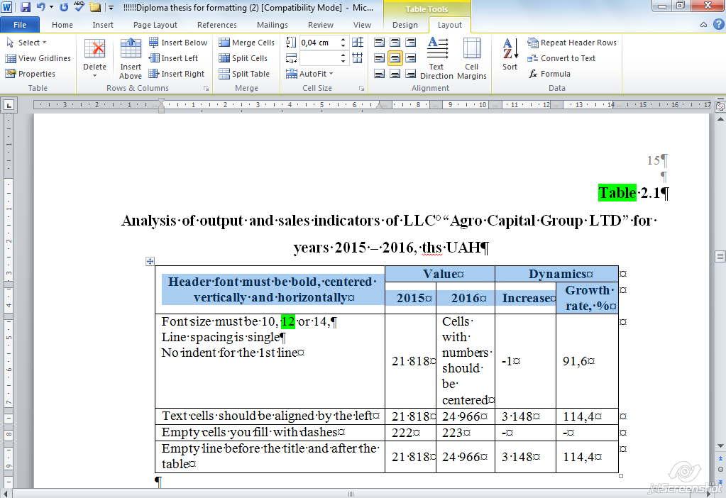
Figures is better to make in drawing canvas:
Insert – Shapes – New Drawing Canvas

Formulas:
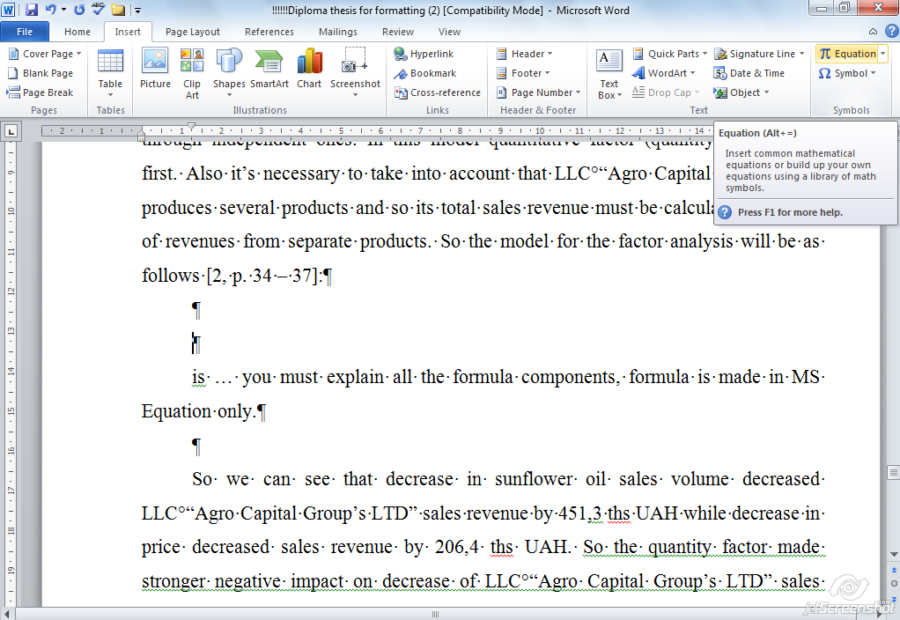

References (make reference list numbered):


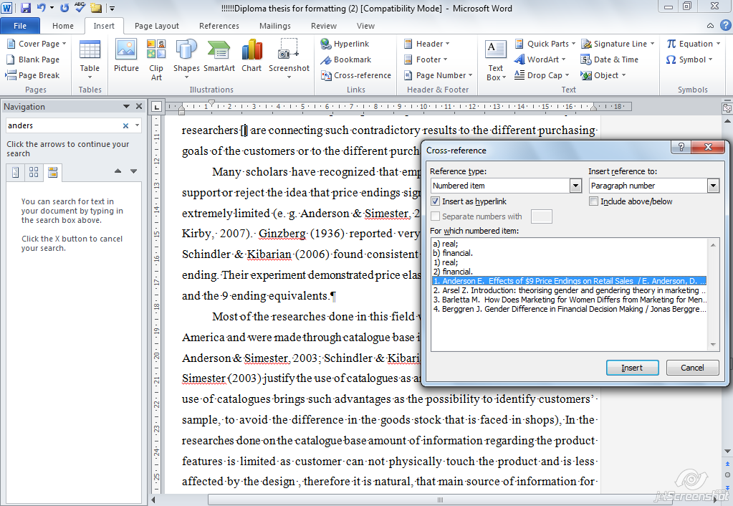

НАВЧАЛЬНЕ ВИДАННЯ

Методичні рекомендації до написання дипломної роботи на здобуття освітньо-кваліфікаційного рівня «бакалавр» для студентів напряму підготовки 6.030601 – менеджмент усіх форм навчання

Укладач Лепейко Тетяна Іванівна

Відповідальний за випуск Лепейко Т. І.

Редактор

Коректор

План 2011 р., Поз. №

Підп. до друку Формат 60х90 1/16.
Папір ТАТRA. Друк офсетний.

Ум.-друк. арк. Обл.-вид. арк.
Тираж прим. Зам № Безкоштовно

Свідоцтво про внесення до Державного реєстру суб’єктів видавничої справи Дк №481 від 13.06.2001 р.
Видавець і виготівник – видавництво ХНЕУ, 61001, м. Харків,
пр. Леніна, 9а

